THE SIMPLE SERVICE
FIELD MANUAL
200 SMALL ACTIONS FOR STRONGER COMMUNITIES
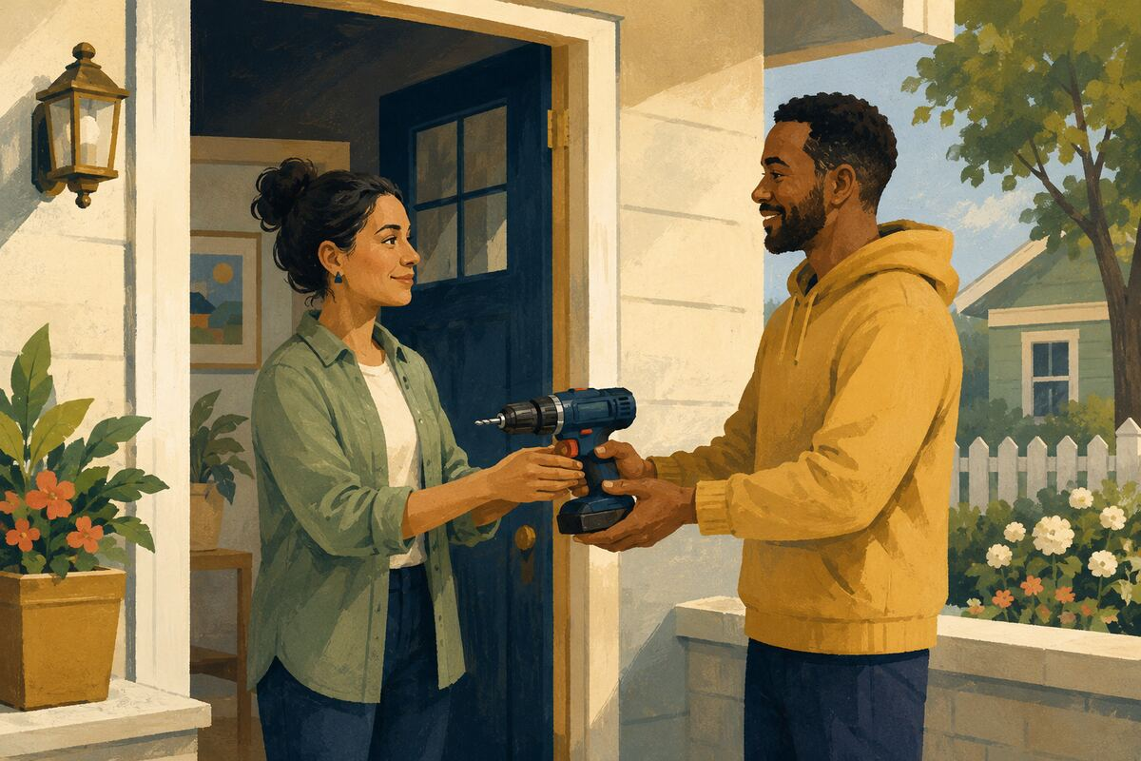
A practical, illustrated guide to everyday citizenship
Small actions multiply. Trust grows. Communities become stronger.

How to use this manual
Choose one action that fits the moment. Do it carefully, invite others without pressure, and let younger people see both the action and the reason behind it. Repetition matters more than spectacle: ordinary habits, practiced by many people, become community culture.
DO
A specific, realistic step that an ordinary person can take.
COMMUNITY BENEFIT
The shared improvement the action helps create.
EXAMPLE FOR YOUNGER GENERATIONS
The civic value demonstrated through everyday behavior.
A note on safety and respect
Use judgment. Do not handle hazardous waste, enter unsafe places, perform repairs beyond your training, share private information, or impose help on someone who has declined it. Follow local rules and involve qualified services when a situation requires them.

Twenty fields of everyday service
001–010  Everyday Courtesy and Public Trust | 101–110  Food, Hunger, and Responsible Sharing
011–020  Neighbors and Block-Level Connection | 111–120  Local Businesses and Service Workers
021–030  Clean, Safe, and Welcoming Public Spaces | 121–130  Truthful Information and Digital Citizenship
031–040  Roads, Walking, Cycling, and Transit | 131–140  Workplaces and Organizations
041–050  Children, Families, and Caregivers | 141–150  Civic Participation and Public Institutions
051–060  Schools, Libraries, and Learning | 151–160  Welcoming, Inclusion, and Belonging
061–070  Older Adults and People with Disabilities | 161–170  Homes, Buildings, and Property Stewardship
071–080  Health, Safety, and Emergency Readiness | 171–180  Skills, Mentoring, and Opportunity
081–090  Heat, Weather, and Disaster Resilience | 181–190  Animals and Shared Responsibility
091–100  Water, Energy, and Environmental Stewardship | 191–200  Community Culture, Morale, and Memory

EVERYDAY COURTESY AND PUBLIC TRUST
001 Return what you borrow
DO Return a borrowed tool, book, dish, or charger clean, complete, and on the promised date.

COMMUNITY BENEFIT Keeps shared resources circulating and makes neighbors more willing to help one another.

EXAMPLE FOR YOUNGER GENERATIONS Shows that trust is built by keeping small promises.

EVERYDAY COURTESY AND PUBLIC TRUST
002 Hold the door without making assumptions
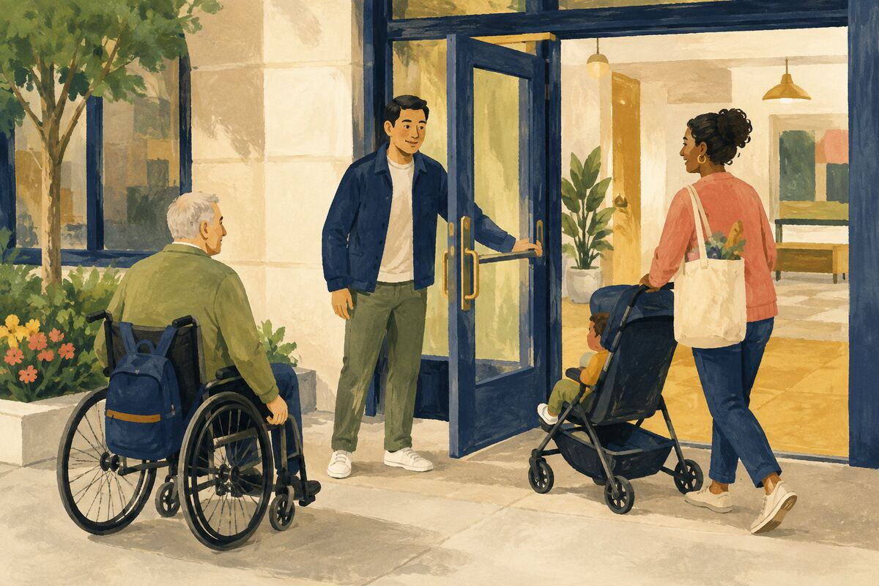
DO Hold a door when someone is close behind, especially if they are carrying items, pushing a stroller, or using mobility equipment.

COMMUNITY BENEFIT Removes a small physical obstacle and makes public places feel more considerate.

EXAMPLE FOR YOUNGER GENERATIONS Shows children how to notice another person’s situation without expecting praise.

EVERYDAY COURTESY AND PUBLIC TRUST
003 Let one car merge

DO Leave space and wave one waiting driver into slow traffic when it is safe and lawful.

COMMUNITY BENEFIT Reduces aggressive driving and helps traffic move with less conflict.

EXAMPLE FOR YOUNGER GENERATIONS Demonstrates that cooperation can work even among strangers.

EVERYDAY COURTESY AND PUBLIC TRUST
004 Use people’s names correctly
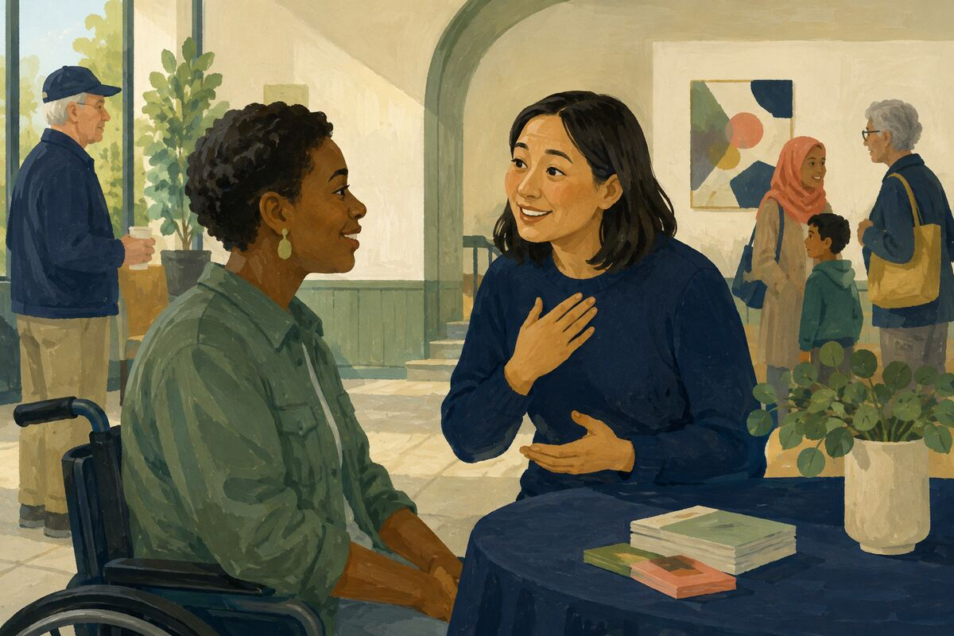
DO Ask how a person pronounces their name, repeat it correctly, and correct your own mistake without making excuses.

COMMUNITY BENEFIT Communicates respect and improves belonging.

EXAMPLE FOR YOUNGER GENERATIONS Shows that another person’s identity is worth the effort to learn.

EVERYDAY COURTESY AND PUBLIC TRUST
005 Give clear directions
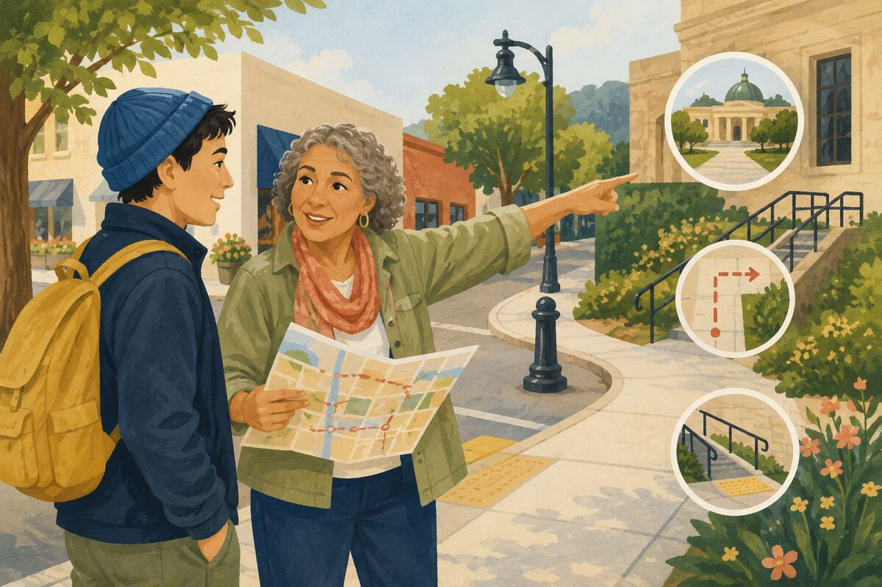
DO When someone asks for directions, include the turn, landmark, distance, and accessibility issue you actually know; say when you are unsure.

COMMUNITY BENEFIT Prevents wasted time and helps people navigate unfamiliar places safely.

EXAMPLE FOR YOUNGER GENERATIONS Models accuracy instead of pretending to know everything.

EVERYDAY COURTESY AND PUBLIC TRUST
006 Make room in shared spaces
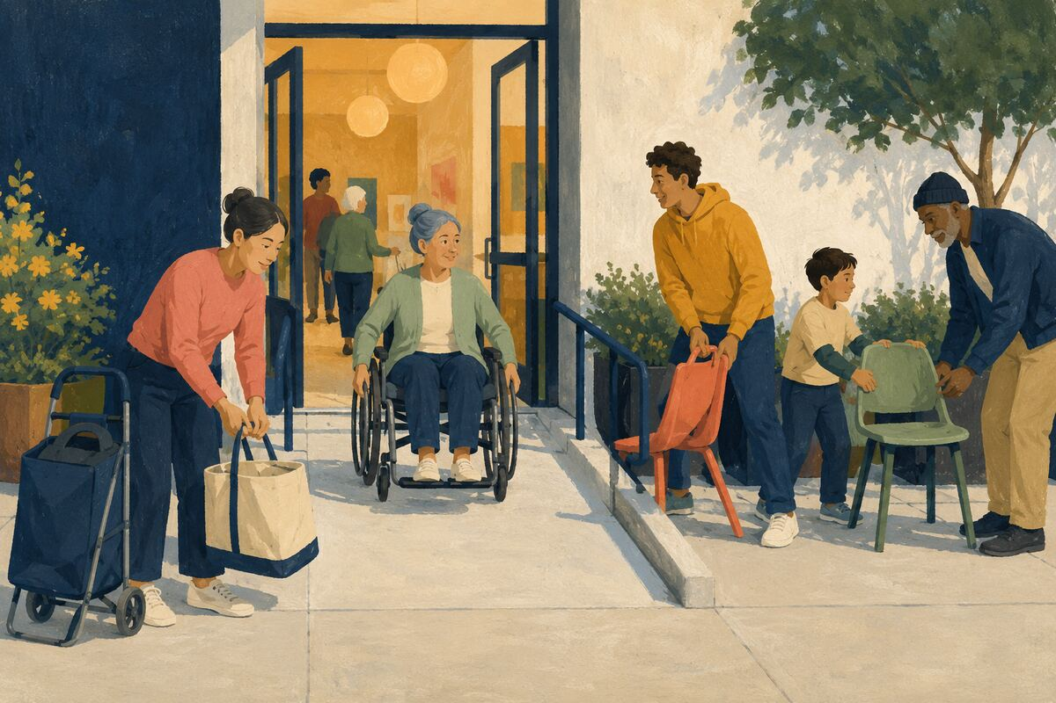
DO Move bags, carts, chairs, and groups out of walkways, ramps, doors, and aisles.

COMMUNITY BENEFIT Keeps public spaces usable for everyone, including people with limited mobility.

EXAMPLE FOR YOUNGER GENERATIONS Teaches that shared space comes with shared responsibility.

EVERYDAY COURTESY AND PUBLIC TRUST
007 Lower unnecessary noise

DO Reduce music, speakerphone volume, idling, or late-night noise when it reaches other homes or public areas.

COMMUNITY BENEFIT Protects sleep, concentration, and peaceful use of shared places.

EXAMPLE FOR YOUNGER GENERATIONS Shows that freedom includes considering how our choices affect others.

EVERYDAY COURTESY AND PUBLIC TRUST
008 Say thank you specifically
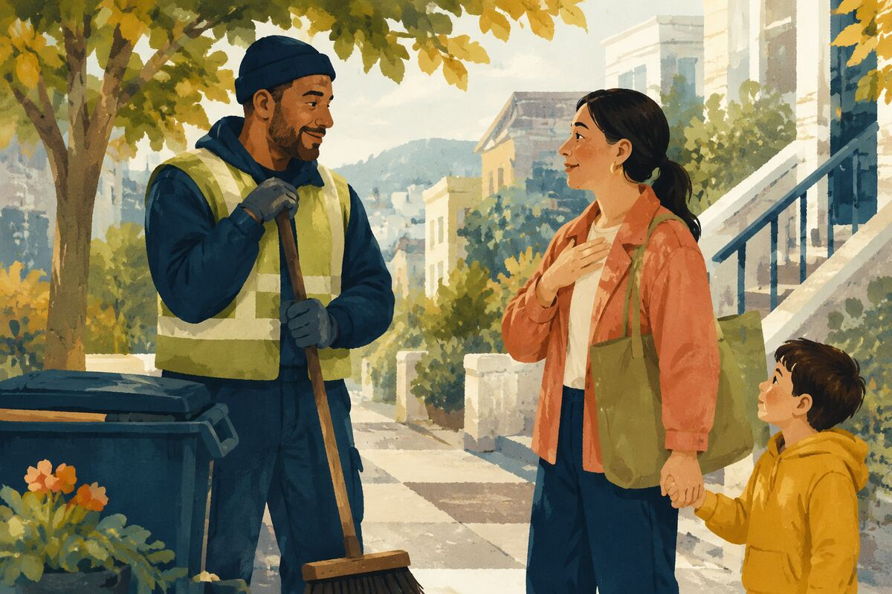
DO Tell a worker, volunteer, teacher, or neighbor exactly what they did that helped.

COMMUNITY BENEFIT Reinforces useful behavior and helps overlooked contributors feel seen.

EXAMPLE FOR YOUNGER GENERATIONS Teaches young people to notice effort, not only outcomes.

EVERYDAY COURTESY AND PUBLIC TRUST
009 Apologize and repair
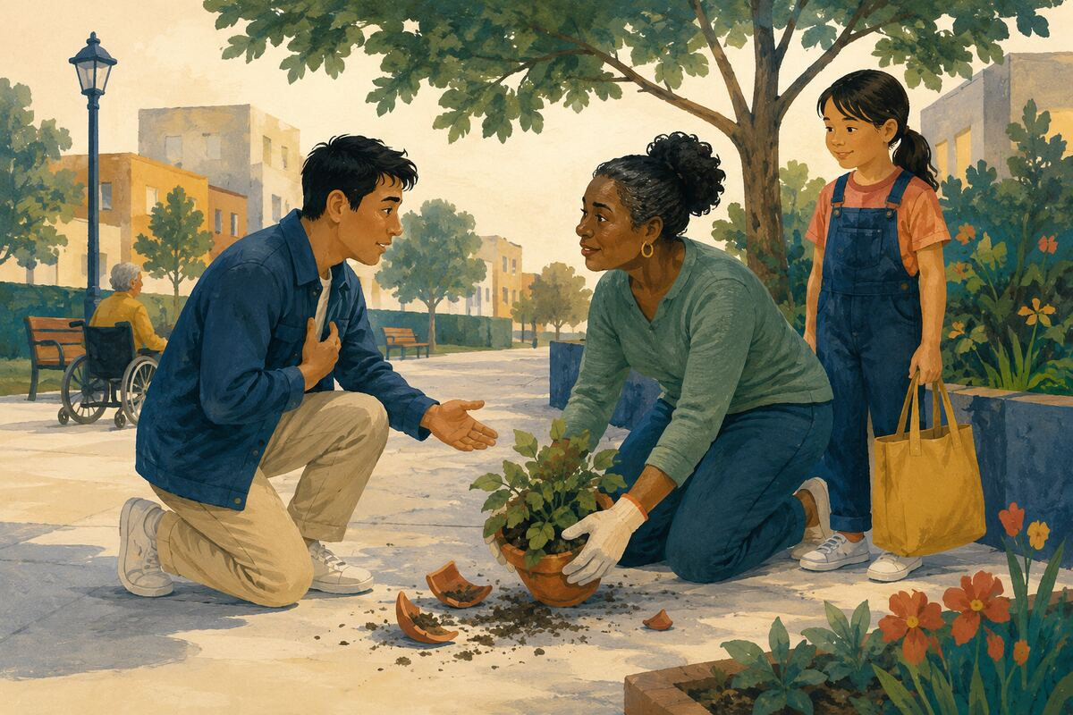
DO When you cause a problem, name what happened, apologize without conditions, and correct what you can.

COMMUNITY BENEFIT Stops small harms from becoming lasting conflicts.

EXAMPLE FOR YOUNGER GENERATIONS Shows that accountability is stronger than defensiveness.

EVERYDAY COURTESY AND PUBLIC TRUST
010 Leave the next person a clean start
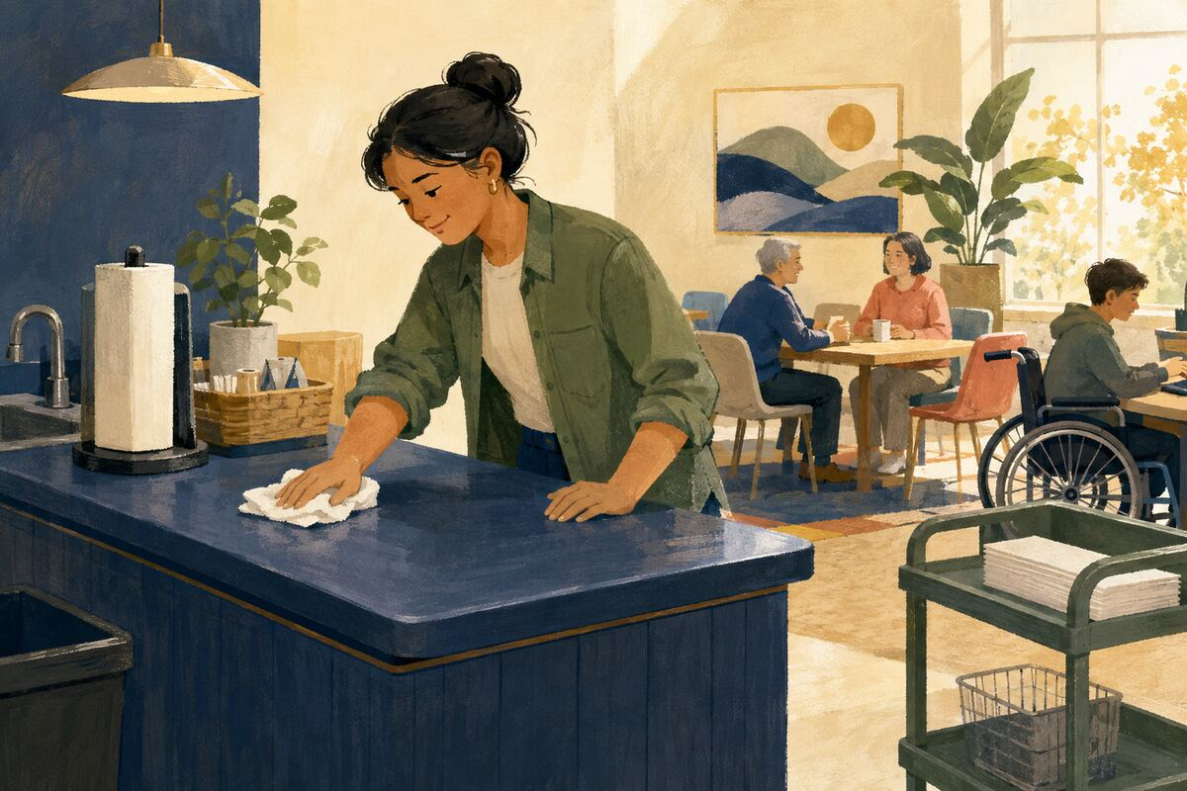
DO Wipe the counter, refill the paper, clear the table, return the cart, or reset shared equipment after use.

COMMUNITY BENEFIT Reduces invisible work and keeps common resources ready.

EXAMPLE FOR YOUNGER GENERATIONS Demonstrates that good citizenship includes people we may never meet.

NEIGHBORS AND BLOCK-LEVEL CONNECTION
011 Introduce yourself to one neighbor

DO Share your first name and a simple way to contact you, but only if both parties are comfortable.

COMMUNITY BENEFIT Creates a basic connection before a package, pet, safety, or emergency issue arises.

EXAMPLE FOR YOUNGER GENERATIONS Shows that community begins with a respectful first step.

NEIGHBORS AND BLOCK-LEVEL CONNECTION
012 Learn who may need a weather check
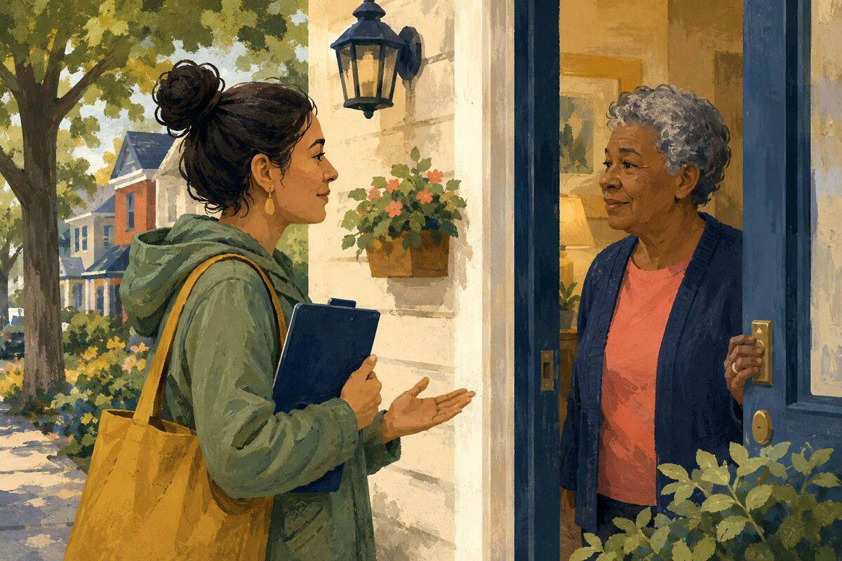
DO Privately ask an older adult, person living alone, or medically vulnerable neighbor whether they want a check-in during extreme weather.

COMMUNITY BENEFIT Builds a consent-based safety net for emergencies.

EXAMPLE FOR YOUNGER GENERATIONS Teaches care without intrusion or assumptions.

NEIGHBORS AND BLOCK-LEVEL CONNECTION
013 Bring in a bin
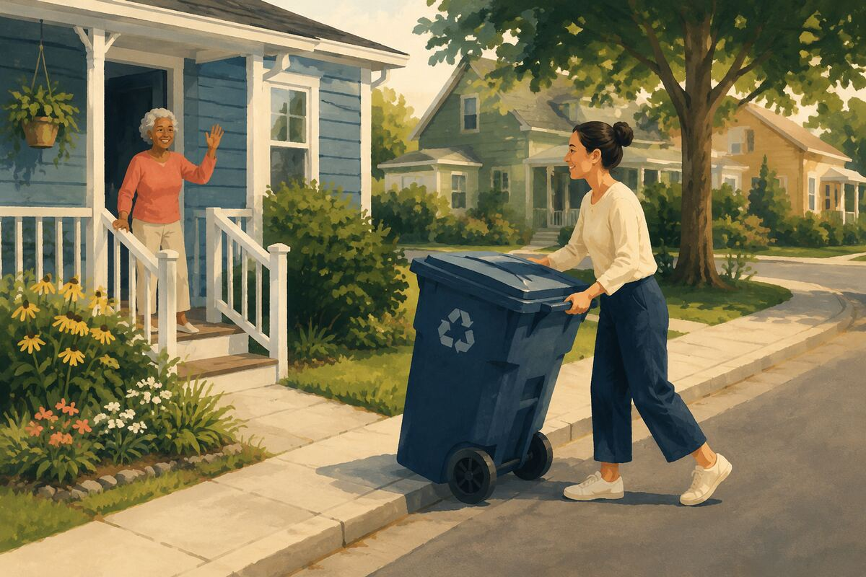
DO Move a neighbor’s trash or recycling bin back from the street when you know they welcome the help.

COMMUNITY BENEFIT Removes an obstacle and provides practical help at almost no cost.

EXAMPLE FOR YOUNGER GENERATIONS Shows that useful service is often ordinary and quiet.

NEIGHBORS AND BLOCK-LEVEL CONNECTION
014 Create a two-household backup plan
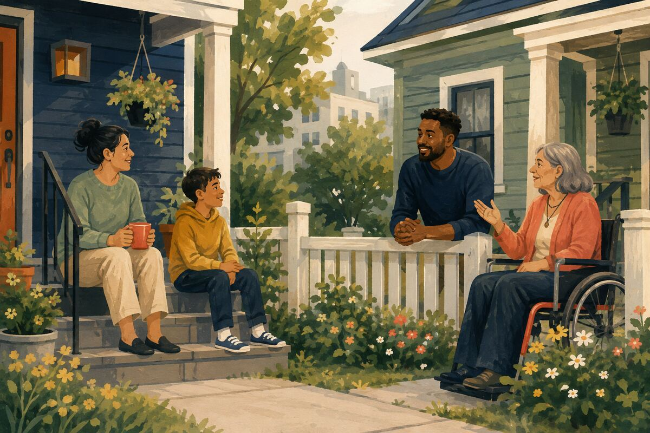
DO Agree with one nearby household on how to reach each other during a power outage, evacuation, or family emergency.

COMMUNITY BENEFIT Provides immediate local support when normal communications fail.

EXAMPLE FOR YOUNGER GENERATIONS Models preparedness as cooperation rather than fear.

NEIGHBORS AND BLOCK-LEVEL CONNECTION
015 Welcome a new household
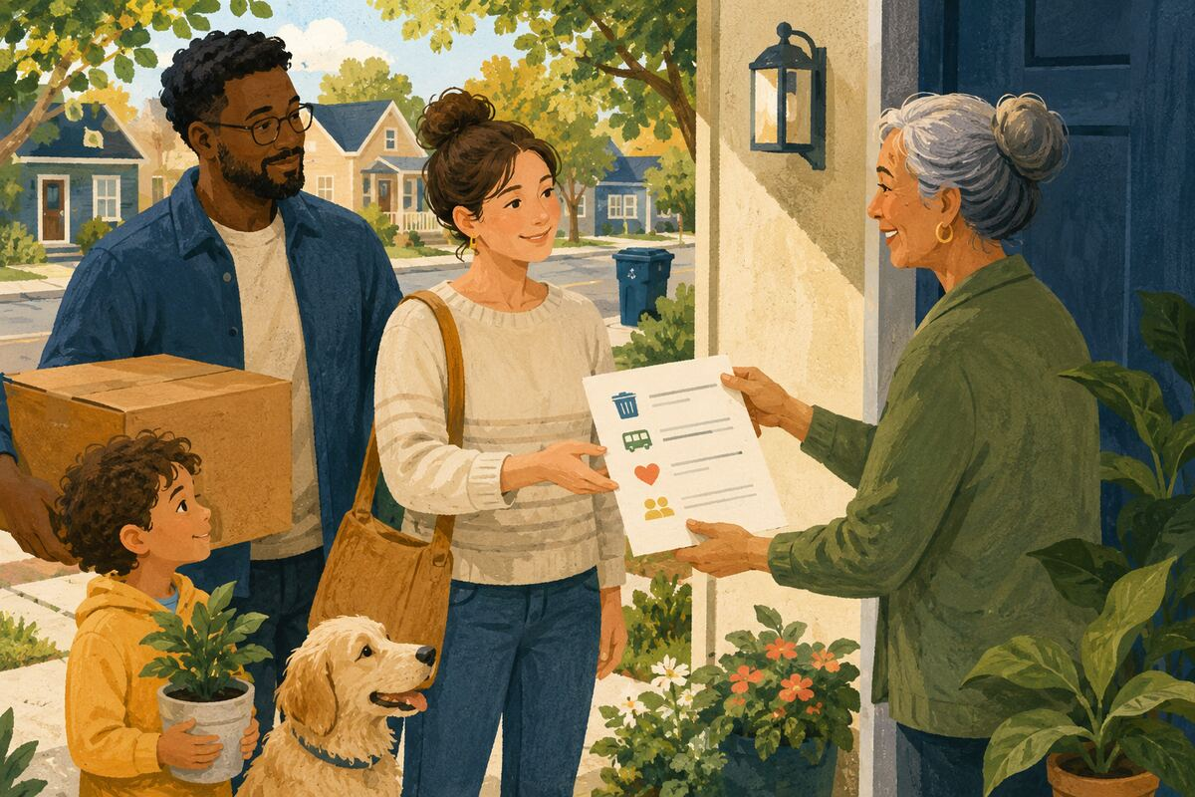
DO Give new neighbors a short list of trash days, nearby services, and neighborhood contacts without overwhelming them.

COMMUNITY BENEFIT Helps newcomers become capable participants sooner.

EXAMPLE FOR YOUNGER GENERATIONS Shows young people how inclusion can be practical.

NEIGHBORS AND BLOCK-LEVEL CONNECTION
016 Offer one specific favor
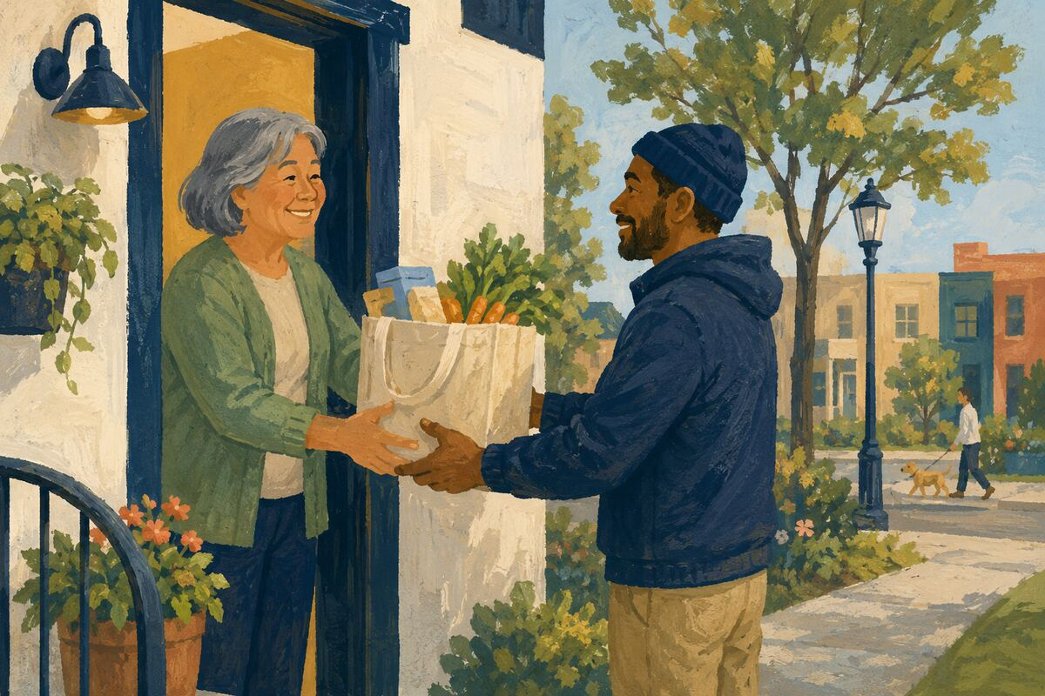
DO Offer a defined task such as one ride, one grocery pickup, one hour of lifting, or one pet check.

COMMUNITY BENEFIT Makes help easier to accept and more likely to be completed.

EXAMPLE FOR YOUNGER GENERATIONS Teaches that reliable commitments are better than vague promises.

NEIGHBORS AND BLOCK-LEVEL CONNECTION
017 Share a rarely used tool
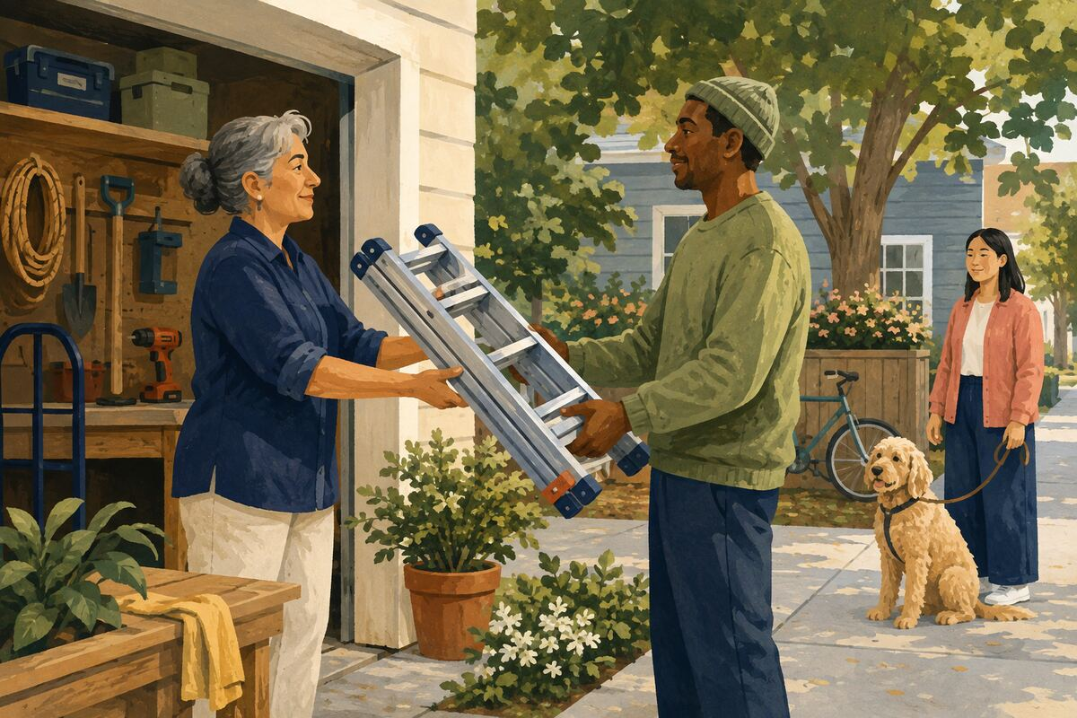
DO Lend a ladder, drill, dolly, or specialty tool with clear expectations for safe use and return.

COMMUNITY BENEFIT Reduces unnecessary purchases and strengthens neighbor-to-neighbor trust.

EXAMPLE FOR YOUNGER GENERATIONS Shows that resources can create more value when shared responsibly.

NEIGHBORS AND BLOCK-LEVEL CONNECTION
018 Exchange emergency pet information
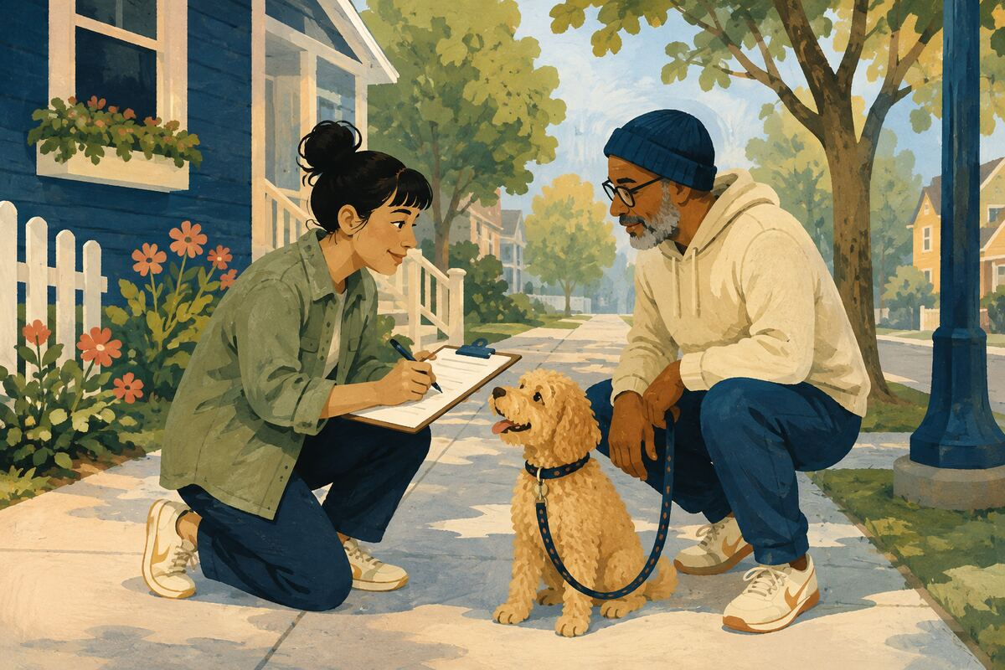
DO With permission, record a nearby pet owner’s preferred contact and what to do if their animal is loose or they are delayed.

COMMUNITY BENEFIT Helps animals receive quicker, more appropriate care.

EXAMPLE FOR YOUNGER GENERATIONS Teaches planning for dependents who cannot speak for themselves.

NEIGHBORS AND BLOCK-LEVEL CONNECTION
019 Resolve a nuisance directly and calmly
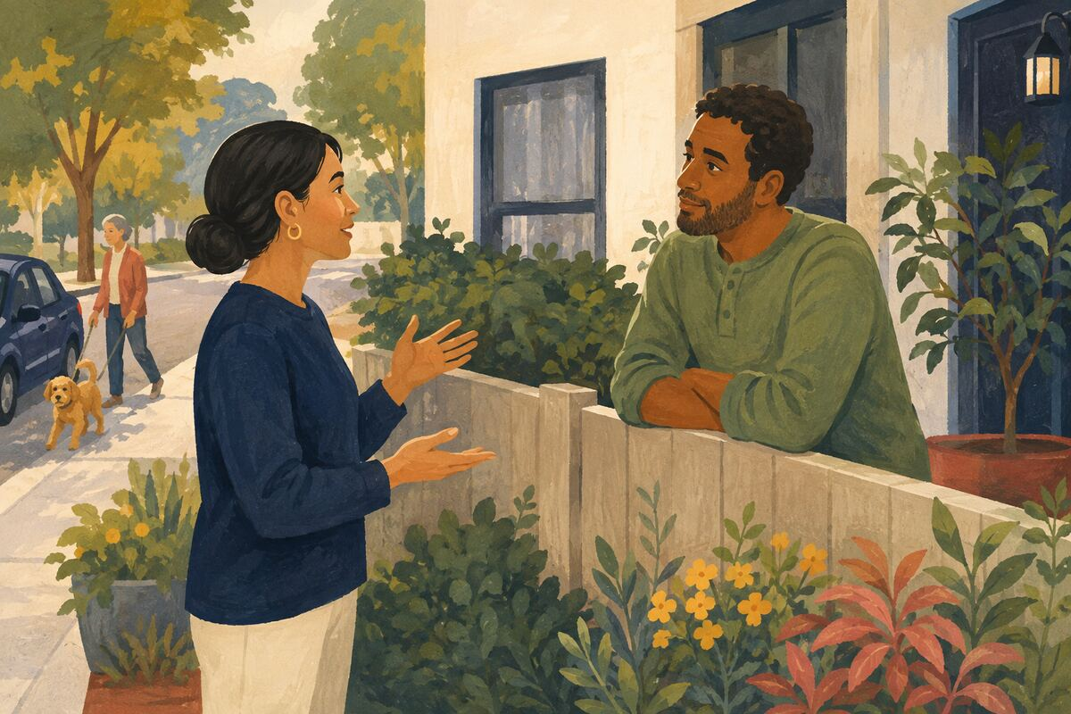
DO Raise a minor noise, parking, tree, or boundary issue privately, with facts and a reasonable request, before public escalation.

COMMUNITY BENEFIT Prevents misunderstandings from hardening into neighborhood conflict.

EXAMPLE FOR YOUNGER GENERATIONS Models respectful problem-solving.

NEIGHBORS AND BLOCK-LEVEL CONNECTION
020 Connect two compatible neighbors
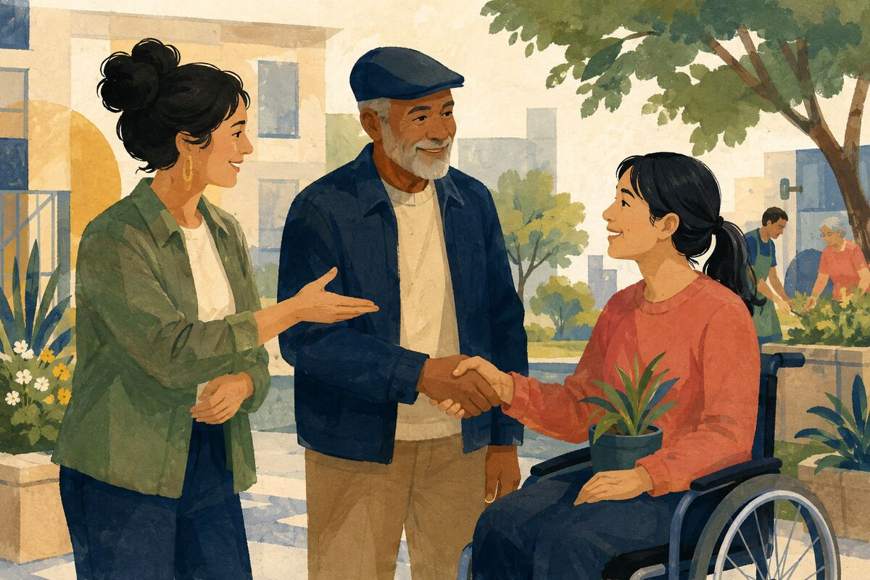
DO Introduce people who share a language, school, hobby, trade, caregiving need, or practical skill, with their permission.

COMMUNITY BENEFIT Creates relationships that can continue without a central organizer.

EXAMPLE FOR YOUNGER GENERATIONS Shows that community builders help others connect, not just themselves.

CLEAN, SAFE, AND WELCOMING PUBLIC SPACES
021 Pick up five safe pieces of litter
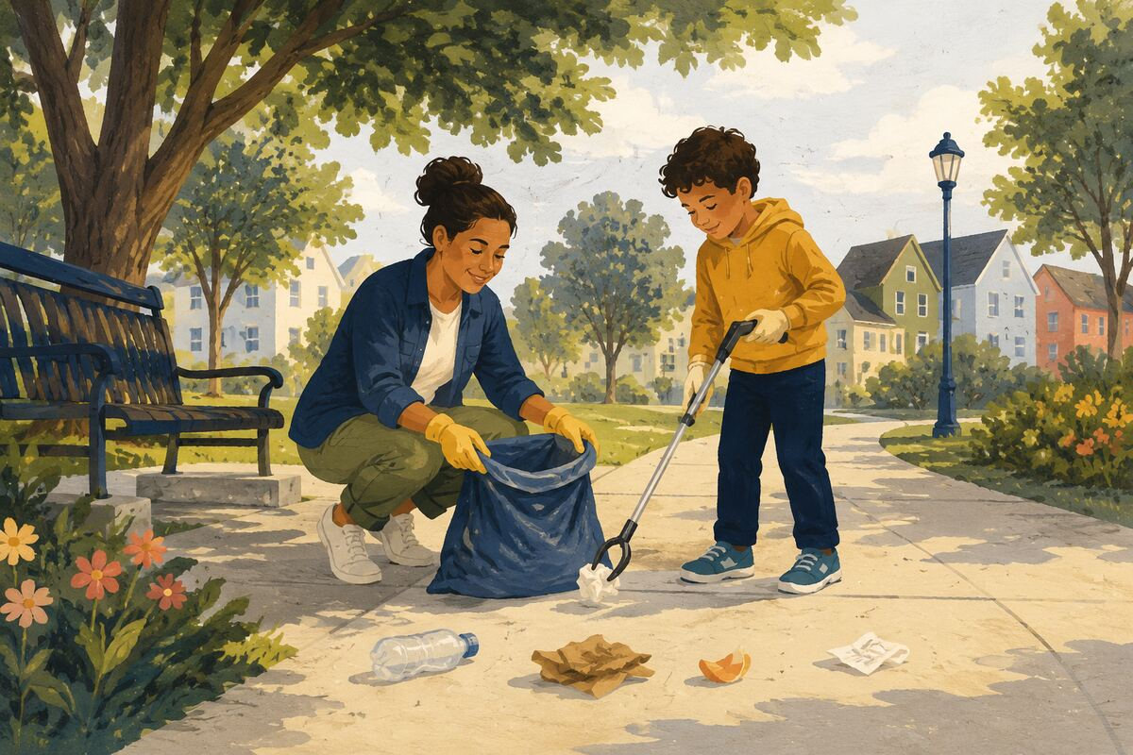
DO Use gloves to collect ordinary litter; leave needles, chemicals, sharp metal, and unknown materials for trained services.

COMMUNITY BENEFIT Produces an immediate visible improvement and prevents some waste from reaching drains and waterways.

EXAMPLE FOR YOUNGER GENERATIONS Shows that a small area is worth caring for.

CLEAN, SAFE, AND WELCOMING PUBLIC SPACES
022 Report a broken streetlight

DO Use the city, utility, campus, or property reporting channel and include the pole number or exact location.

COMMUNITY BENEFIT Improves nighttime visibility and gives repair crews actionable information.

EXAMPLE FOR YOUNGER GENERATIONS Teaches that reporting well is a form of participation.

CLEAN, SAFE, AND WELCOMING PUBLIC SPACES
023 Report a blocked sidewalk

DO Document the exact obstruction and location without confronting anyone or posting identifying images unnecessarily.

COMMUNITY BENEFIT Helps restore access for pedestrians, wheelchairs, strollers, and children.

EXAMPLE FOR YOUNGER GENERATIONS Shows that accessibility is a shared public concern.

CLEAN, SAFE, AND WELCOMING PUBLIC SPACES
024 Remove your event signs promptly
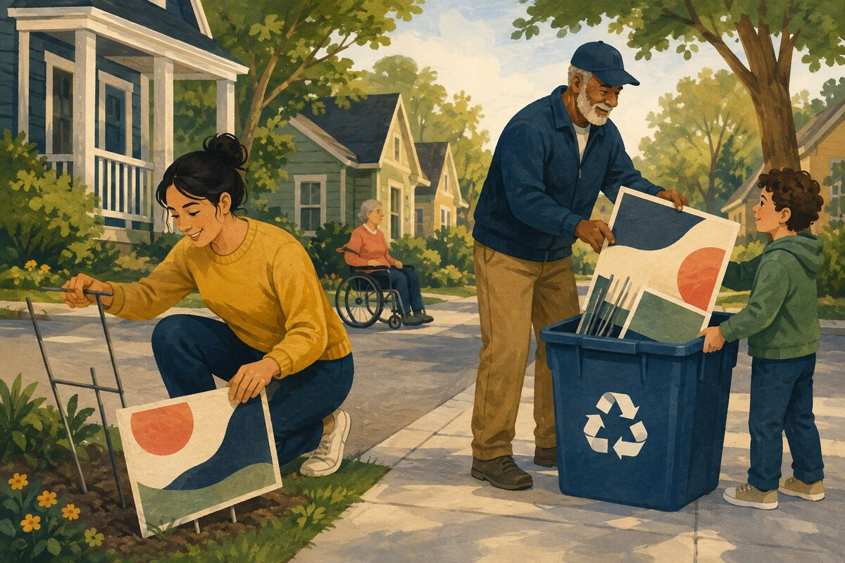
DO Take down yard, directional, sale, or celebration signs when the event ends and recycle them where accepted.

COMMUNITY BENEFIT Reduces visual clutter and windblown debris.

EXAMPLE FOR YOUNGER GENERATIONS Models finishing the cleanup, not only enjoying the event.

CLEAN, SAFE, AND WELCOMING PUBLIC SPACES
025 Return an abandoned cart
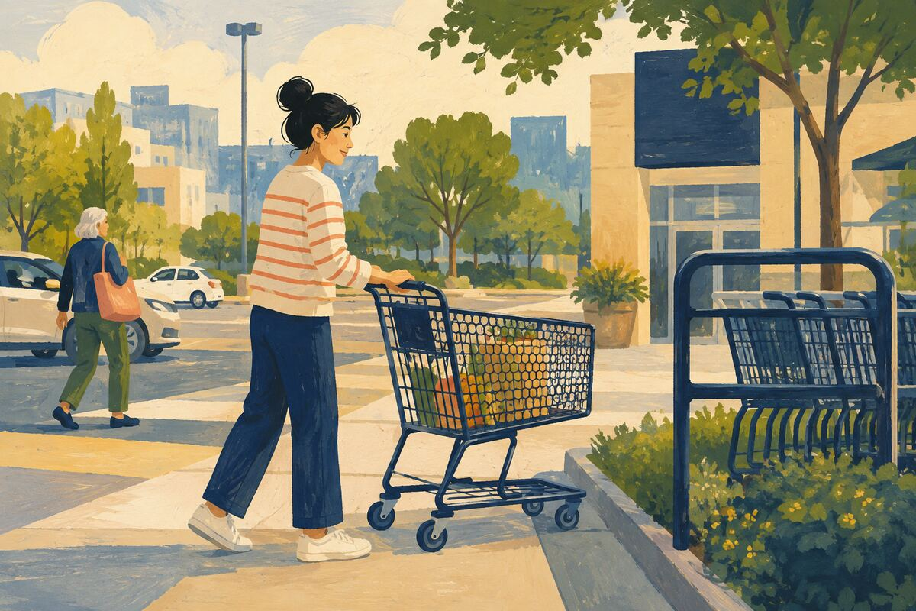
DO Return a nearby shopping cart safely or report it through the retailer’s retrieval system.

COMMUNITY BENEFIT Clears sidewalks, parking spaces, and streets while reducing property loss.

EXAMPLE FOR YOUNGER GENERATIONS Shows respect for shared and borrowed property.

CLEAN, SAFE, AND WELCOMING PUBLIC SPACES
026 Keep a storm drain clear
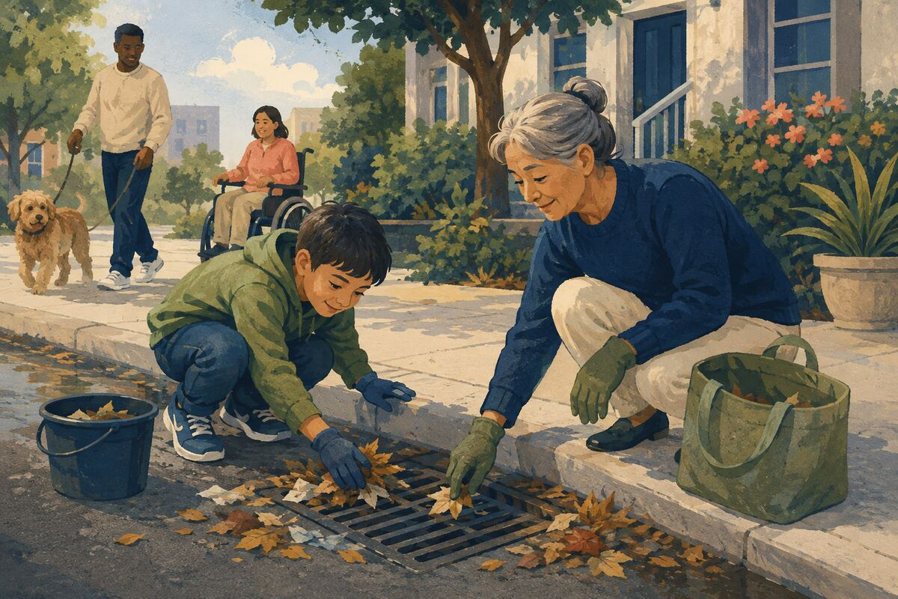
DO Remove only loose, safe leaves or trash from the surface of a drain; report deeper blockages.

COMMUNITY BENEFIT Reduces localized flooding and keeps debris out of drainage systems.

EXAMPLE FOR YOUNGER GENERATIONS Teaches prevention before a crisis.

CLEAN, SAFE, AND WELCOMING PUBLIC SPACES
027 Improve one public notice
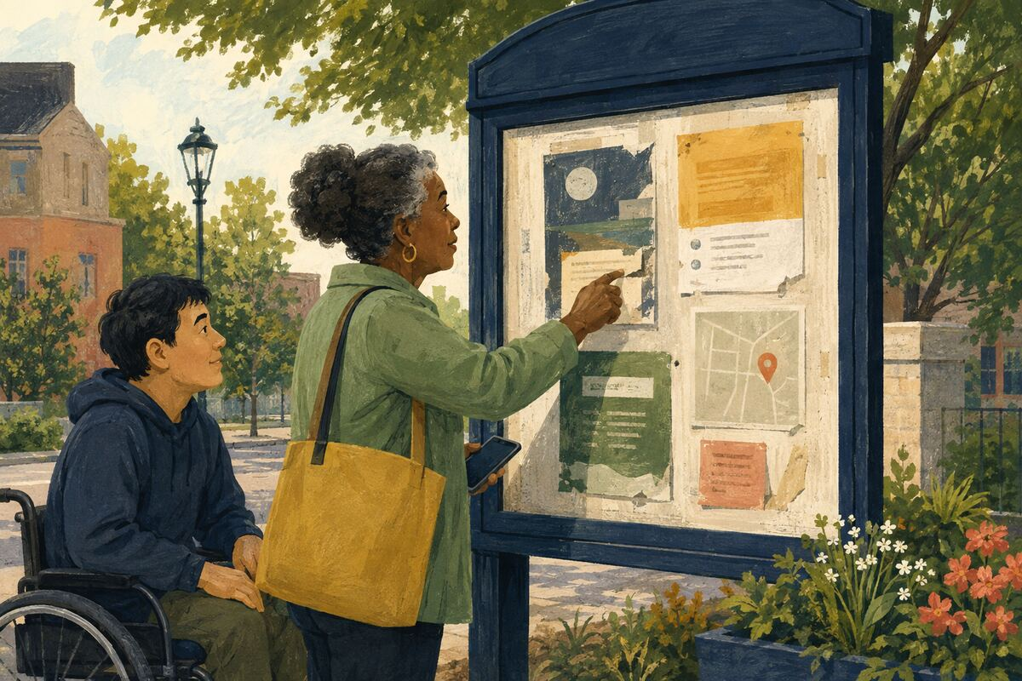
DO Tell the responsible organization when a posted date, phone number, QR code, translation, or instruction is unreadable or outdated.

COMMUNITY BENEFIT Prevents repeated confusion for everyone who comes after.

EXAMPLE FOR YOUNGER GENERATIONS Shows that information is part of public infrastructure.

CLEAN, SAFE, AND WELCOMING PUBLIC SPACES
028 Use a refillable cleanup kit
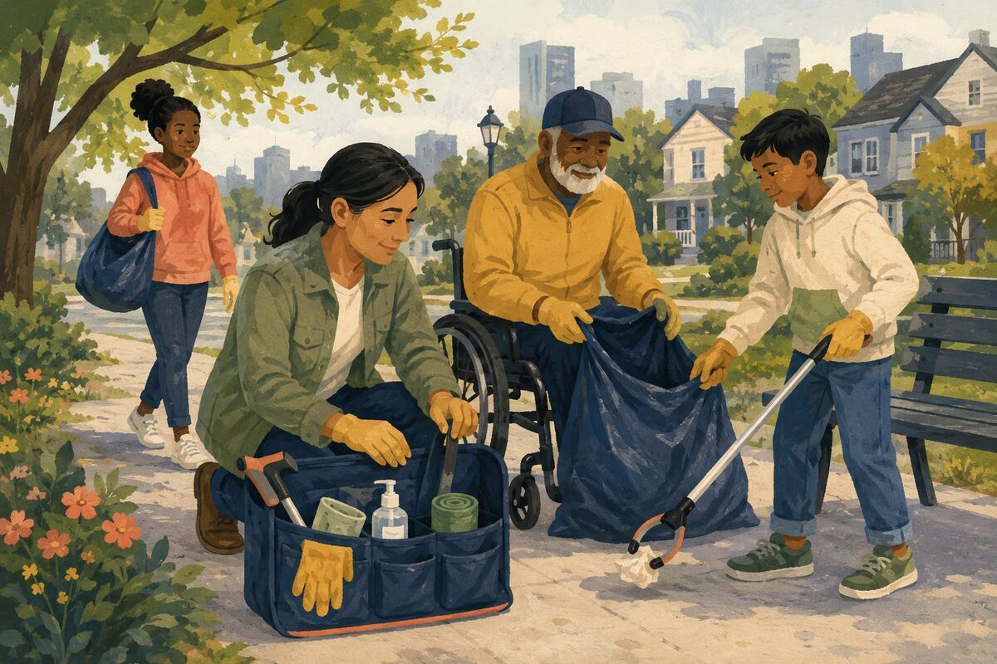
DO Keep gloves, bags, hand sanitizer, and a grabber available for safe neighborhood or park cleanup.

COMMUNITY BENEFIT Makes beneficial action easier to repeat when opportunities appear.

EXAMPLE FOR YOUNGER GENERATIONS Shows that good intentions work better with preparation.

CLEAN, SAFE, AND WELCOMING PUBLIC SPACES
029 Join an authorized cleanup
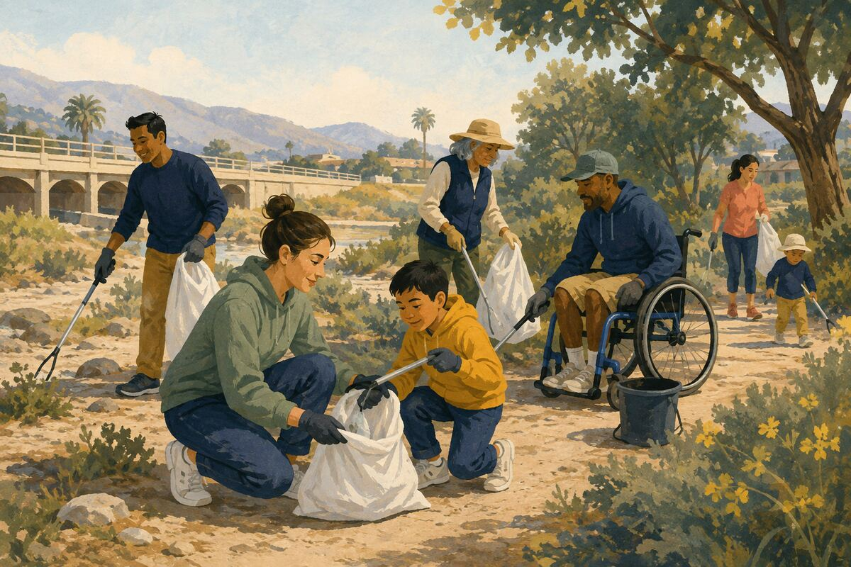
DO Participate in a scheduled park, trail, alley, wash, beach, or roadside cleanup that provides safety guidance.

COMMUNITY BENEFIT Combines many small efforts into a larger maintained area.

EXAMPLE FOR YOUNGER GENERATIONS Lets younger people see adults cooperate on visible work.

CLEAN, SAFE, AND WELCOMING PUBLIC SPACES
030 Leave public furniture usable
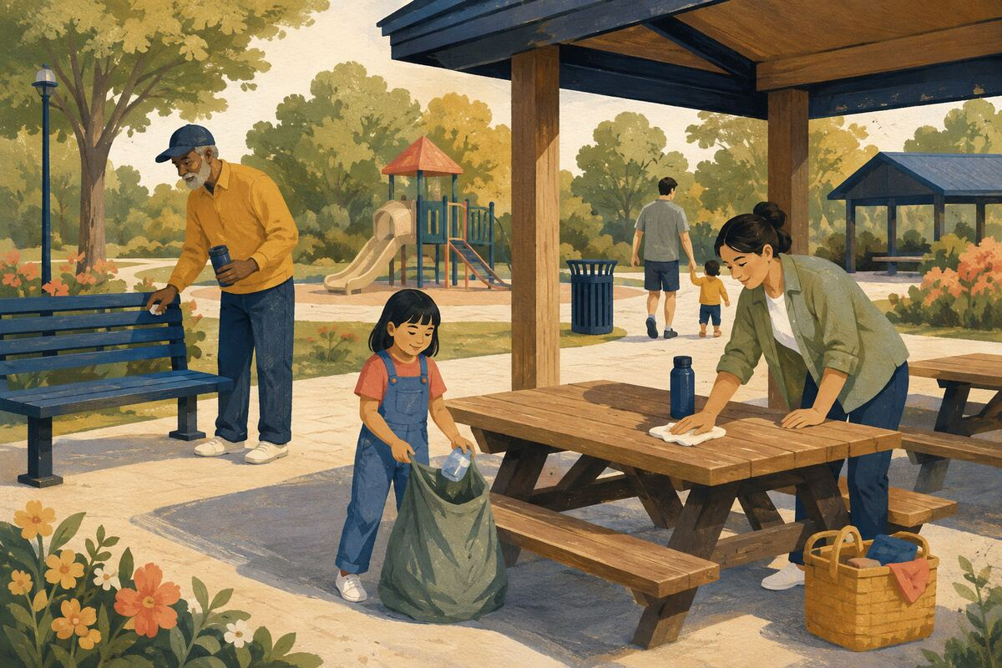
DO Do not block, damage, monopolize, or leave waste on benches, picnic tables, playgrounds, and shelters.

COMMUNITY BENEFIT Preserves shared amenities for more people.

EXAMPLE FOR YOUNGER GENERATIONS Teaches that public property belongs to everyone, including the next user.

ROADS, WALKING, CYCLING, AND TRANSIT
031 Stop before the crosswalk
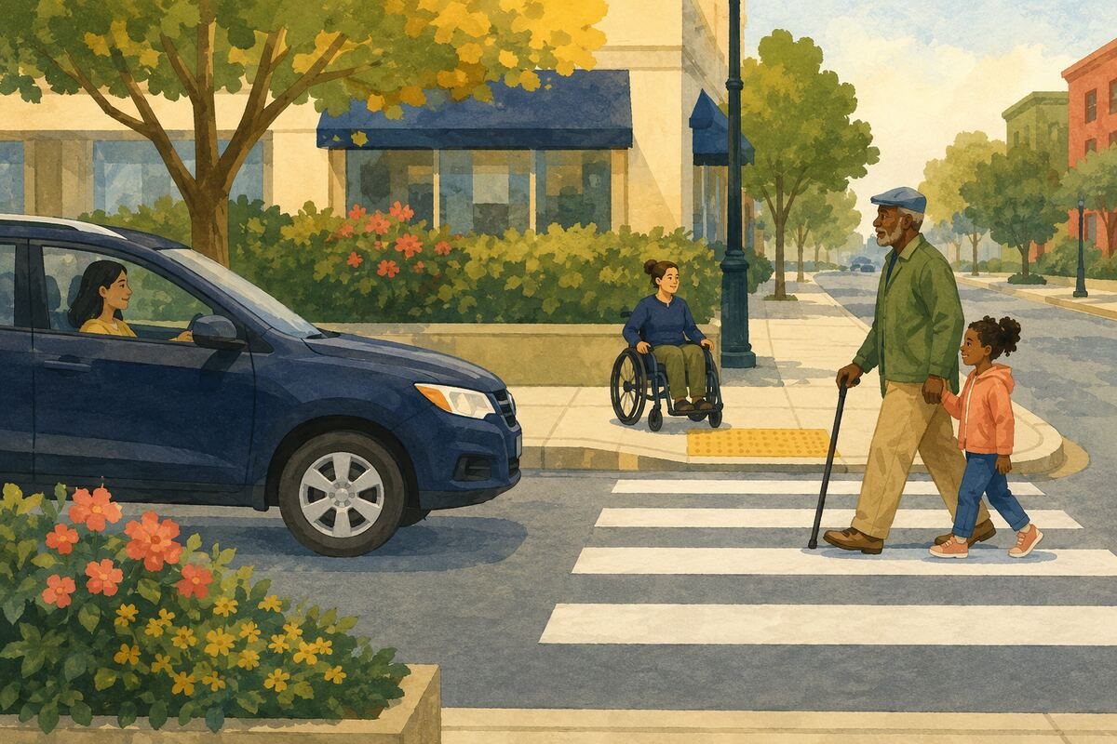
DO Bring the vehicle to a stop before the marked crossing or sidewalk rather than on top of it.

COMMUNITY BENEFIT Preserves visibility and safe passage for pedestrians.

EXAMPLE FOR YOUNGER GENERATIONS Shows children that rules protect real people.

ROADS, WALKING, CYCLING, AND TRANSIT
032 Use turn signals early
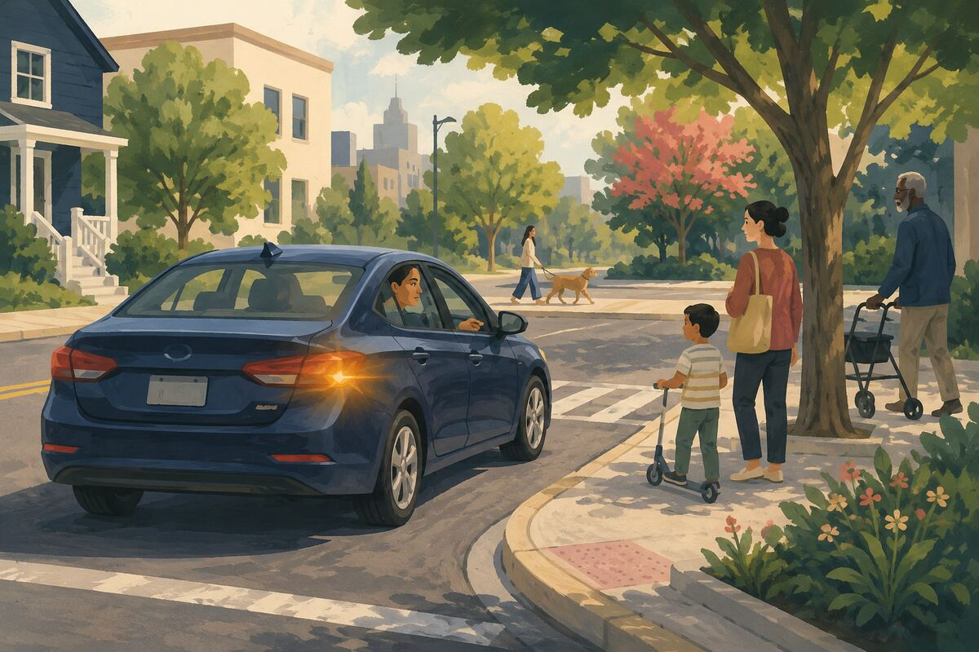
DO Signal before turning, changing lanes, or leaving a curb, even when traffic seems light.

COMMUNITY BENEFIT Makes movement predictable and prevents avoidable collisions.

EXAMPLE FOR YOUNGER GENERATIONS Models communication before action.

ROADS, WALKING, CYCLING, AND TRANSIT
033 Park without blocking access
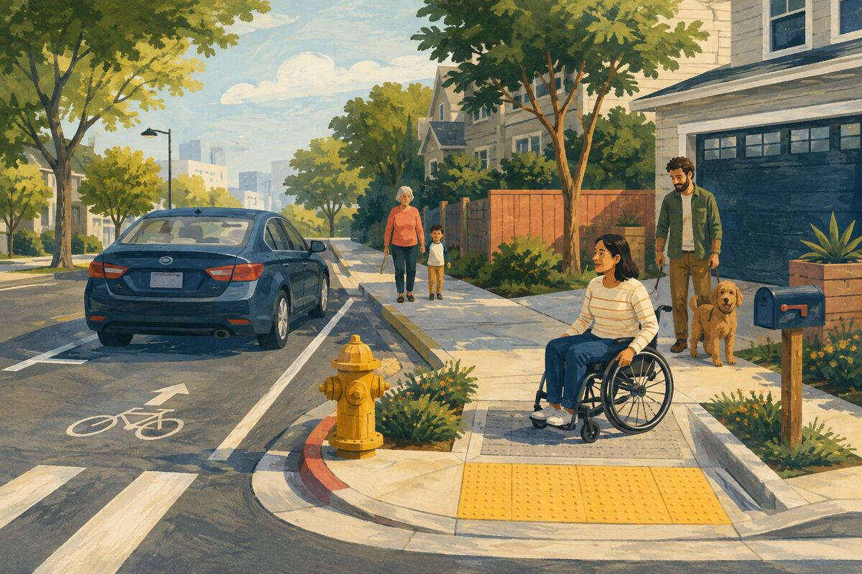
DO Keep driveways, hydrants, ramps, mailboxes, bike lanes, and sidewalks clear.

COMMUNITY BENEFIT Maintains access for residents, deliveries, emergency crews, and people with disabilities.

EXAMPLE FOR YOUNGER GENERATIONS Shows that convenience does not outrank community access.

ROADS, WALKING, CYCLING, AND TRANSIT
034 Slow down near people
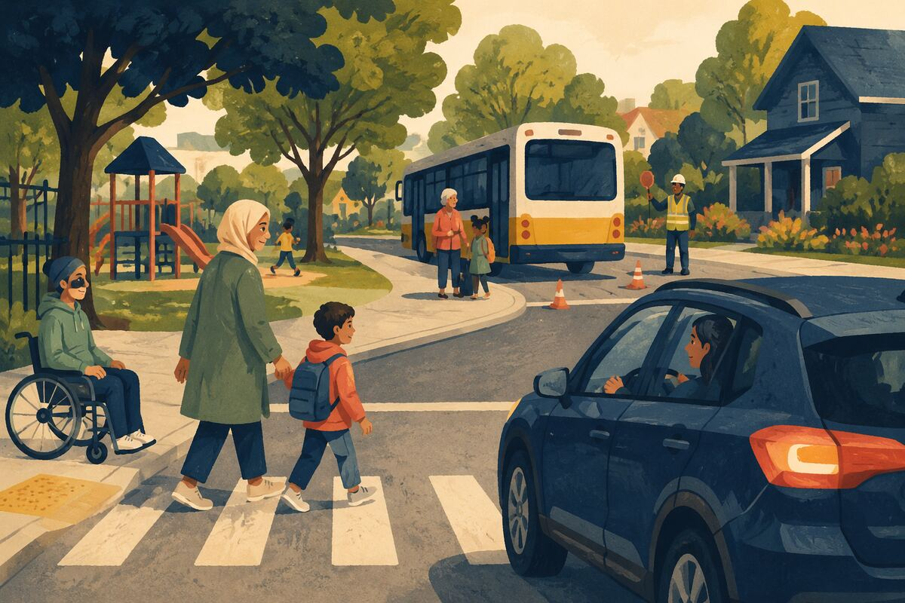
DO Reduce speed around schools, parks, stopped buses, work crews, neighborhoods, and crowded parking lots.

COMMUNITY BENEFIT Creates more reaction time and reduces the severity of crashes.

EXAMPLE FOR YOUNGER GENERATIONS Teaches that arriving slightly later can protect a life.

ROADS, WALKING, CYCLING, AND TRANSIT
035 Give cyclists lawful space
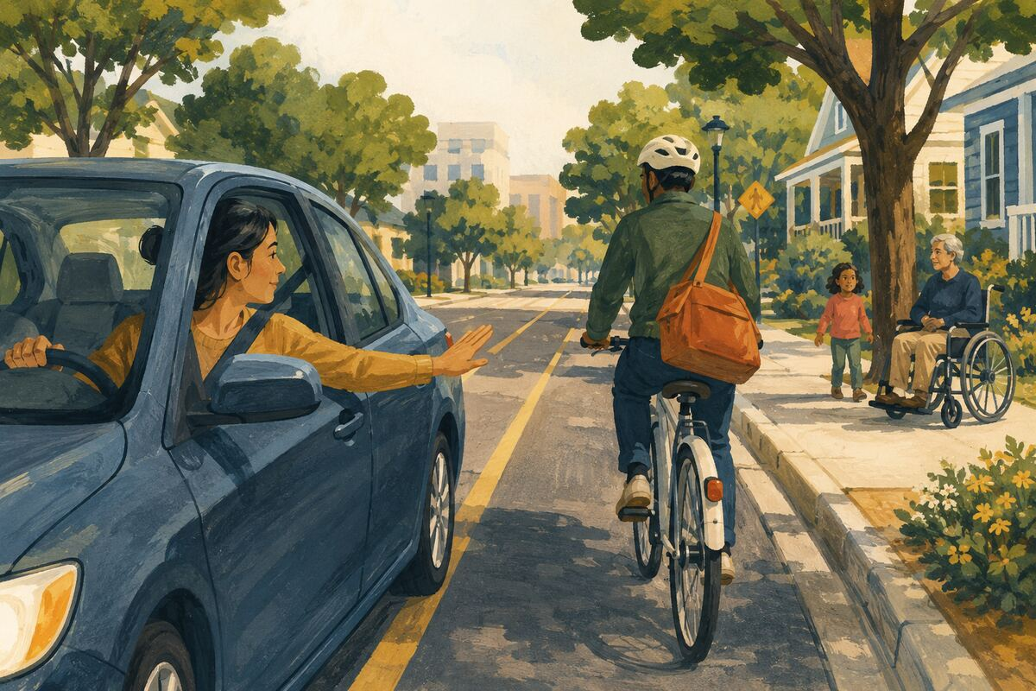
DO Pass only when visibility and legal clearance allow; do not crowd or use the horn aggressively.

COMMUNITY BENEFIT Reduces danger for people using a less-protected form of transportation.

EXAMPLE FOR YOUNGER GENERATIONS Models patience with road users who are different from us.

ROADS, WALKING, CYCLING, AND TRANSIT
036 Keep transit aisles clear
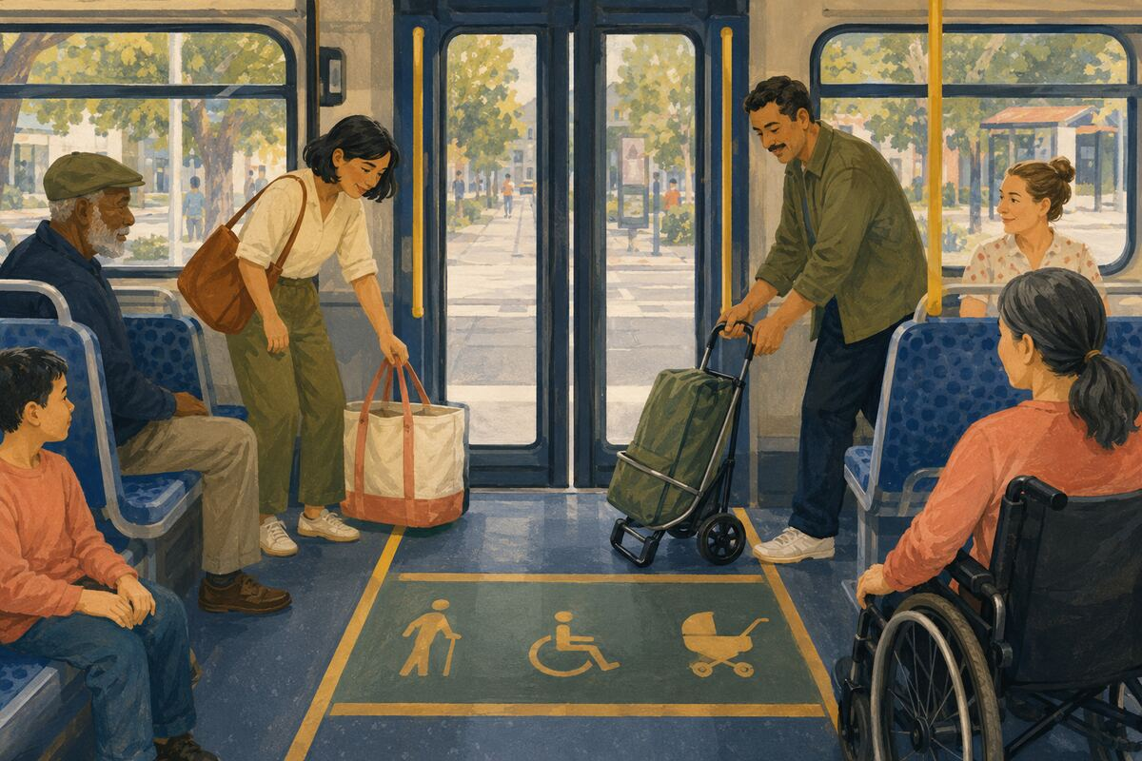
DO Move bags, carts, and bodies away from doors, priority areas, and aisles.

COMMUNITY BENEFIT Speeds boarding and keeps transit accessible.

EXAMPLE FOR YOUNGER GENERATIONS Shows that shared systems work when riders cooperate.

ROADS, WALKING, CYCLING, AND TRANSIT
037 Offer priority seating
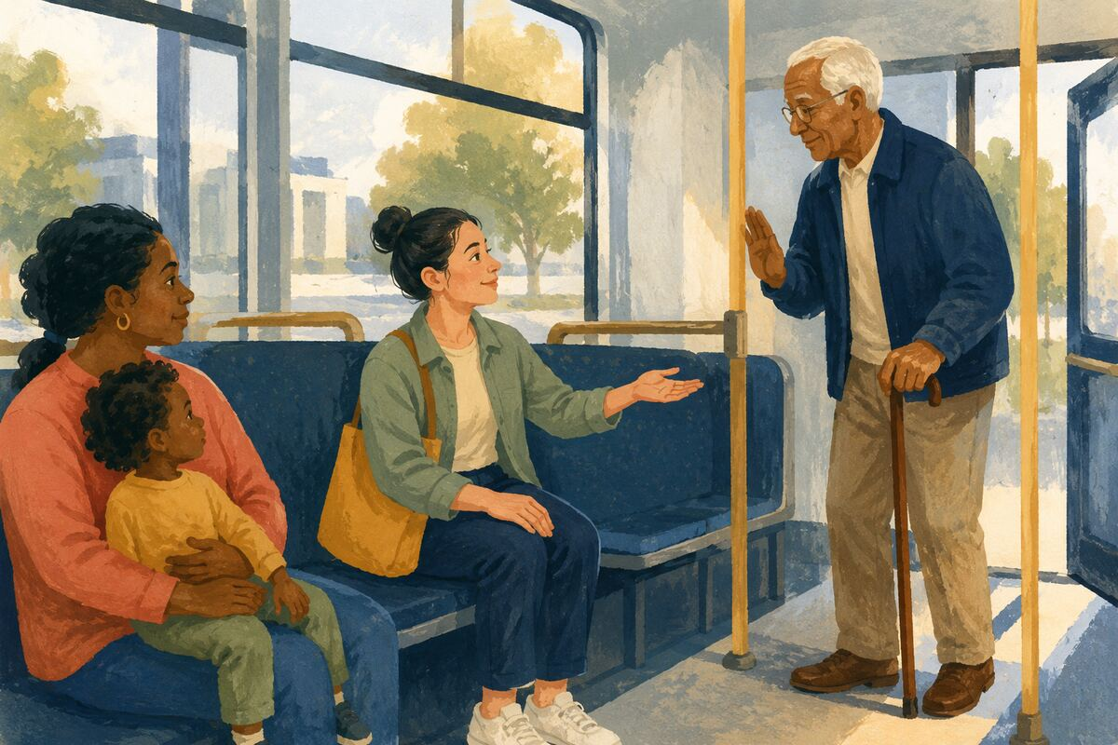
DO Offer a seat to someone who appears to need it, while accepting their answer without argument.

COMMUNITY BENEFIT Makes travel safer and less tiring for vulnerable riders.

EXAMPLE FOR YOUNGER GENERATIONS Teaches courtesy with dignity and consent.

ROADS, WALKING, CYCLING, AND TRANSIT
038 Report a dangerous signal or sign

DO Submit the exact intersection, direction of travel, time, and observed malfunction to the proper agency.

COMMUNITY BENEFIT Helps technicians find and correct a high-risk defect.

EXAMPLE FOR YOUNGER GENERATIONS Shows how precise observations can protect strangers.

ROADS, WALKING, CYCLING, AND TRANSIT
039 Remove loose cargo before driving
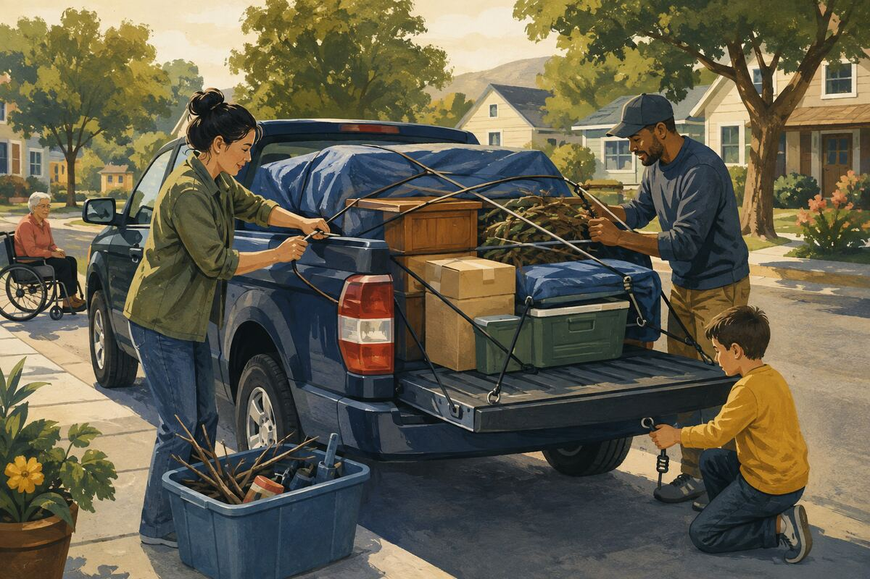
DO Secure tools, boxes, branches, furniture, and waste so nothing can fall or blow into traffic.

COMMUNITY BENEFIT Prevents road hazards, litter, and injuries.

EXAMPLE FOR YOUNGER GENERATIONS Models responsibility for the full consequences of our actions.

ROADS, WALKING, CYCLING, AND TRANSIT
040 Share an essential ride
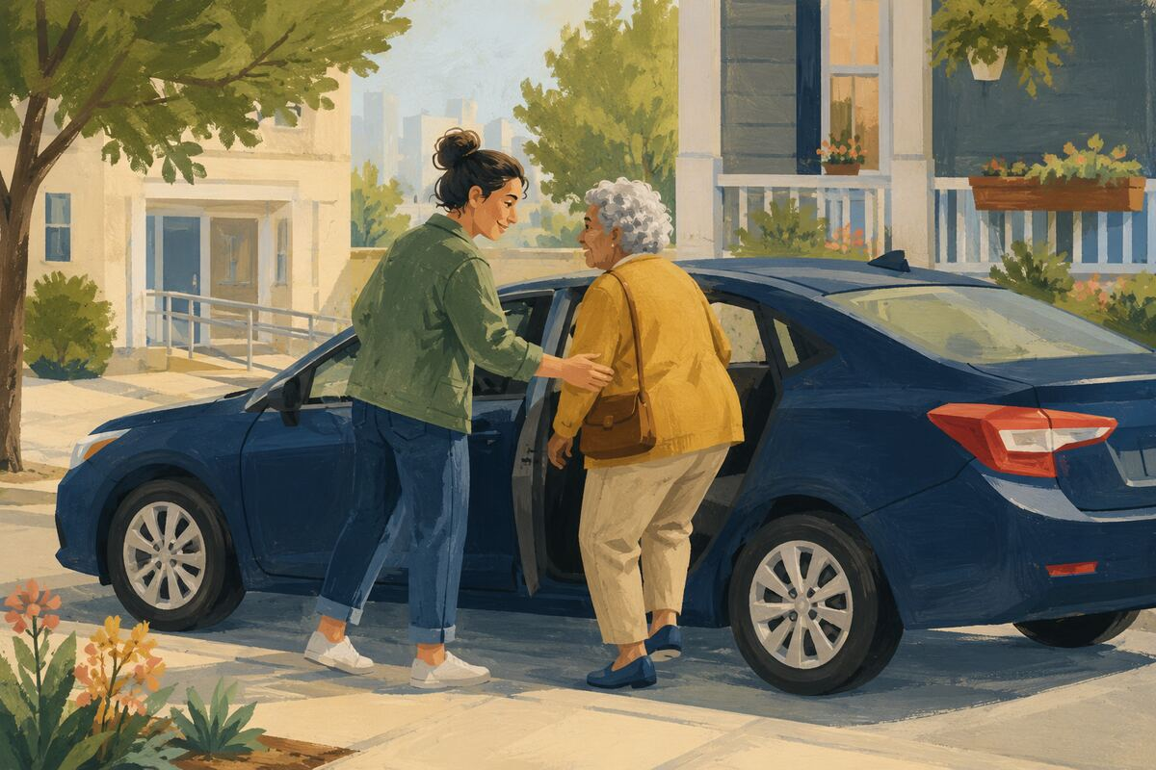
DO When safe and practical, offer a trusted person a ride to a medical appointment, grocery store, school event, or voting location.

COMMUNITY BENEFIT Reduces transportation barriers to essential participation.

EXAMPLE FOR YOUNGER GENERATIONS Shows that mobility can be shared as a community resource.

CHILDREN, FAMILIES, AND CAREGIVERS
041 Read aloud for fifteen minutes

DO Read a library book, story, article, or instructions with a child and let them ask questions.

COMMUNITY BENEFIT Builds language, attention, knowledge, and connection.

EXAMPLE FOR YOUNGER GENERATIONS Shows that learning deserves regular time.

CHILDREN, FAMILIES, AND CAREGIVERS
042 Let a child help with real work
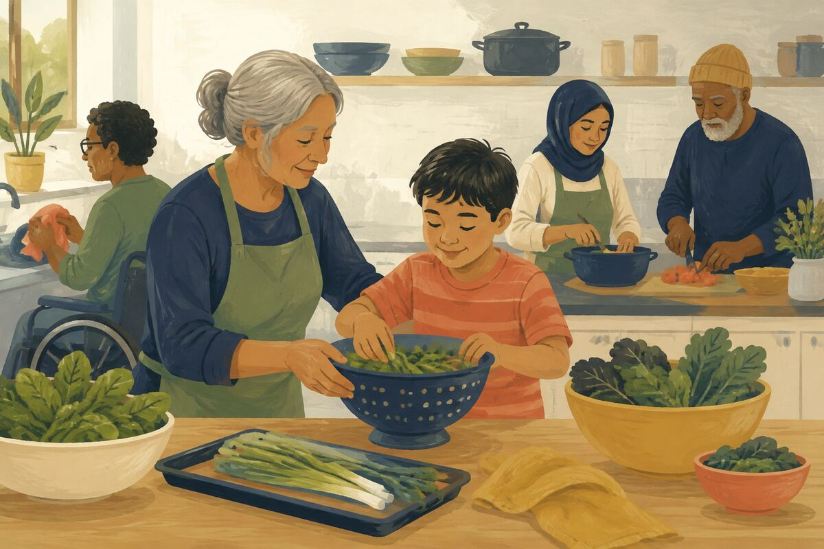
DO Give a safe, age-appropriate role in cooking, sorting, cleanup, gardening, or preparation.

COMMUNITY BENEFIT Builds competence and reduces the idea that service is only adult work.

EXAMPLE FOR YOUNGER GENERATIONS Teaches contribution through practice.

CHILDREN, FAMILIES, AND CAREGIVERS
043 Model phone-free attention
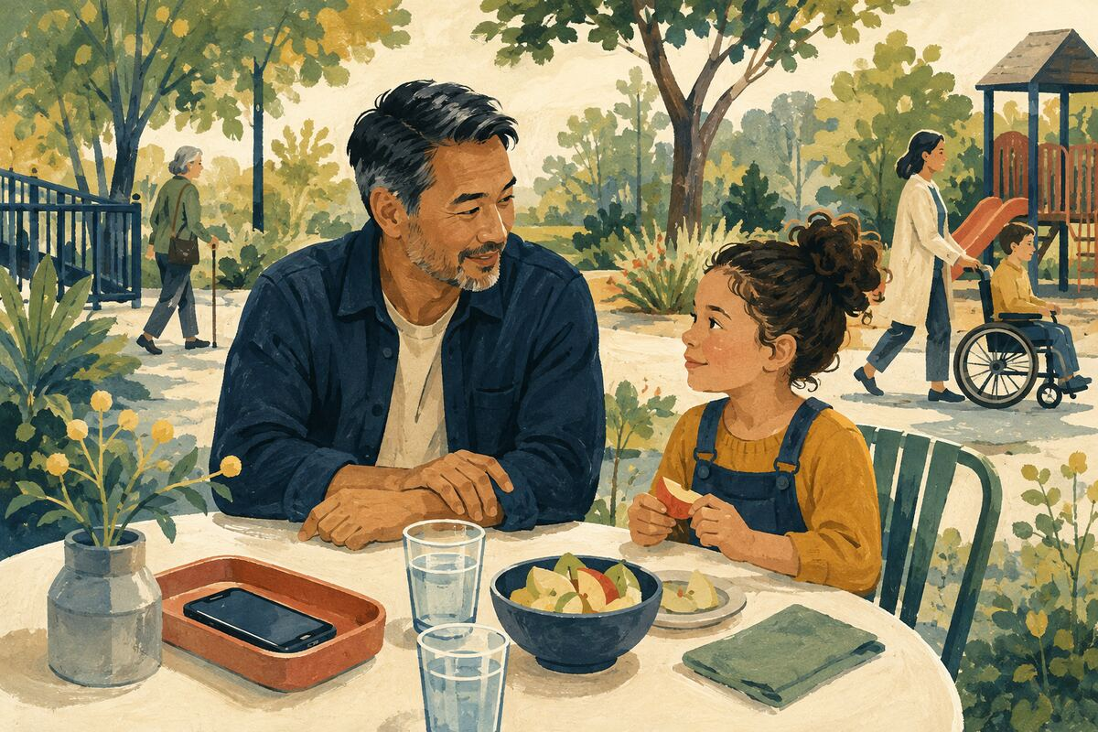
DO Put the phone away during one meal, conversation, walk, or play period.

COMMUNITY BENEFIT Improves connection and demonstrates attentive listening.

EXAMPLE FOR YOUNGER GENERATIONS Shows that people present with us matter more than notifications.

CHILDREN, FAMILIES, AND CAREGIVERS
044 Thank a caregiver specifically

DO Recognize a parent, guardian, teacher, aide, coach, or childcare worker for a concrete act of care.

COMMUNITY BENEFIT Supports people doing demanding and often invisible work.

EXAMPLE FOR YOUNGER GENERATIONS Teaches children to value caregiving.

CHILDREN, FAMILIES, AND CAREGIVERS
045 Share outgrown items responsibly
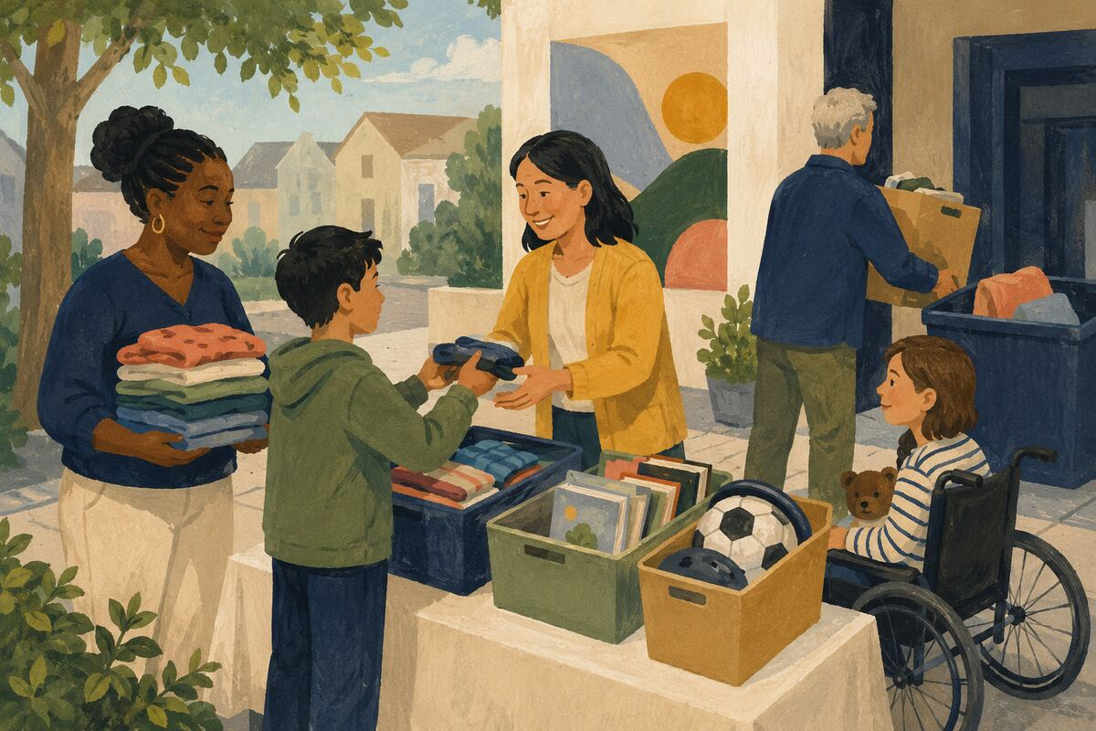
DO Offer clean, safe, complete children’s clothing, books, or equipment through a trusted channel; discard recalled or unsafe items.

COMMUNITY BENEFIT Extends useful life and helps families avoid unnecessary expense.

EXAMPLE FOR YOUNGER GENERATIONS Shows generosity with quality, not leftovers as burden.

CHILDREN, FAMILIES, AND CAREGIVERS
046 Learn one child-safety skill
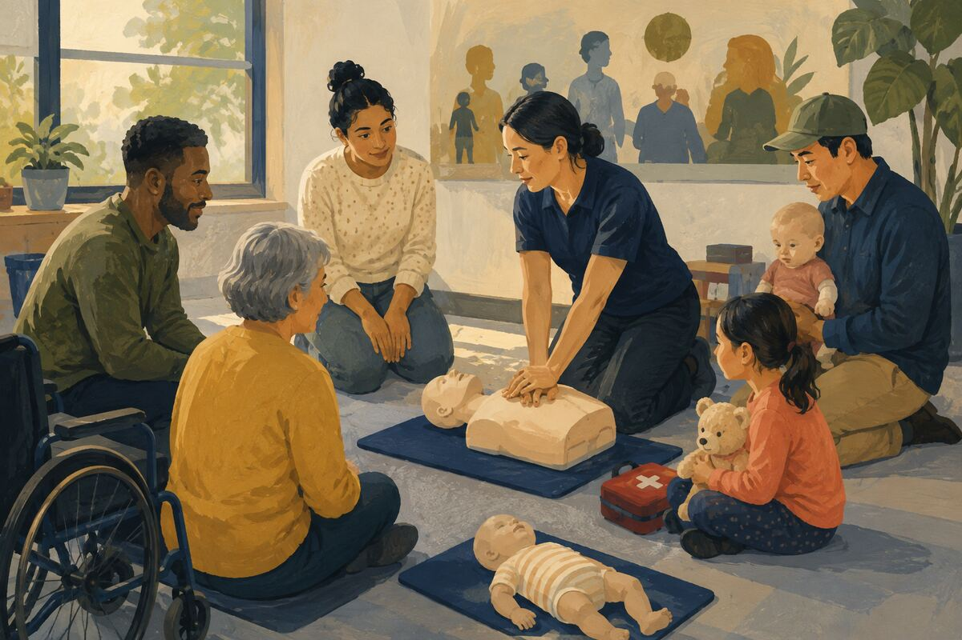
DO Take an approved course in CPR, first aid, car-seat use, water safety, or safe sleep appropriate to your role.

COMMUNITY BENEFIT Improves adult readiness for preventable emergencies.

EXAMPLE FOR YOUNGER GENERATIONS Shows that caring includes learning what to do.

CHILDREN, FAMILIES, AND CAREGIVERS
047 Include the quiet child

DO Invite a child who is standing apart into an age-appropriate game or group without forcing participation.

COMMUNITY BENEFIT Reduces isolation and widens belonging.

EXAMPLE FOR YOUNGER GENERATIONS Models noticing people who are easy to overlook.

CHILDREN, FAMILIES, AND CAREGIVERS
048 Help a family with one logistical task
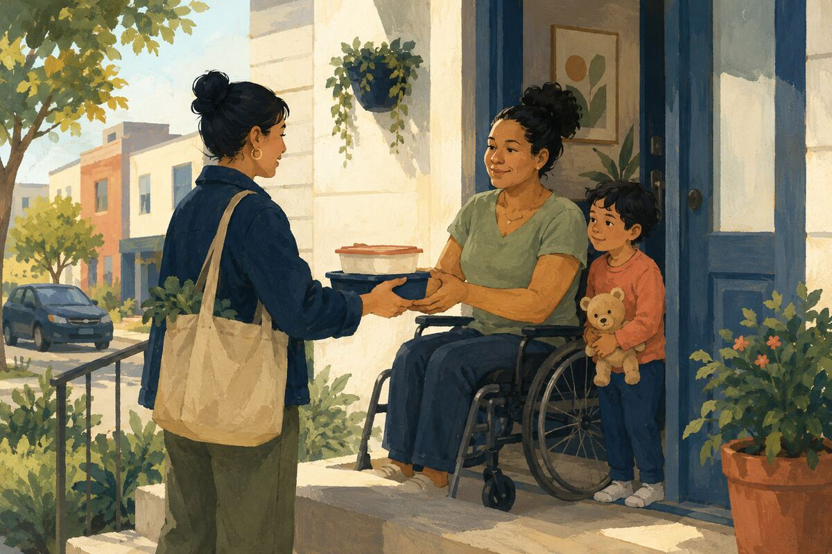
DO Offer a meal drop-off, school pickup, pharmacy run, laundry load, or one hour of supervision within trusted boundaries.

COMMUNITY BENEFIT Relieves a specific pressure during illness, birth, grief, or overload.

EXAMPLE FOR YOUNGER GENERATIONS Shows that support can be concrete and dependable.

CHILDREN, FAMILIES, AND CAREGIVERS
049 Protect children’s privacy online
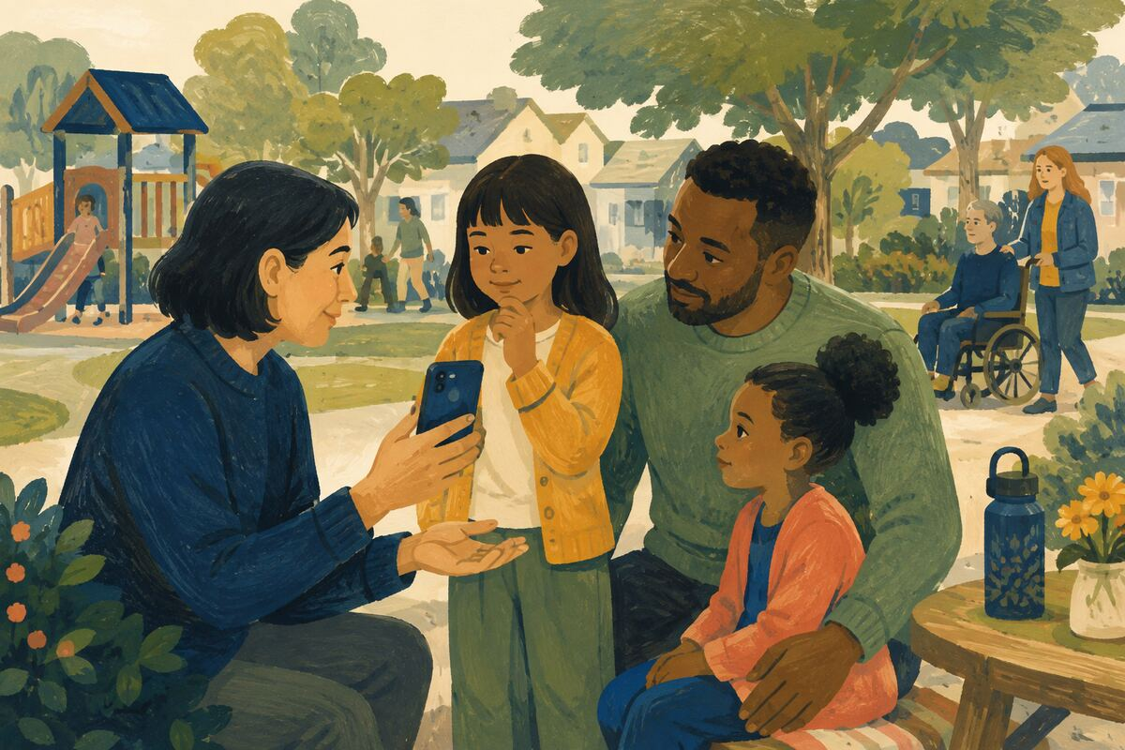
DO Ask permission before posting and avoid sharing full names, locations, schedules, school details, or embarrassing moments.

COMMUNITY BENEFIT Reduces digital exposure that children cannot meaningfully control.

EXAMPLE FOR YOUNGER GENERATIONS Teaches respect for another person’s future autonomy.

CHILDREN, FAMILIES, AND CAREGIVERS
050 Talk through one good deed

DO After helping, ask a child what changed for the other person and what could be done next time.

COMMUNITY BENEFIT Turns a single action into reflection and learning.

EXAMPLE FOR YOUNGER GENERATIONS Shows that service is about impact, not applause.

SCHOOLS, LIBRARIES, AND LEARNING
051 Return library materials on time
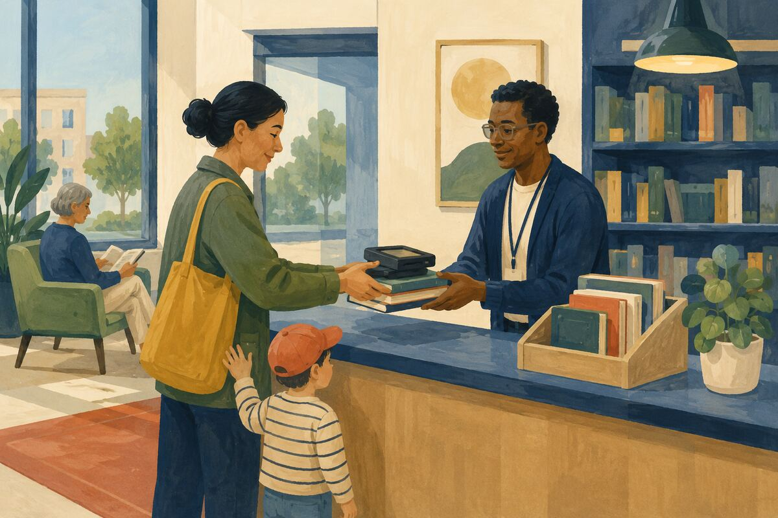
DO Renew or return books, tools, hotspots, and media before the due date.

COMMUNITY BENEFIT Makes limited public resources available to the next learner.

EXAMPLE FOR YOUNGER GENERATIONS Shows that shared access depends on responsible use.

SCHOOLS, LIBRARIES, AND LEARNING
052 Donate what was requested

DO Use a teacher’s, library’s, or school’s actual wish list instead of delivering unneeded items.

COMMUNITY BENEFIT Directs money and materials toward real needs without creating sorting work.

EXAMPLE FOR YOUNGER GENERATIONS Teaches listening before giving.

SCHOOLS, LIBRARIES, AND LEARNING
053 Read the school message completely

DO Review dates, forms, pickup changes, and requested actions before asking staff to repeat the information.

COMMUNITY BENEFIT Reduces preventable administrative work and missed deadlines.

EXAMPLE FOR YOUNGER GENERATIONS Models preparation and respect for others’ time.

SCHOOLS, LIBRARIES, AND LEARNING
054 Volunteer for a defined shift

DO Choose one approved event, reading period, cleanup, field trip, or supply task and arrive prepared.

COMMUNITY BENEFIT Gives educators dependable help without creating extra supervision.

EXAMPLE FOR YOUNGER GENERATIONS Shows that reliability matters more than grand promises.

SCHOOLS, LIBRARIES, AND LEARNING
055 Support a classroom discreetly

DO Contribute to an approved general fund or shared supply pool rather than identifying a particular child’s need publicly.

COMMUNITY BENEFIT Helps students while protecting dignity and privacy.

EXAMPLE FOR YOUNGER GENERATIONS Teaches generosity without exposing recipients.

SCHOOLS, LIBRARIES, AND LEARNING
056 Help someone use the library

DO Show a neighbor how to get a card, search the catalog, reserve a room, access a database, or find a program.

COMMUNITY BENEFIT Connects more people to free learning and community resources.

EXAMPLE FOR YOUNGER GENERATIONS Shows that knowledge becomes more valuable when shared.

SCHOOLS, LIBRARIES, AND LEARNING
057 Attend one student performance
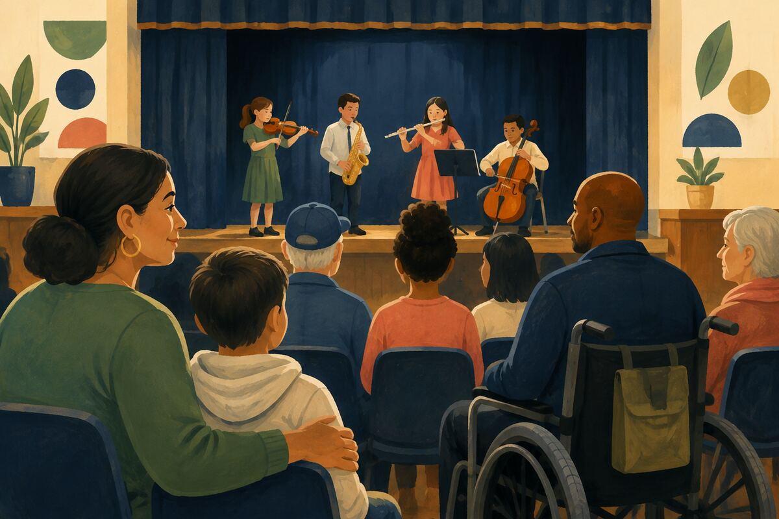
DO Show up for a school play, concert, exhibit, game, or presentation open to the community.

COMMUNITY BENEFIT Signals that young people’s preparation and creativity matter.

EXAMPLE FOR YOUNGER GENERATIONS Demonstrates community attention to effort, not only achievement.

SCHOOLS, LIBRARIES, AND LEARNING
058 Report bullying through the proper process

DO Record specific behavior, dates, locations, and immediate safety concerns; avoid online pile-ons.

COMMUNITY BENEFIT Gives responsible adults usable information while protecting children’s privacy.

EXAMPLE FOR YOUNGER GENERATIONS Models courage guided by fairness and evidence.

SCHOOLS, LIBRARIES, AND LEARNING
059 Offer career reality, not a sales pitch
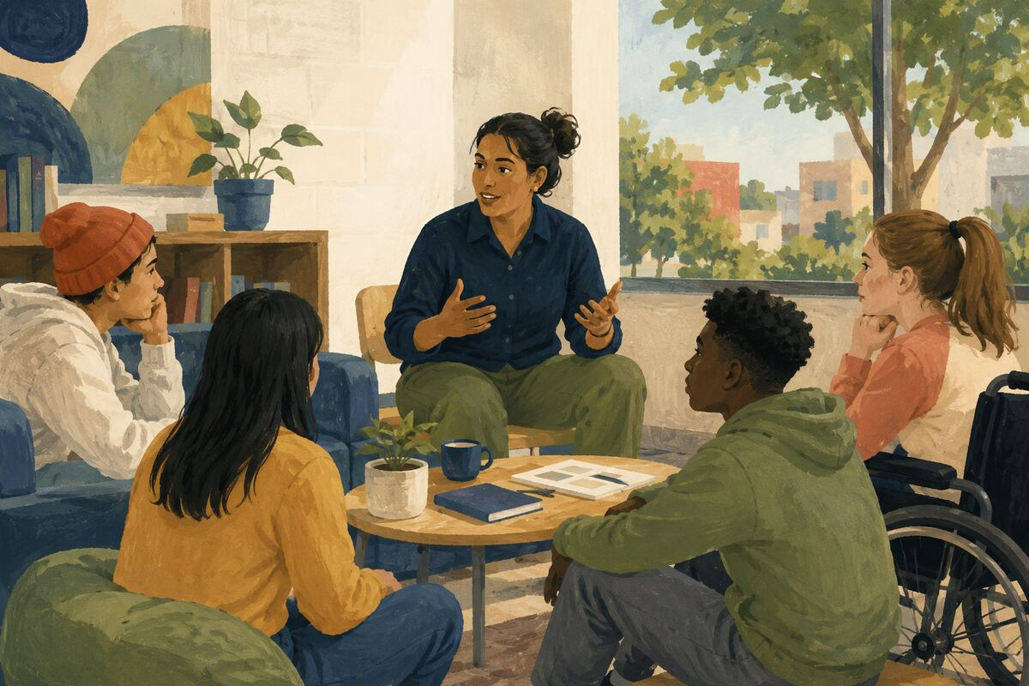
DO Describe your work, education, mistakes, and daily responsibilities honestly when speaking with students.

COMMUNITY BENEFIT Gives young people a more useful picture of possible futures.

EXAMPLE FOR YOUNGER GENERATIONS Shows that meaningful work includes learning and setbacks.

SCHOOLS, LIBRARIES, AND LEARNING
060 Teach how to check a source
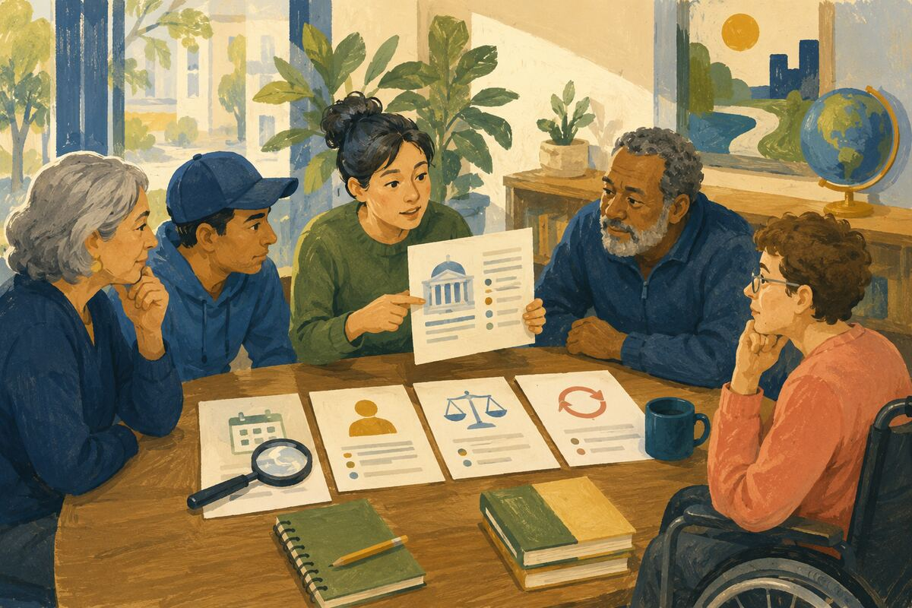
DO Compare one claim with the original document, date, author, evidence, and later corrections.

COMMUNITY BENEFIT Builds resistance to misinformation.

EXAMPLE FOR YOUNGER GENERATIONS Shows younger generations how responsible belief is formed.

OLDER ADULTS AND PEOPLE WITH DISABILITIES
061 Ask before helping
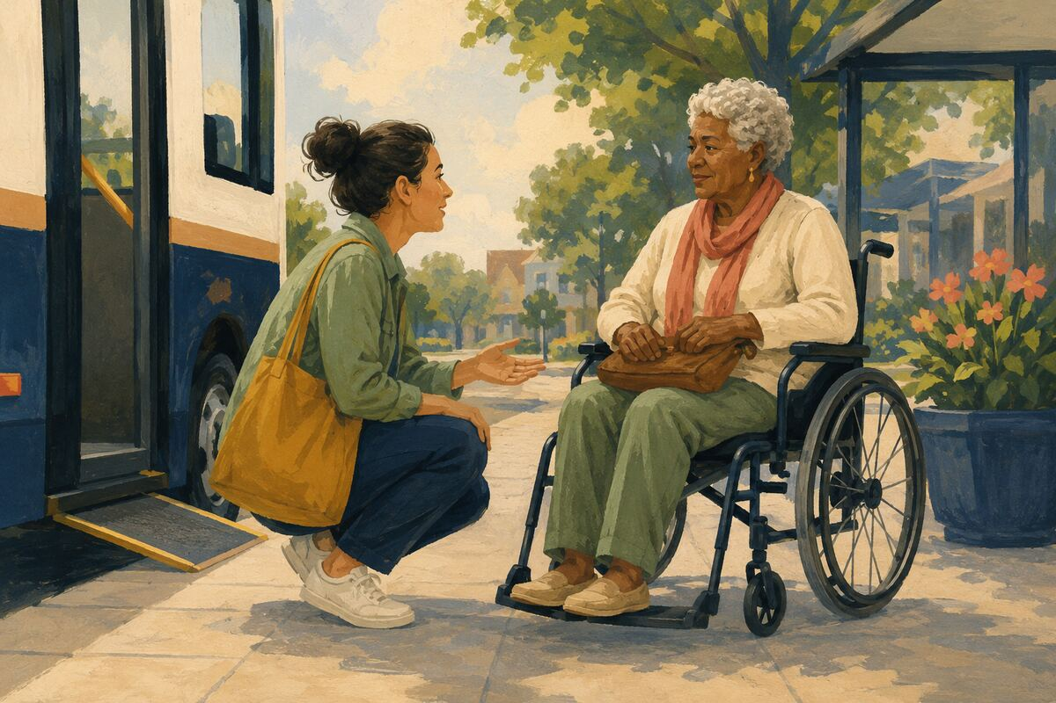
DO Offer assistance and wait for the person’s answer instead of taking over a wheelchair, cane, bag, or task.

COMMUNITY BENEFIT Protects safety, dignity, and personal control.

EXAMPLE FOR YOUNGER GENERATIONS Teaches that help should respect consent.

OLDER ADULTS AND PEOPLE WITH DISABILITIES
062 Check a ramp and route
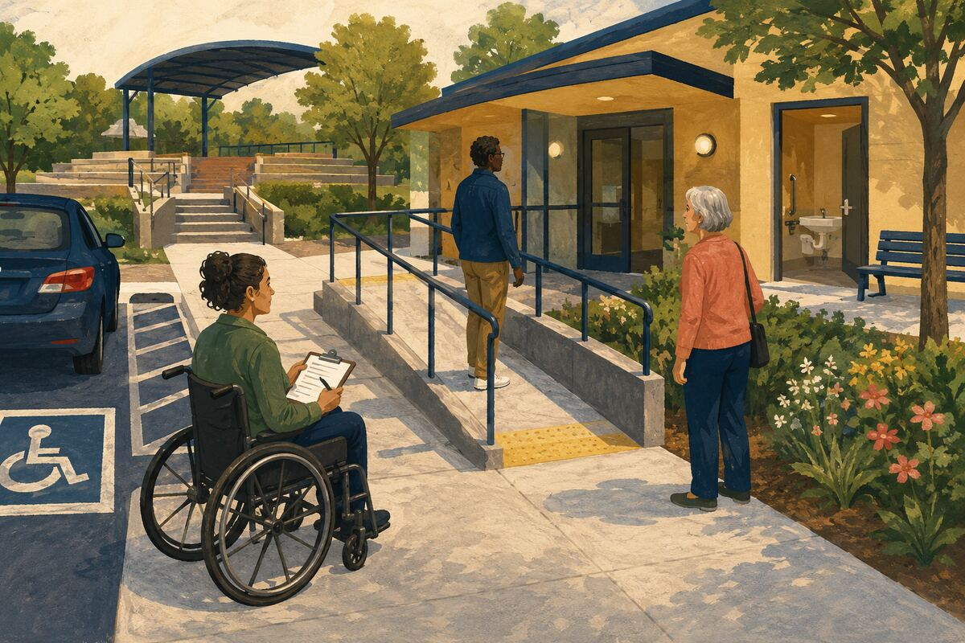
DO Before an event, confirm that parking, entrances, restrooms, seating, and paths are actually accessible.

COMMUNITY BENEFIT Prevents exclusion caused by avoidable physical barriers.

EXAMPLE FOR YOUNGER GENERATIONS Shows that inclusion requires preparation, not slogans.

OLDER ADULTS AND PEOPLE WITH DISABILITIES
063 Make one document easier to read
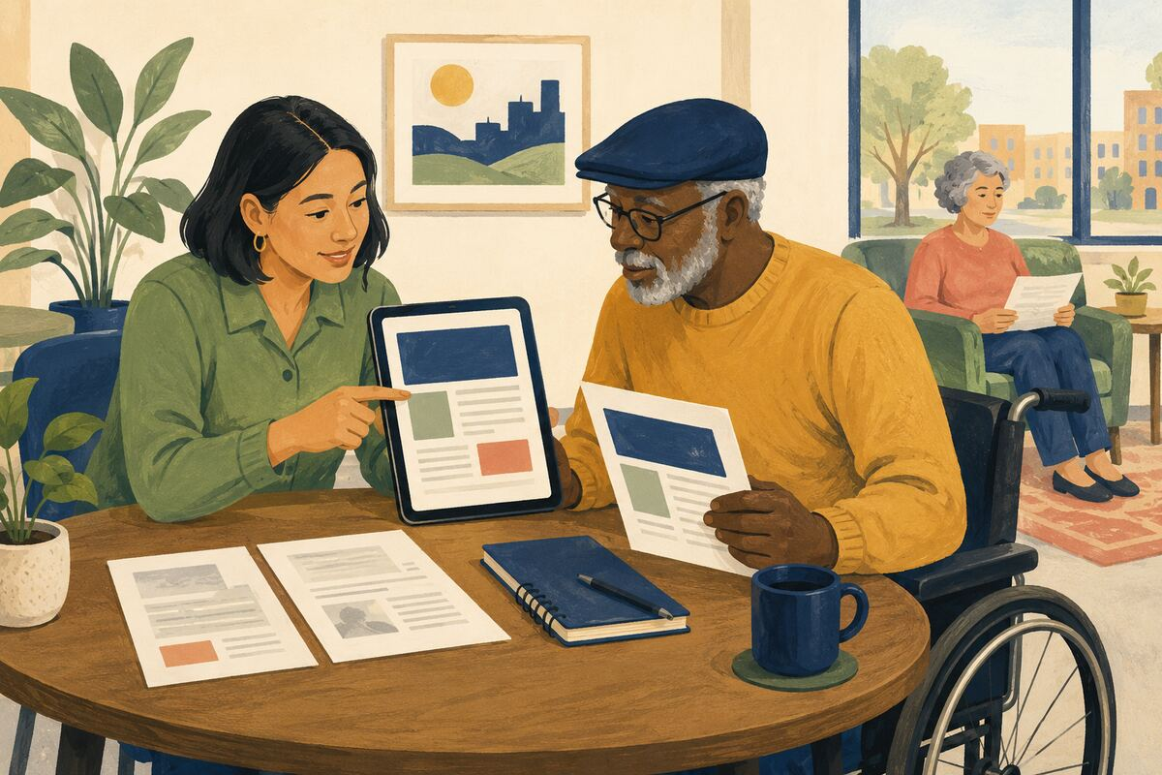
DO Increase contrast and type size, use plain language, and provide a digital or large-print version when needed.

COMMUNITY BENEFIT Lets more people understand and act on important information.

EXAMPLE FOR YOUNGER GENERATIONS Teaches that communication succeeds only when the audience can use it.

OLDER ADULTS AND PEOPLE WITH DISABILITIES
064 Offer a technology lesson

DO Help with one chosen task such as video calling, password management, transportation apps, or scam detection without taking control of accounts.

COMMUNITY BENEFIT Increases independence and reduces isolation or fraud risk.

EXAMPLE FOR YOUNGER GENERATIONS Shows patience and respect across generations.

OLDER ADULTS AND PEOPLE WITH DISABILITIES
065 Check on cooling and heating
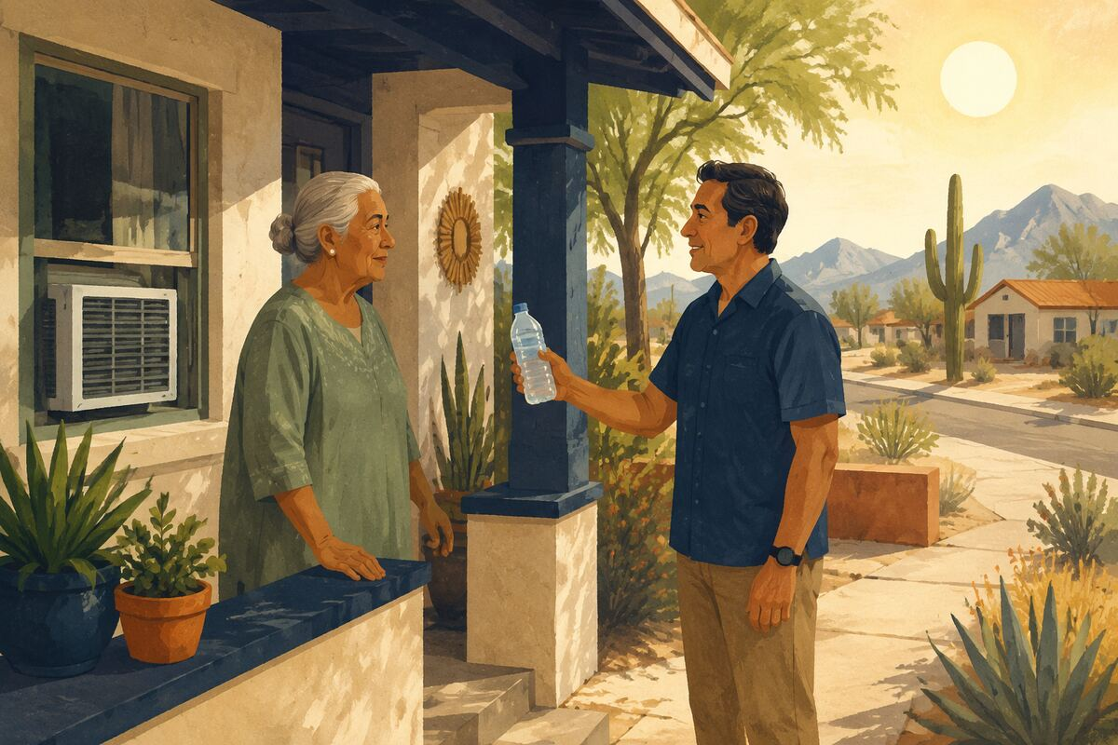
DO With prior agreement, contact a vulnerable neighbor during extreme temperatures and confirm that their home system works.

COMMUNITY BENEFIT Identifies dangerous conditions before they become medical emergencies.

EXAMPLE FOR YOUNGER GENERATIONS Models attentive care for people at higher risk.

OLDER ADULTS AND PEOPLE WITH DISABILITIES
066 Give extra crossing time
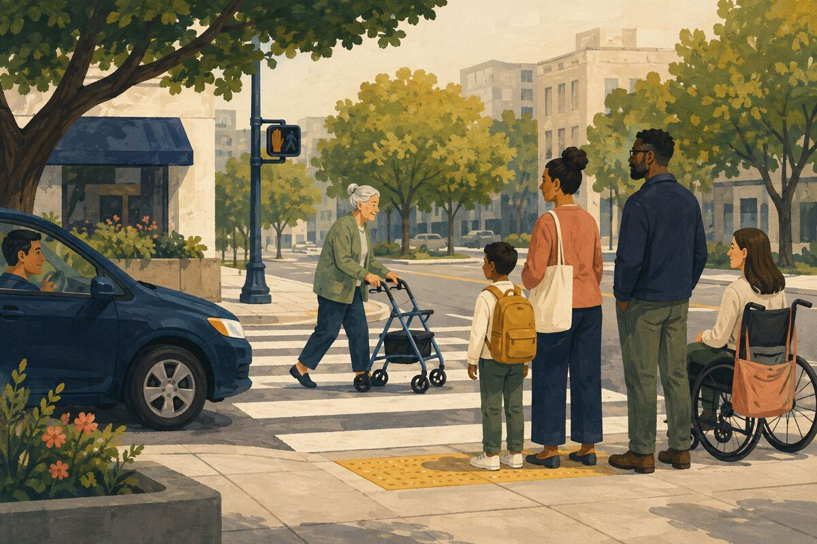
DO Wait without honking or crowding when a person needs more time to cross, board, stand, or navigate.

COMMUNITY BENEFIT Reduces pressure and prevents falls or panic.

EXAMPLE FOR YOUNGER GENERATIONS Teaches that public life should not punish people for moving differently.

OLDER ADULTS AND PEOPLE WITH DISABILITIES
067 Keep accessible parking available
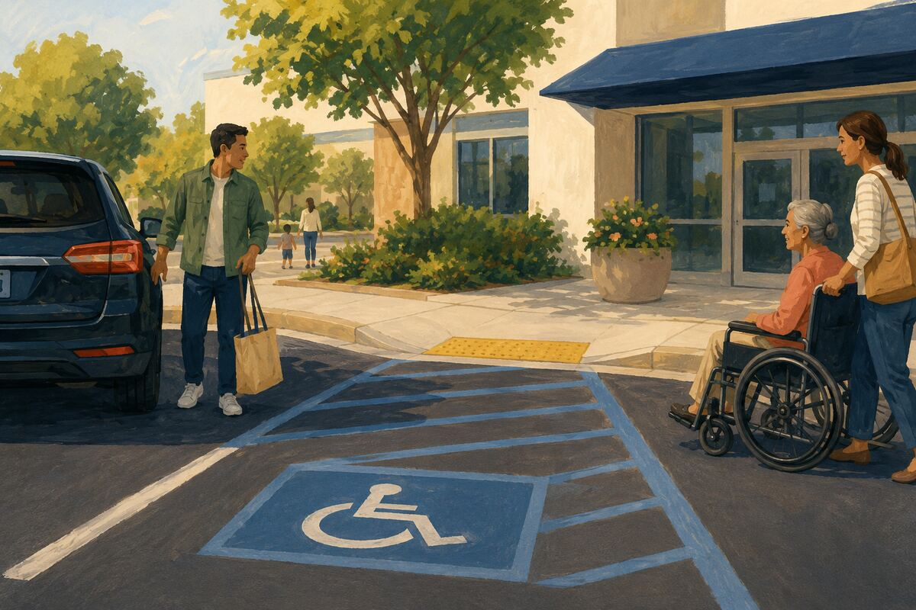
DO Never use an accessible space, access aisle, curb cut, or loading zone without legal authorization and actual need.

COMMUNITY BENEFIT Preserves essential access, not merely convenient parking.

EXAMPLE FOR YOUNGER GENERATIONS Shows respect for rights even when enforcement is absent.

OLDER ADULTS AND PEOPLE WITH DISABILITIES
068 Make a friendly scheduled call
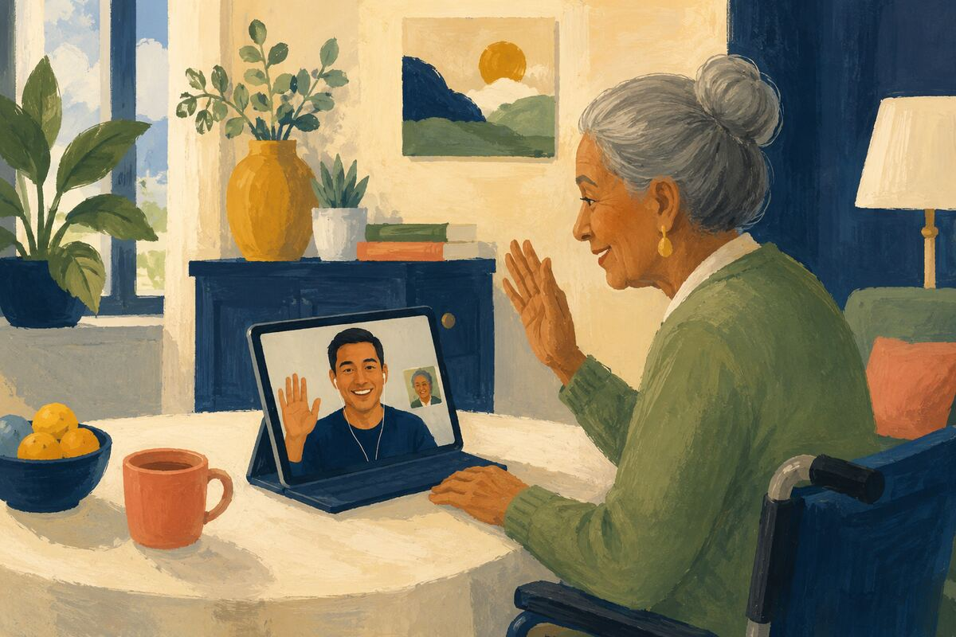
DO Arrange a regular short call or visit with someone who wants more contact.

COMMUNITY BENEFIT Reduces loneliness and creates a predictable opportunity to notice changing needs.

EXAMPLE FOR YOUNGER GENERATIONS Teaches consistency in relationships.

OLDER ADULTS AND PEOPLE WITH DISABILITIES
069 Preserve decision-making authority
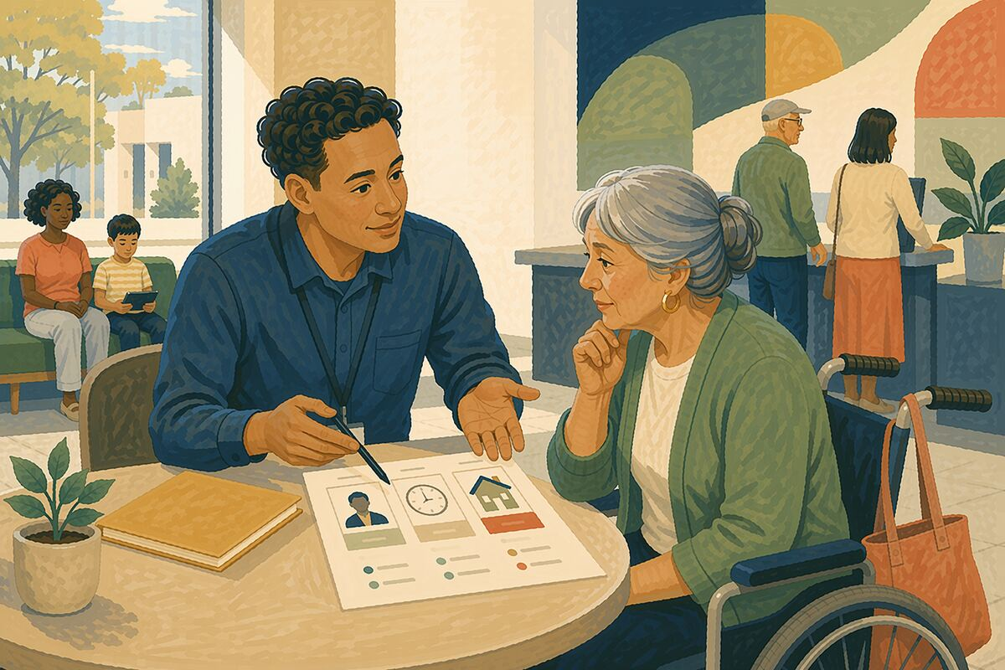
DO When assisting with forms, purchases, or appointments, explain options and let the person make their own decisions unless lawful authority says otherwise.

COMMUNITY BENEFIT Protects autonomy and reduces exploitation.

EXAMPLE FOR YOUNGER GENERATIONS Shows that support is not control.

OLDER ADULTS AND PEOPLE WITH DISABILITIES
070 Report accessibility failures constructively
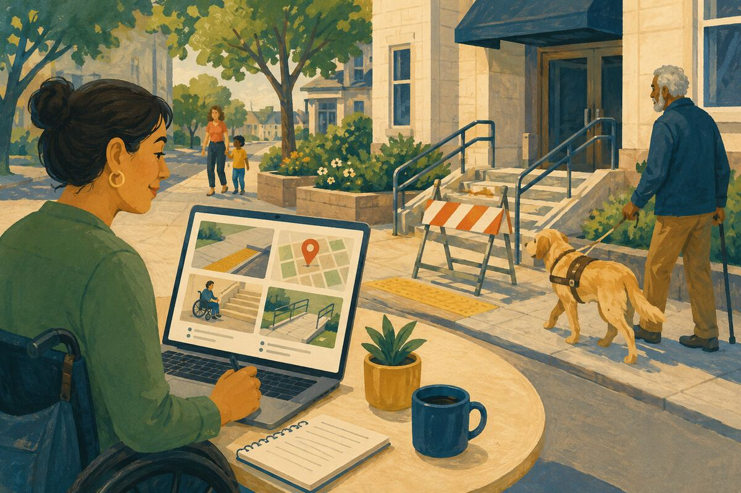
DO Give the responsible organization the exact barrier, location, impact, and a reasonable correction.

COMMUNITY BENEFIT Turns exclusion into an actionable improvement opportunity.

EXAMPLE FOR YOUNGER GENERATIONS Models advocacy that is specific and solution-oriented.

HEALTH, SAFETY, AND EMERGENCY READINESS
071 Learn CPR and first aid
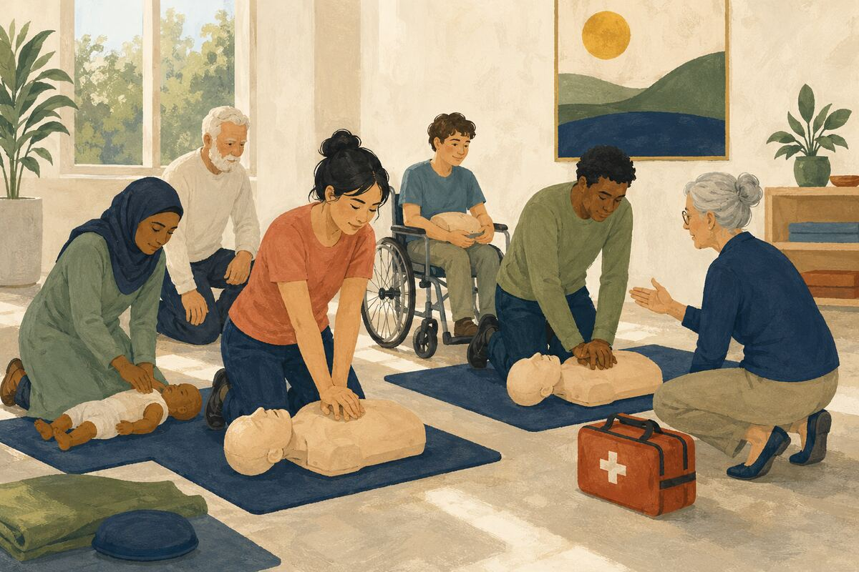
DO Complete a recognized course and refresh it as recommended.

COMMUNITY BENEFIT Increases the number of bystanders able to help before professionals arrive.

EXAMPLE FOR YOUNGER GENERATIONS Shows that courage is strengthened by preparation.

HEALTH, SAFETY, AND EMERGENCY READINESS
072 Test smoke alarms
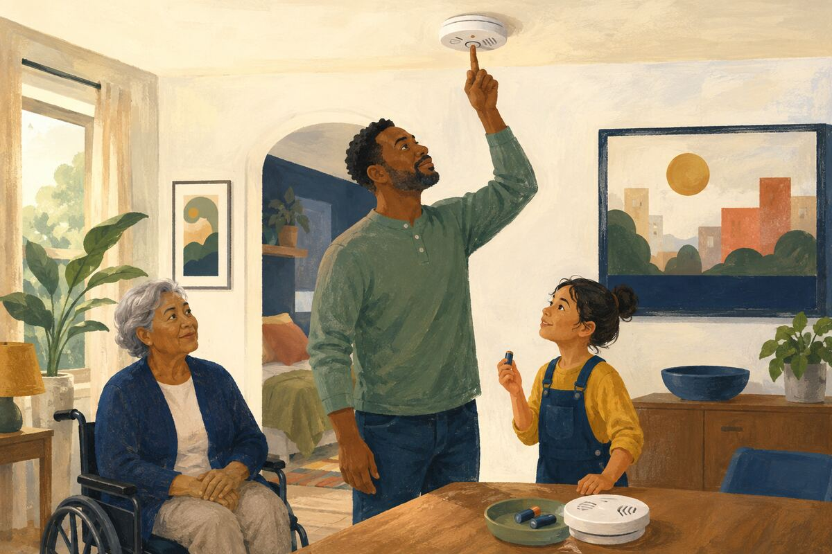
DO Use the test button regularly and replace batteries or expired units according to manufacturer guidance.

COMMUNITY BENEFIT Provides earlier warning during a fire.

EXAMPLE FOR YOUNGER GENERATIONS Teaches that safety equipment requires maintenance.

HEALTH, SAFETY, AND EMERGENCY READINESS
073 Post the home address clearly
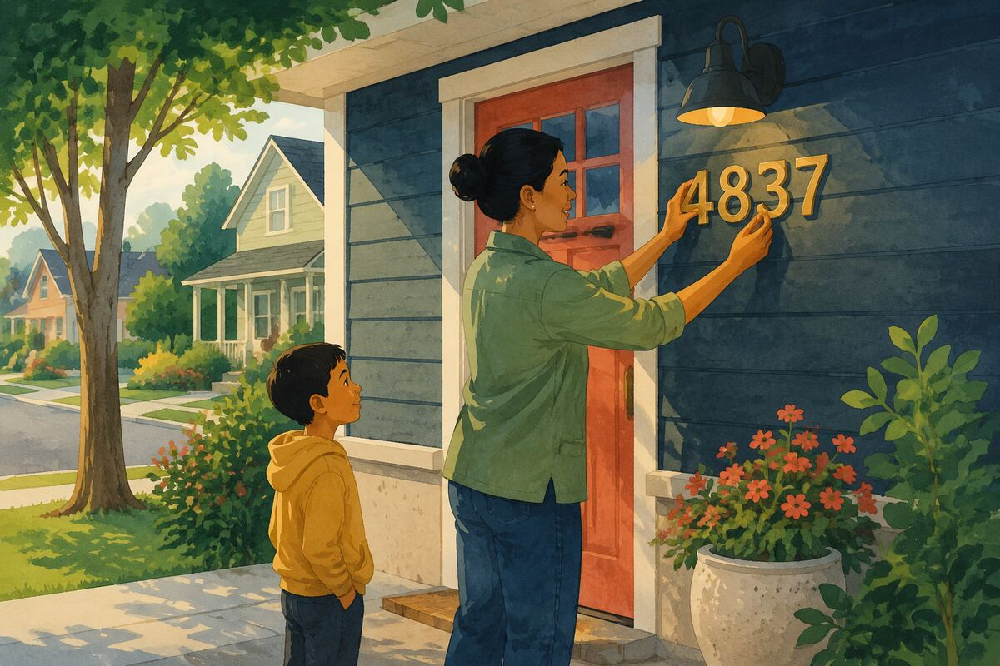
DO Use durable, contrasting numbers visible from the street and keep them unobstructed.

COMMUNITY BENEFIT Helps emergency crews locate the correct property faster.

EXAMPLE FOR YOUNGER GENERATIONS Shows how a small maintenance task can matter in a crisis.

HEALTH, SAFETY, AND EMERGENCY READINESS
074 Build a basic emergency contact card
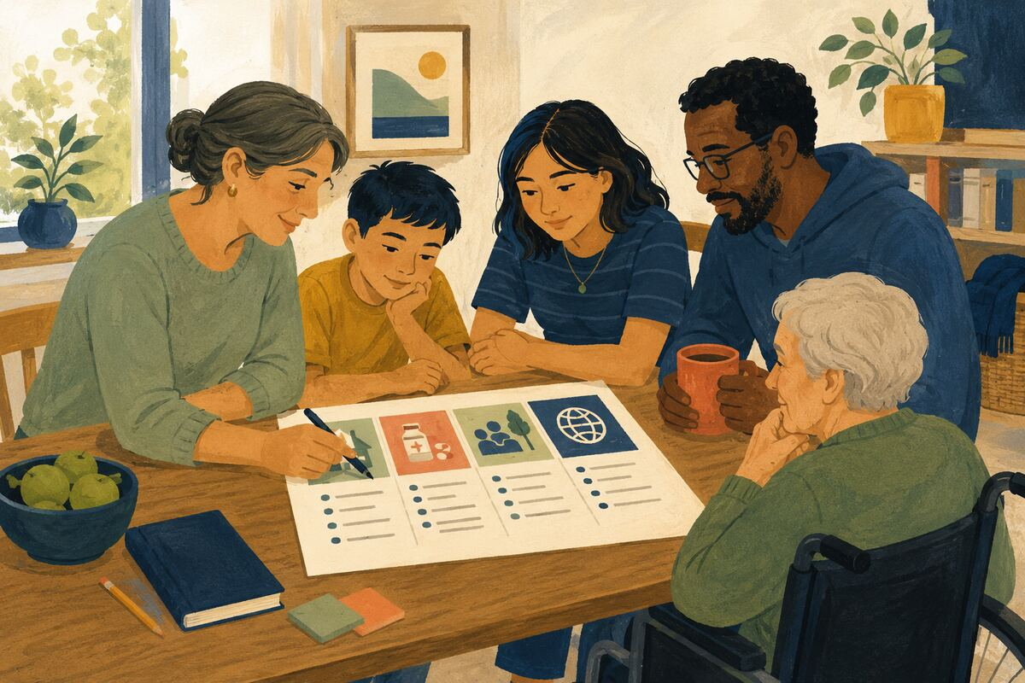
DO Include household contacts, medications or allergies as appropriate, meeting points, and out-of-area contact information.

COMMUNITY BENEFIT Provides usable information when phones are lost, dead, or inaccessible.

EXAMPLE FOR YOUNGER GENERATIONS Teaches planning before pressure.

HEALTH, SAFETY, AND EMERGENCY READINESS
075 Keep exits clear
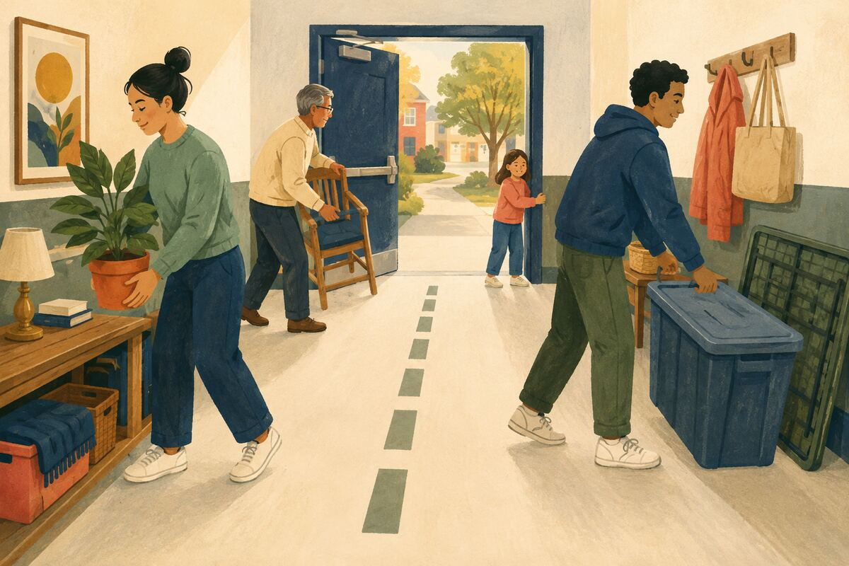
DO Remove storage, furniture, locks, or clutter that blocks normal escape routes.

COMMUNITY BENEFIT Reduces evacuation time and trip hazards.

EXAMPLE FOR YOUNGER GENERATIONS Shows that convenience should not compromise safety.

HEALTH, SAFETY, AND EMERGENCY READINESS
076 Store medications safely
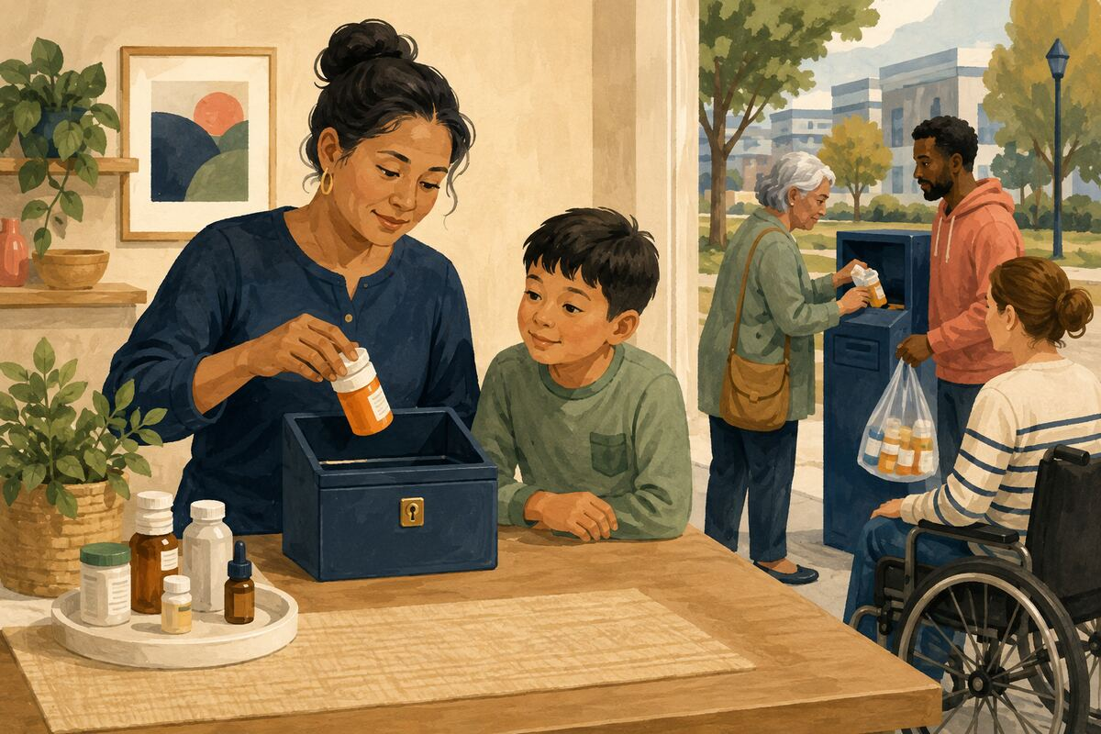
DO Keep medicines labeled, secured from children, and disposed of through approved programs when no longer needed.

COMMUNITY BENEFIT Reduces poisoning, misuse, and confusion.

EXAMPLE FOR YOUNGER GENERATIONS Models careful stewardship of powerful substances.

HEALTH, SAFETY, AND EMERGENCY READINESS
077 Secure heavy furniture

DO Anchor bookcases, televisions, and tall furniture where tipping is a risk, especially around children.

COMMUNITY BENEFIT Prevents a common source of serious household injury.

EXAMPLE FOR YOUNGER GENERATIONS Shows that adults are responsible for hazards children cannot see.

HEALTH, SAFETY, AND EMERGENCY READINESS
078 Learn when to call emergency services
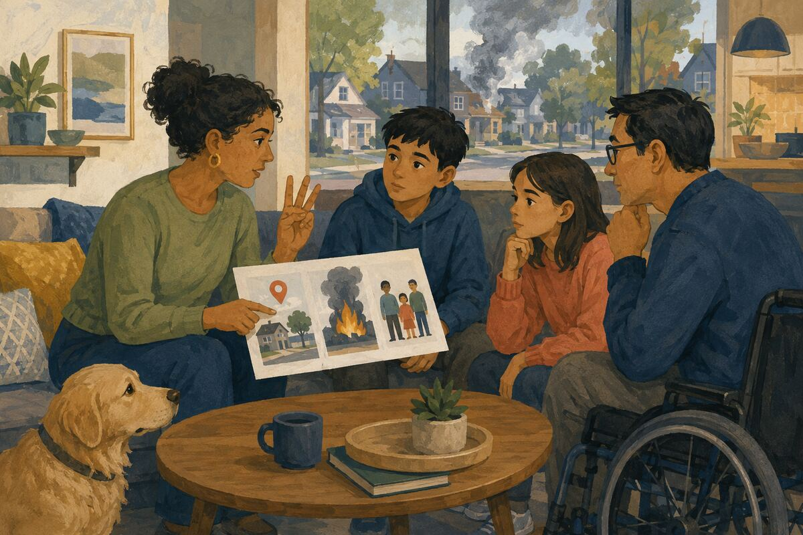
DO Teach household members how to describe the location, danger, and number of people affected, and when not to delay.

COMMUNITY BENEFIT Improves the quality and speed of emergency response.

EXAMPLE FOR YOUNGER GENERATIONS Shows that asking for qualified help is responsible.

HEALTH, SAFETY, AND EMERGENCY READINESS
079 Keep hydrants and emergency lanes clear
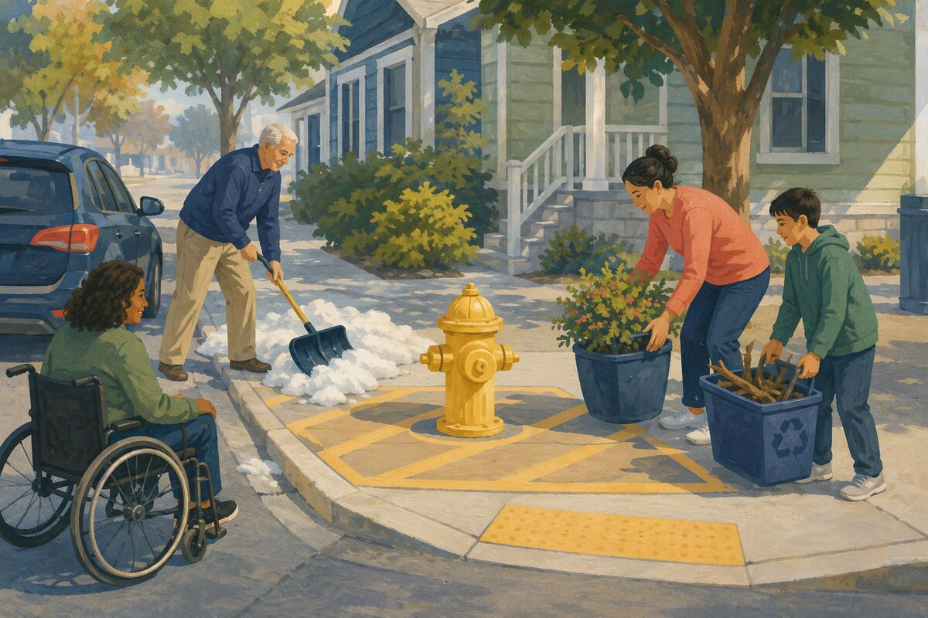
DO Do not park, store items, or pile snow, branches, or waste where responders need access.

COMMUNITY BENEFIT Protects critical response routes.

EXAMPLE FOR YOUNGER GENERATIONS Teaches that emergency infrastructure serves everyone.

HEALTH, SAFETY, AND EMERGENCY READINESS
080 Donate blood if eligible

DO Schedule through a qualified blood-collection organization and follow its current health guidance.

COMMUNITY BENEFIT Supports the medical supply needed for surgeries, trauma, and treatment.

EXAMPLE FOR YOUNGER GENERATIONS Shows that one person can give something another person cannot manufacture.

HEAT, WEATHER, AND DISASTER RESILIENCE
081 Share official alerts, not rumors
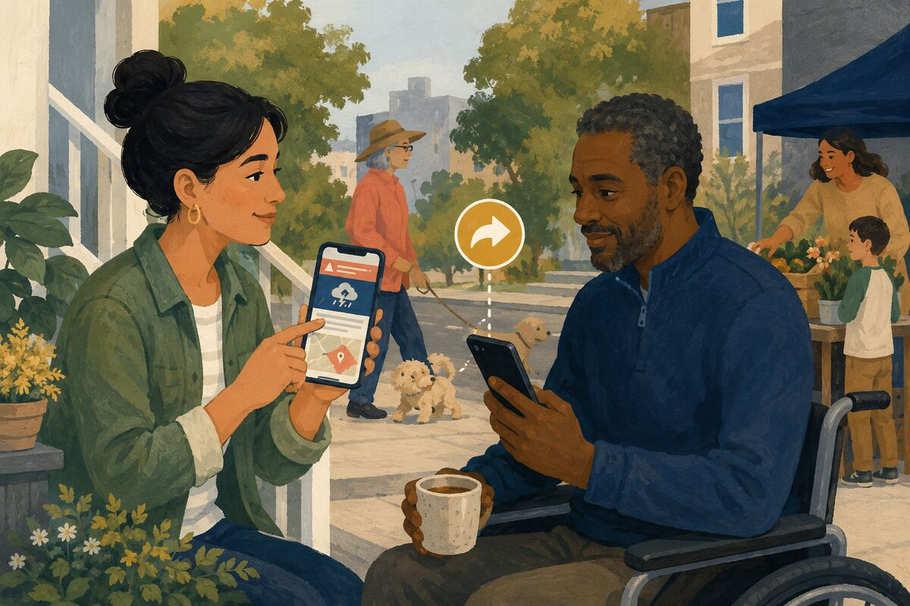
DO Forward the original emergency-management, weather-service, utility, or public-safety notice with its date and location.

COMMUNITY BENEFIT Helps people act on reliable information and reduces confusion.

EXAMPLE FOR YOUNGER GENERATIONS Teaches that urgency does not excuse inaccuracy.

HEAT, WEATHER, AND DISASTER RESILIENCE
082 Learn the nearest safe public location
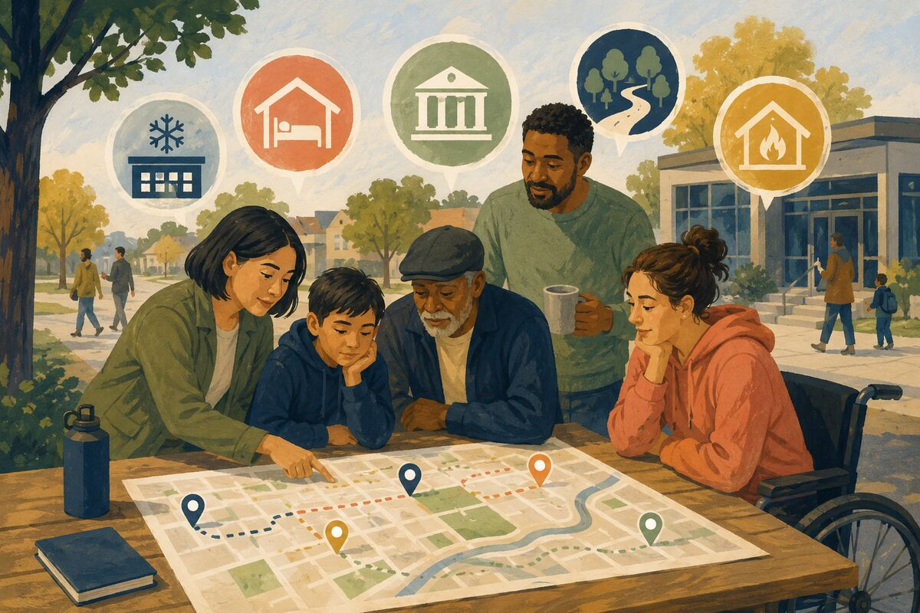
DO Identify cooling centers, shelters, libraries, evacuation routes, or warming centers before they are needed.

COMMUNITY BENEFIT Reduces decision time during dangerous conditions.

EXAMPLE FOR YOUNGER GENERATIONS Models preparation based on real local resources.

HEAT, WEATHER, AND DISASTER RESILIENCE
083 Freeze water and charge devices before an outage
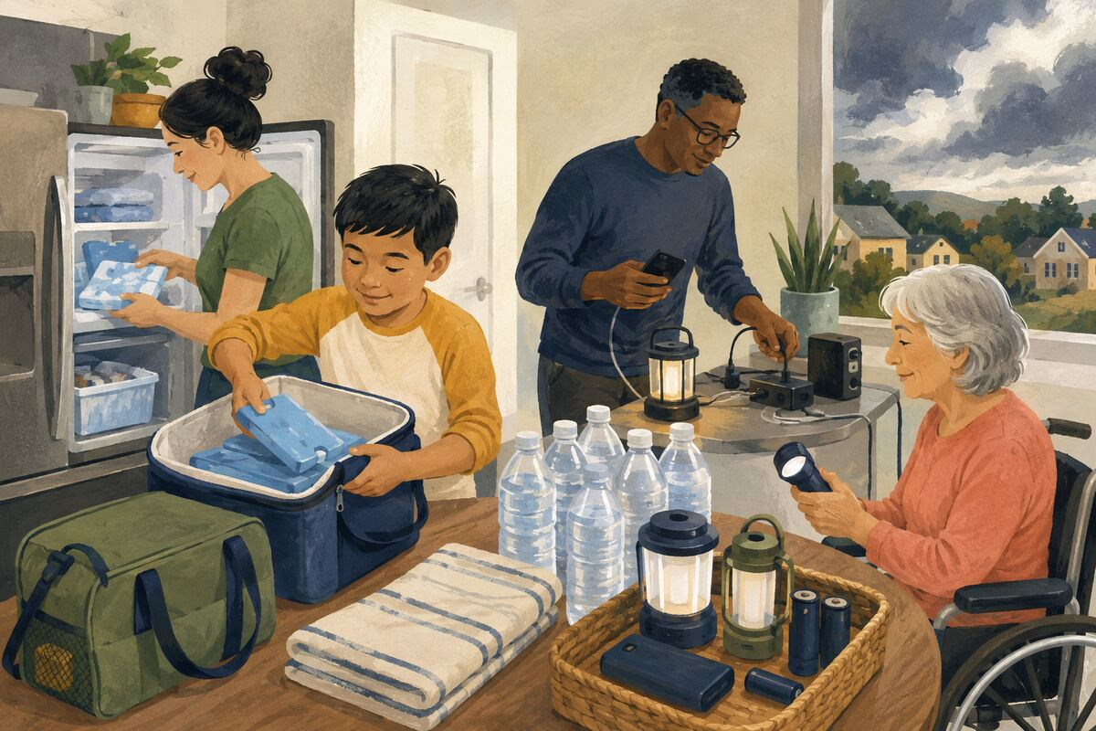
DO Prepare reusable cold packs, drinking water, lights, and communication devices when disruption is forecast.

COMMUNITY BENEFIT Extends household comfort and communication during short outages.

EXAMPLE FOR YOUNGER GENERATIONS Shows how early action reduces later hardship.

HEAT, WEATHER, AND DISASTER RESILIENCE
084 Trim hazards before storm season
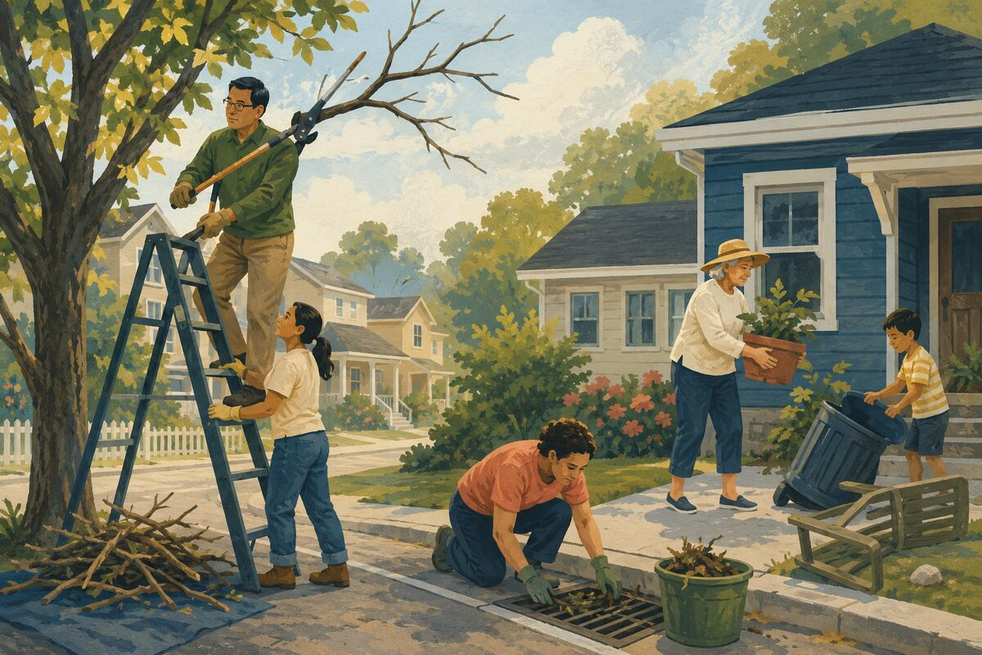
DO Use qualified help and proper permission to address dead limbs, loose materials, clogged drains, or unstable outdoor objects.

COMMUNITY BENEFIT Reduces damage to people, property, and utility lines.

EXAMPLE FOR YOUNGER GENERATIONS Teaches prevention rather than last-minute panic.

HEAT, WEATHER, AND DISASTER RESILIENCE
085 Check on outdoor workers
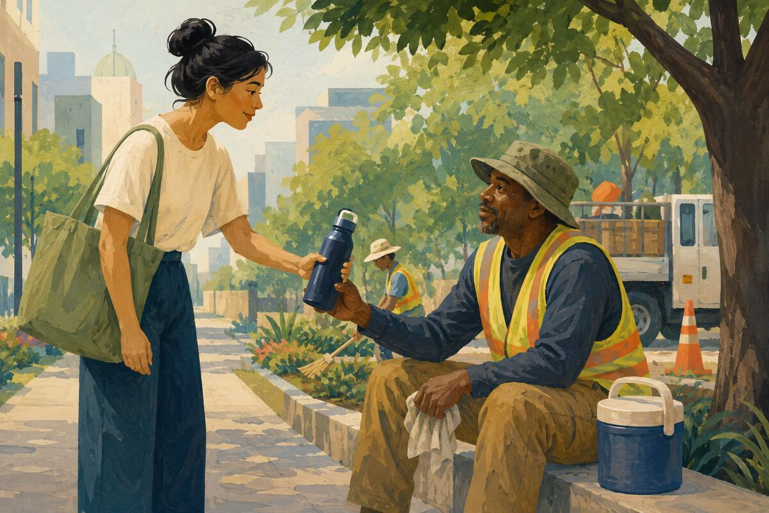
DO Offer sealed water or a brief cool rest where appropriate without interfering with their job or employer rules.

COMMUNITY BENEFIT Reduces heat strain and communicates care for people exposed to harsh conditions.

EXAMPLE FOR YOUNGER GENERATIONS Shows respect for labor that keeps communities functioning.

HEAT, WEATHER, AND DISASTER RESILIENCE
086 Never leave a person or animal in a parked vehicle
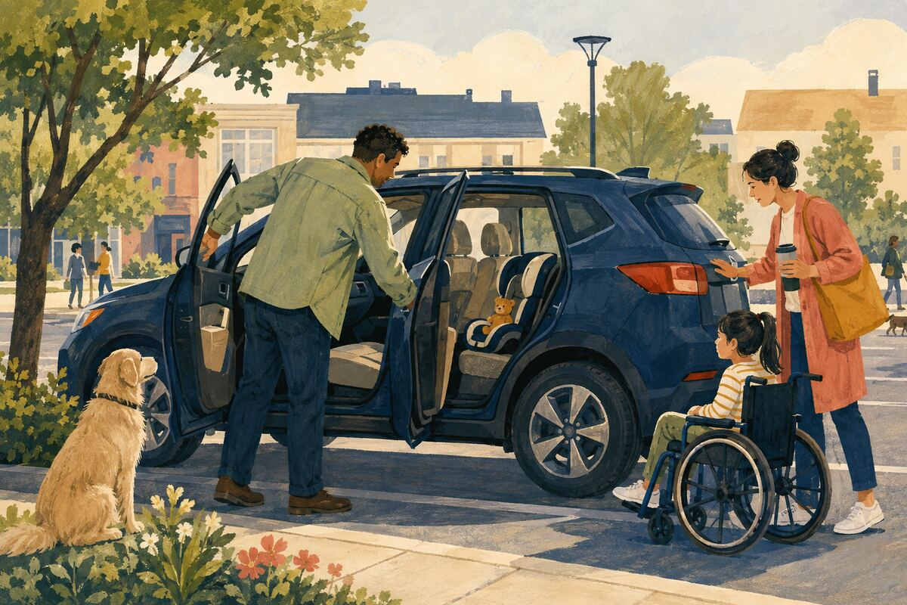
DO Check the entire vehicle before locking it and create a reminder routine for every trip.

COMMUNITY BENEFIT Prevents rapid heat injury and death.

EXAMPLE FOR YOUNGER GENERATIONS Teaches that safety routines protect those who depend on us.

HEAT, WEATHER, AND DISASTER RESILIENCE
087 Know how to shut off utilities
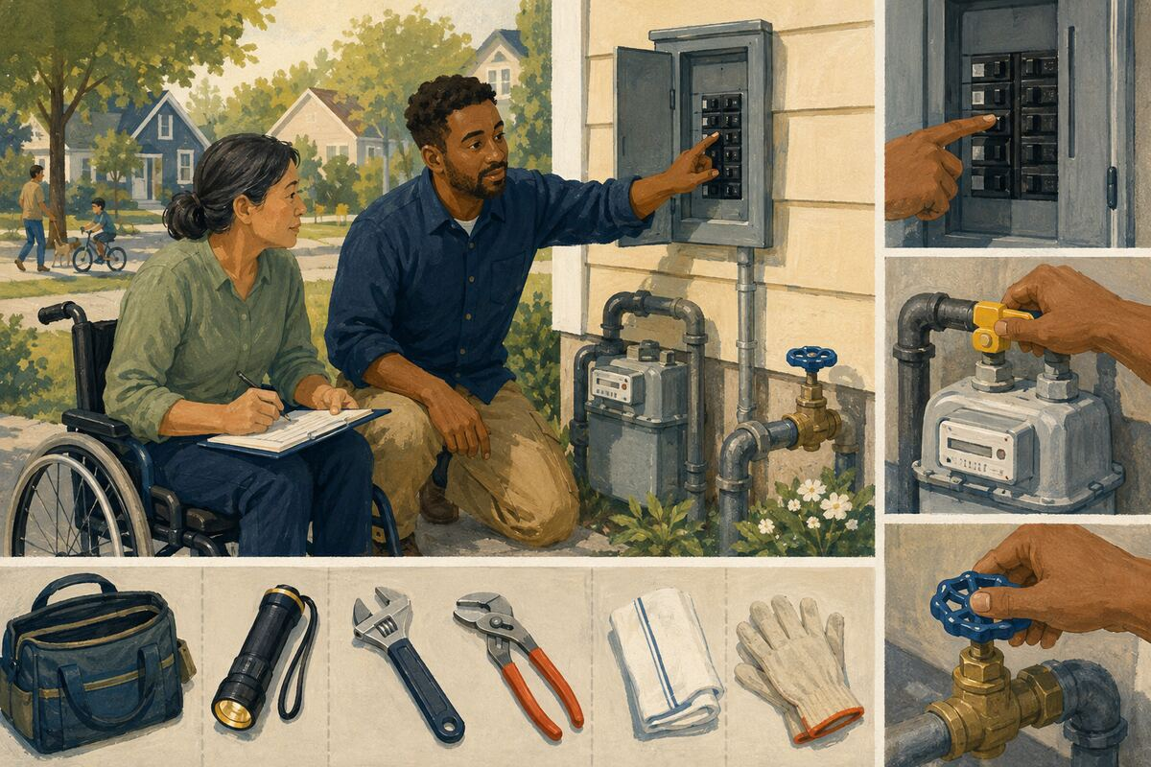
DO Learn the safe, authorized method for your home’s water, gas, and electricity, and label tools needed for the task.

COMMUNITY BENEFIT Limits damage when a leak or emergency occurs.

EXAMPLE FOR YOUNGER GENERATIONS Models practical household competence.

HEAT, WEATHER, AND DISASTER RESILIENCE
088 Photograph property before disaster season

DO Keep secure, current images of major rooms and belongings for insurance and recovery documentation.

COMMUNITY BENEFIT Speeds accurate claims and reduces confusion after loss.

EXAMPLE FOR YOUNGER GENERATIONS Shows the value of records before they are needed.

HEAT, WEATHER, AND DISASTER RESILIENCE
089 Make a family reunification plan
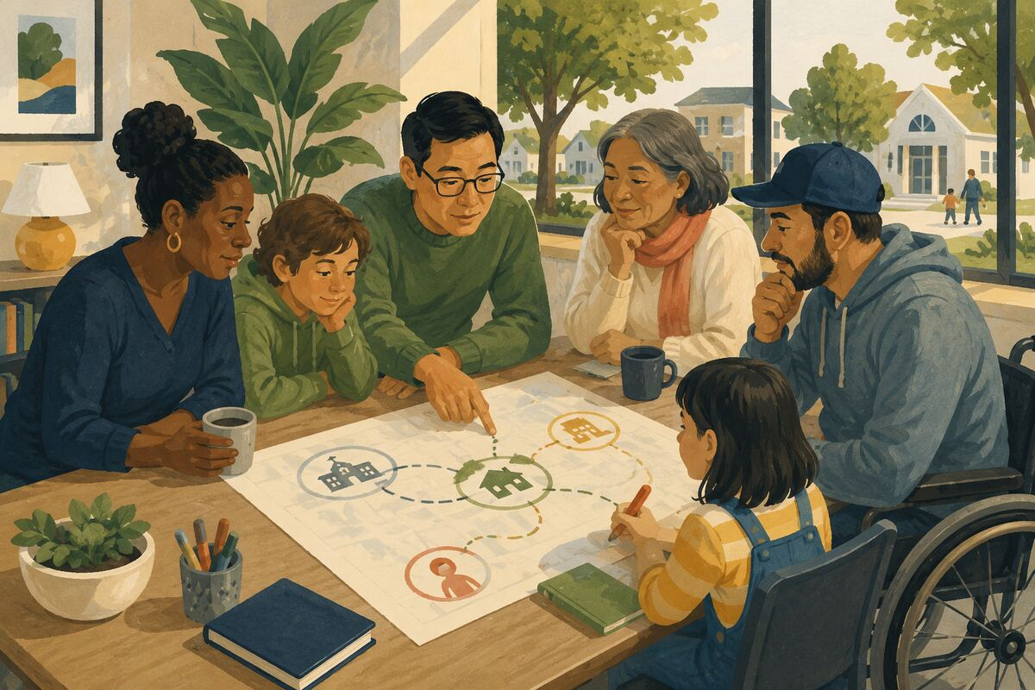
DO Choose meeting locations, school pickup backups, and an out-of-area contact everyone understands.

COMMUNITY BENEFIT Helps separated household members reconnect during disrupted communication.

EXAMPLE FOR YOUNGER GENERATIONS Teaches calm coordination under uncertainty.

HEAT, WEATHER, AND DISASTER RESILIENCE
090 Help after a disaster through verified channels
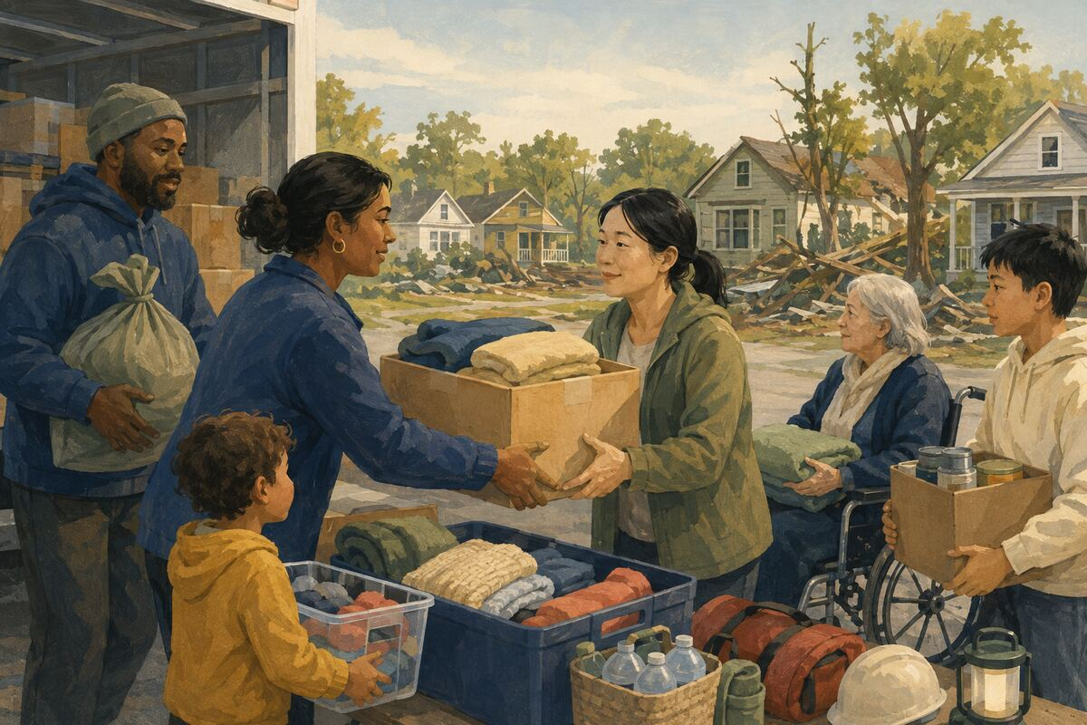
DO Donate requested goods, money, housing, labor, or equipment only through accountable organizations or known local needs.

COMMUNITY BENEFIT Directs help where it can be used without burdening responders.

EXAMPLE FOR YOUNGER GENERATIONS Shows that effective generosity listens first.

WATER, ENERGY, AND ENVIRONMENTAL STEWARDSHIP
091 Fix one leaking faucet or toilet
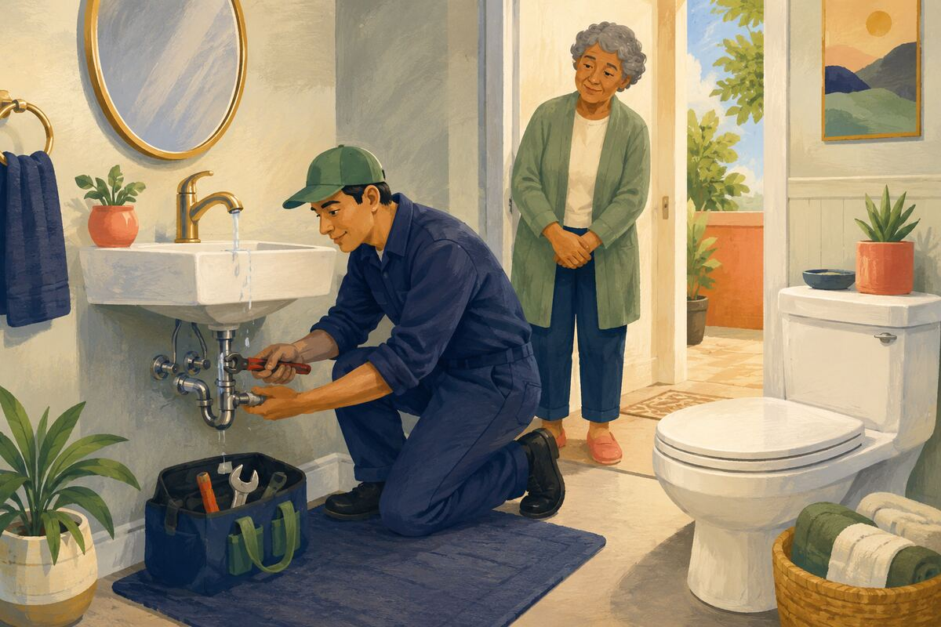
DO Repair the leak or notify the responsible owner with enough detail to act.

COMMUNITY BENEFIT Prevents ongoing water waste and possible property damage.

EXAMPLE FOR YOUNGER GENERATIONS Shows that resource conservation begins with maintenance.

WATER, ENERGY, AND ENVIRONMENTAL STEWARDSHIP
092 Turn off unused lights and equipment
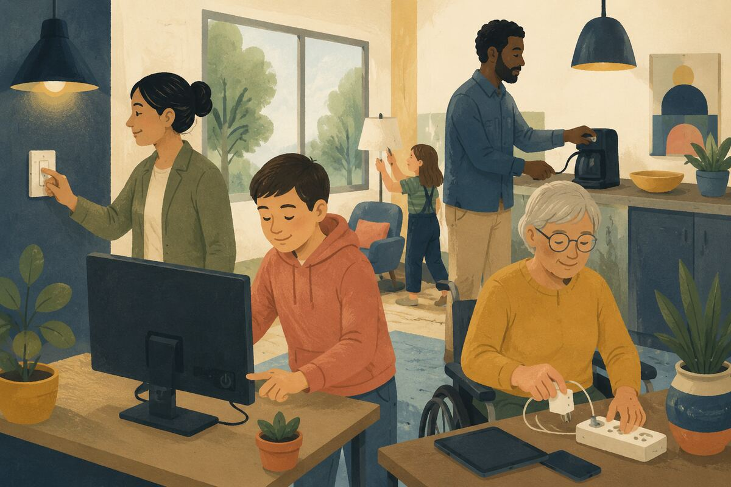
DO Switch off safe, nonessential lighting, screens, chargers, and appliances when a room or device is not in use.

COMMUNITY BENEFIT Reduces energy demand and operating cost.

EXAMPLE FOR YOUNGER GENERATIONS Teaches that small habits multiply across many people.

WATER, ENERGY, AND ENVIRONMENTAL STEWARDSHIP
093 Follow local recycling rules
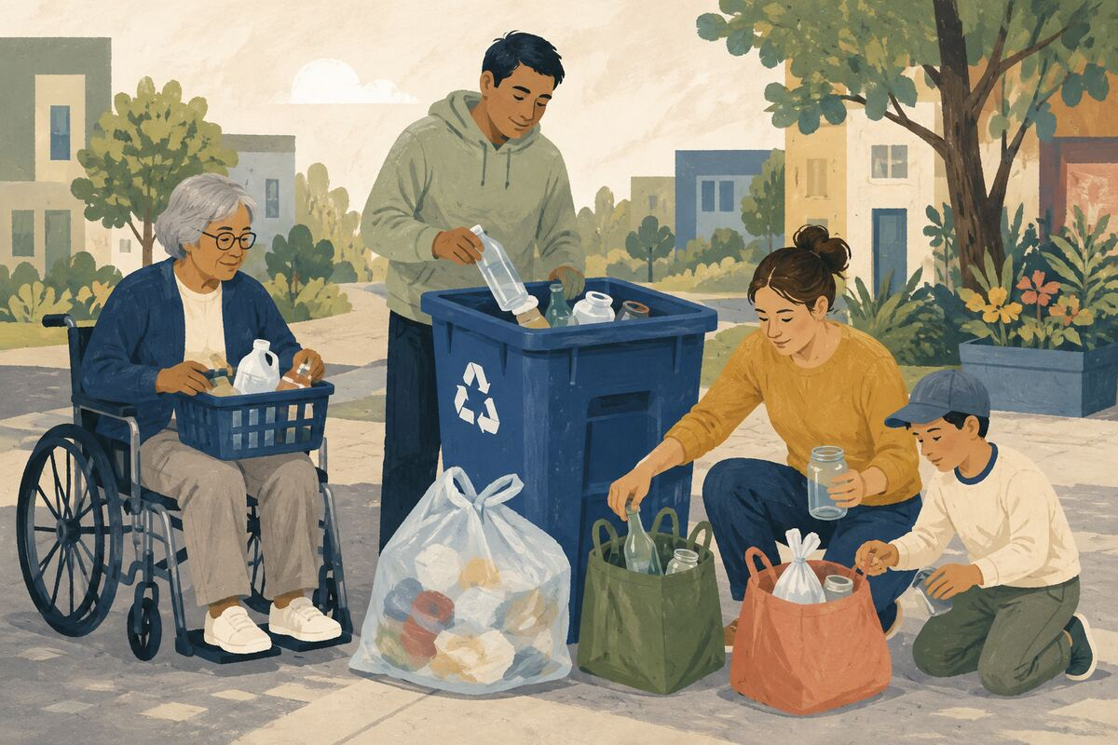
DO Check what is currently accepted and keep bags, food, liquids, and prohibited items out of the recycling stream.

COMMUNITY BENEFIT Reduces contamination and improves recovery of usable material.

EXAMPLE FOR YOUNGER GENERATIONS Shows that good intentions require correct execution.

WATER, ENERGY, AND ENVIRONMENTAL STEWARDSHIP
094 Use a reusable bottle or cup
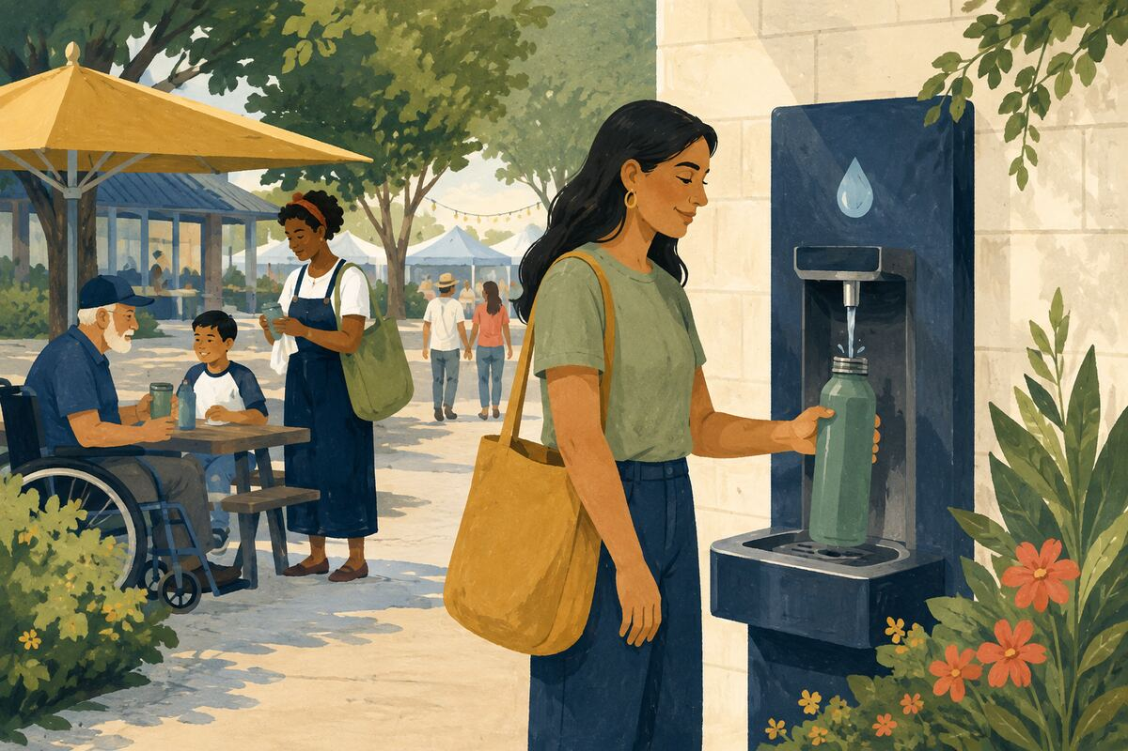
DO Carry and clean a durable container when local water quality and venue rules make it practical.

COMMUNITY BENEFIT Reduces repeated single-use waste.

EXAMPLE FOR YOUNGER GENERATIONS Models preparation that makes the lower-waste choice easy.

WATER, ENERGY, AND ENVIRONMENTAL STEWARDSHIP
095 Choose climate-appropriate plants
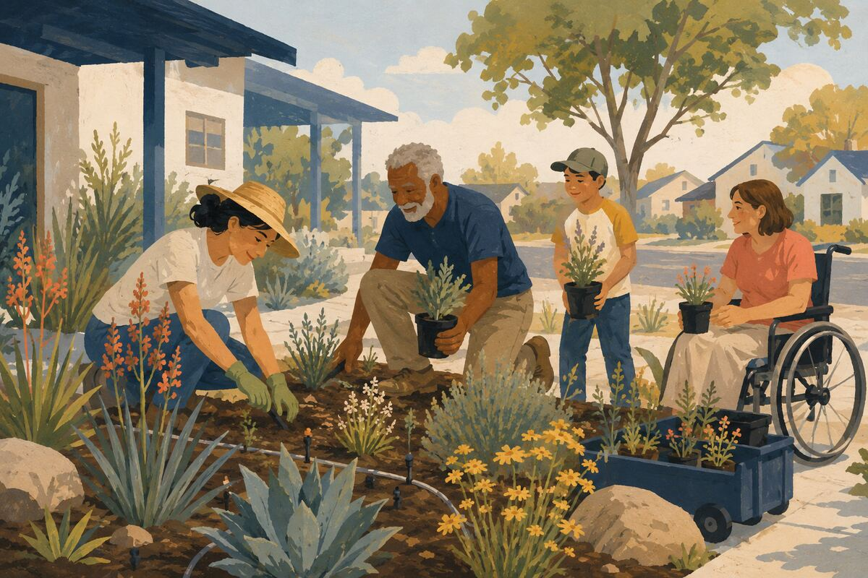
DO Use native or adapted plants and appropriate irrigation rather than high-water landscaping unsuited to the area.

COMMUNITY BENEFIT Supports local habitat and reduces water and maintenance demand.

EXAMPLE FOR YOUNGER GENERATIONS Teaches that good design responds to place.

WATER, ENERGY, AND ENVIRONMENTAL STEWARDSHIP
096 Dispose of hazardous waste correctly
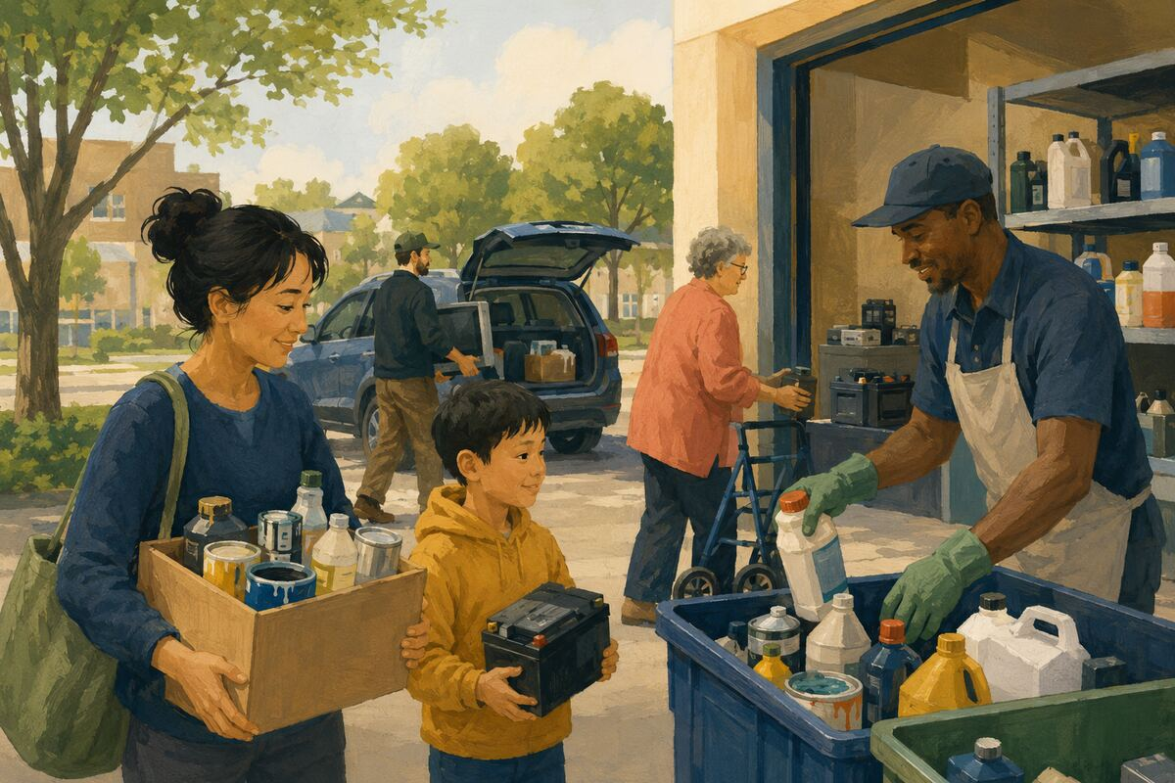
DO Take paint, chemicals, oil, batteries, and electronics to an approved collection program.

COMMUNITY BENEFIT Keeps harmful materials out of soil, drains, trash equipment, and homes.

EXAMPLE FOR YOUNGER GENERATIONS Shows responsibility for waste after a product’s useful life.

WATER, ENERGY, AND ENVIRONMENTAL STEWARDSHIP
097 Combine errands
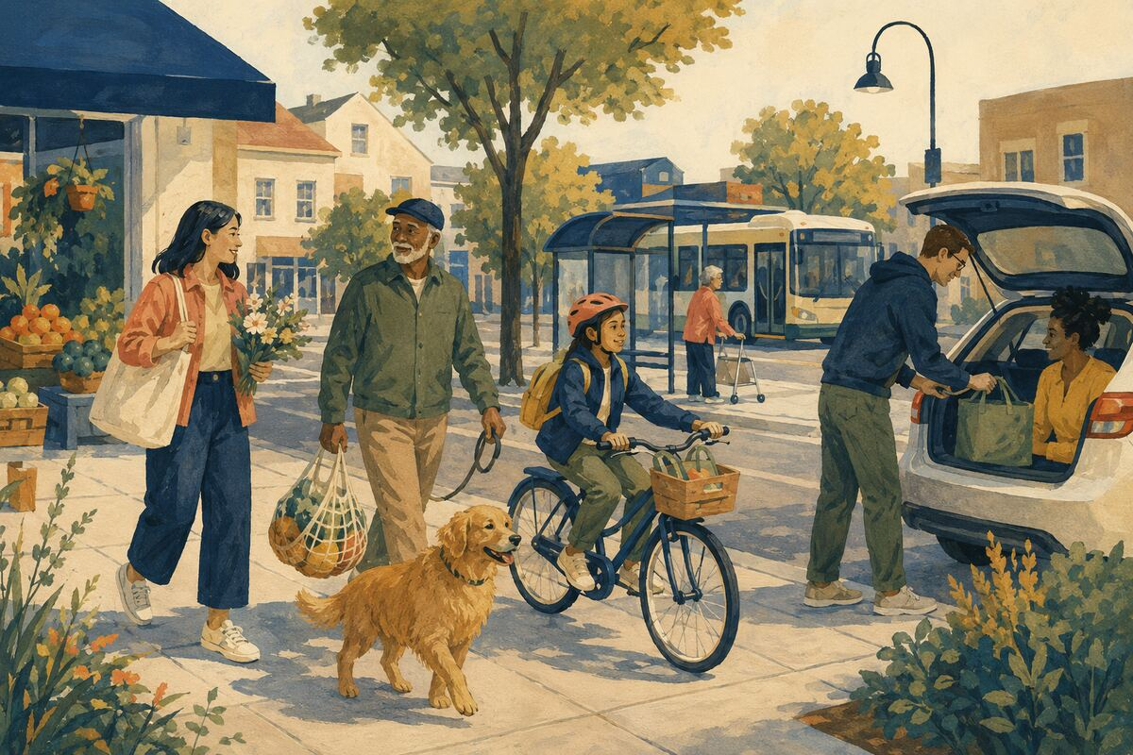
DO Plan nearby stops together, walk, cycle, carpool, or use transit when practical and safe.

COMMUNITY BENEFIT Reduces fuel use, congestion, and repeated travel time.

EXAMPLE FOR YOUNGER GENERATIONS Teaches that planning can conserve both personal and public resources.

WATER, ENERGY, AND ENVIRONMENTAL STEWARDSHIP
098 Protect trees during heat and construction
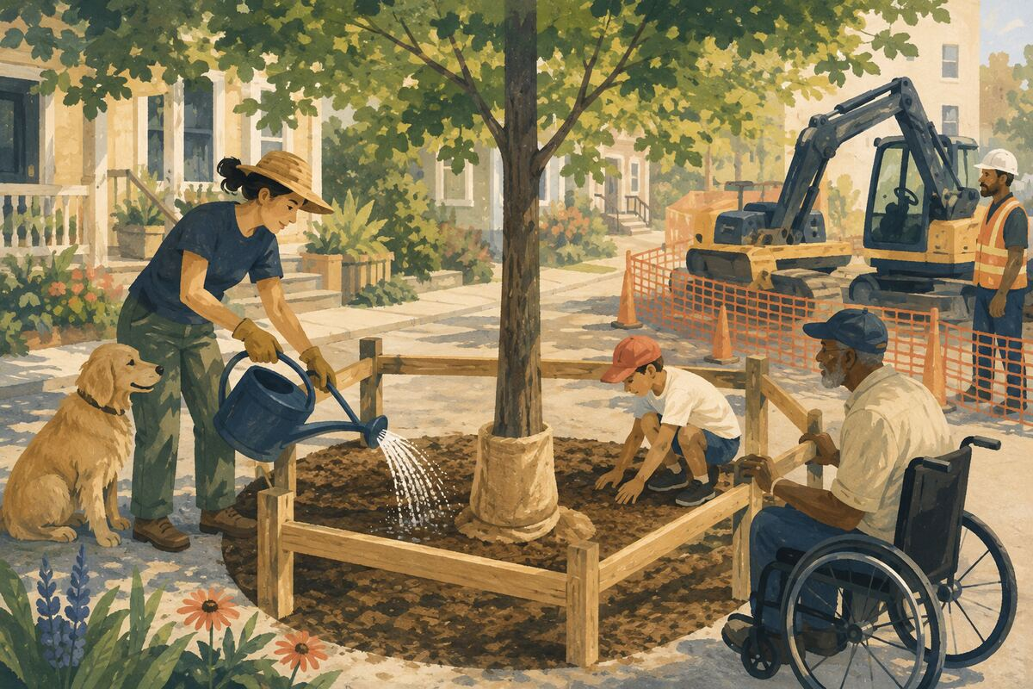
DO Water appropriately, avoid trunk damage, and keep soil compaction or equipment away from roots when responsible for the site.

COMMUNITY BENEFIT Preserves shade, habitat, and long-lived community assets.

EXAMPLE FOR YOUNGER GENERATIONS Shows stewardship whose benefits may outlast us.

WATER, ENERGY, AND ENVIRONMENTAL STEWARDSHIP
099 Report illegal dumping

DO Use the responsible local channel and provide the location and safe observations without handling hazardous waste.

COMMUNITY BENEFIT Helps remove hazards and identify recurring dumping sites.

EXAMPLE FOR YOUNGER GENERATIONS Models lawful action instead of passive complaint.

WATER, ENERGY, AND ENVIRONMENTAL STEWARDSHIP
100 Measure one month of household use
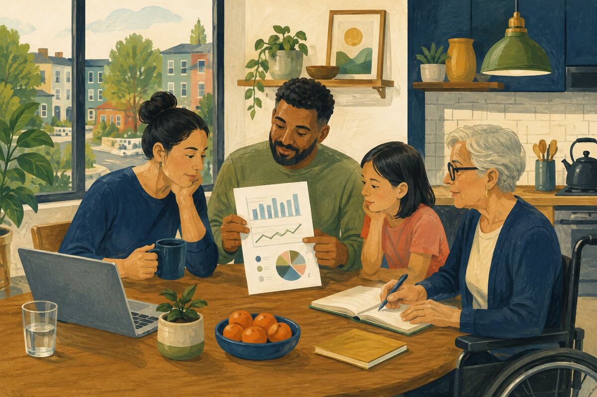
DO Review water, electricity, gas, or waste data and choose one realistic reduction that does not compromise health or safety.

COMMUNITY BENEFIT Turns conservation into a visible, testable practice.

EXAMPLE FOR YOUNGER GENERATIONS Teaches younger people to use evidence when changing habits.

FOOD, HUNGER, AND RESPONSIBLE SHARING
101 Donate requested food
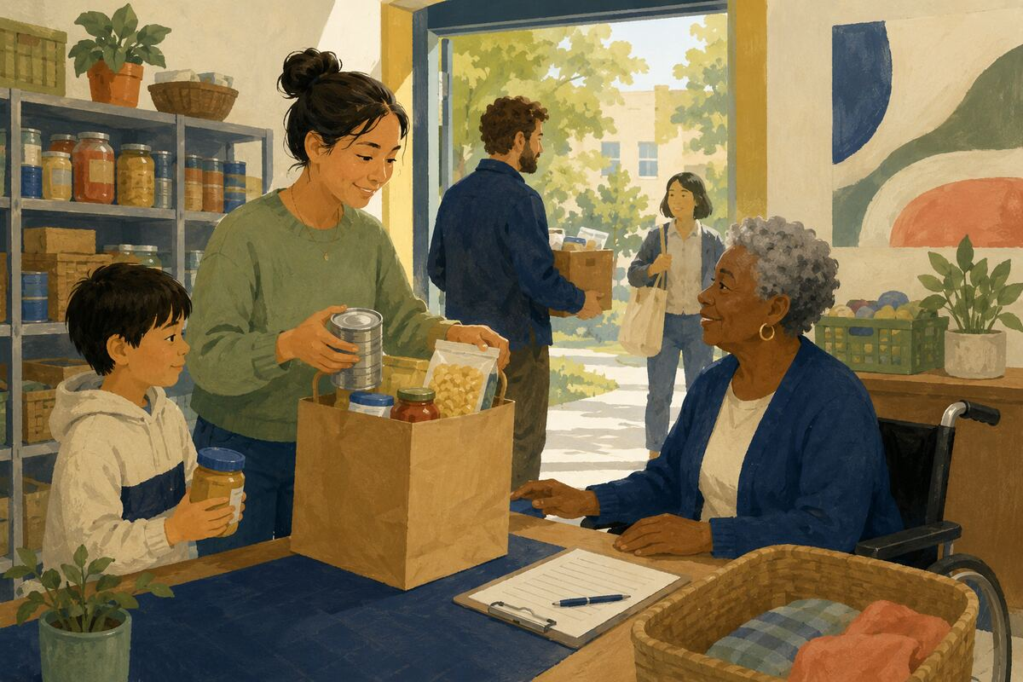
DO Check the pantry’s current list and provide unopened, unexpired items people can actually prepare.

COMMUNITY BENEFIT Fills real gaps while reducing sorting and disposal work.

EXAMPLE FOR YOUNGER GENERATIONS Teaches that giving starts with the recipient’s needs.

FOOD, HUNGER, AND RESPONSIBLE SHARING
102 Start a neighborhood food-share shelf responsibly
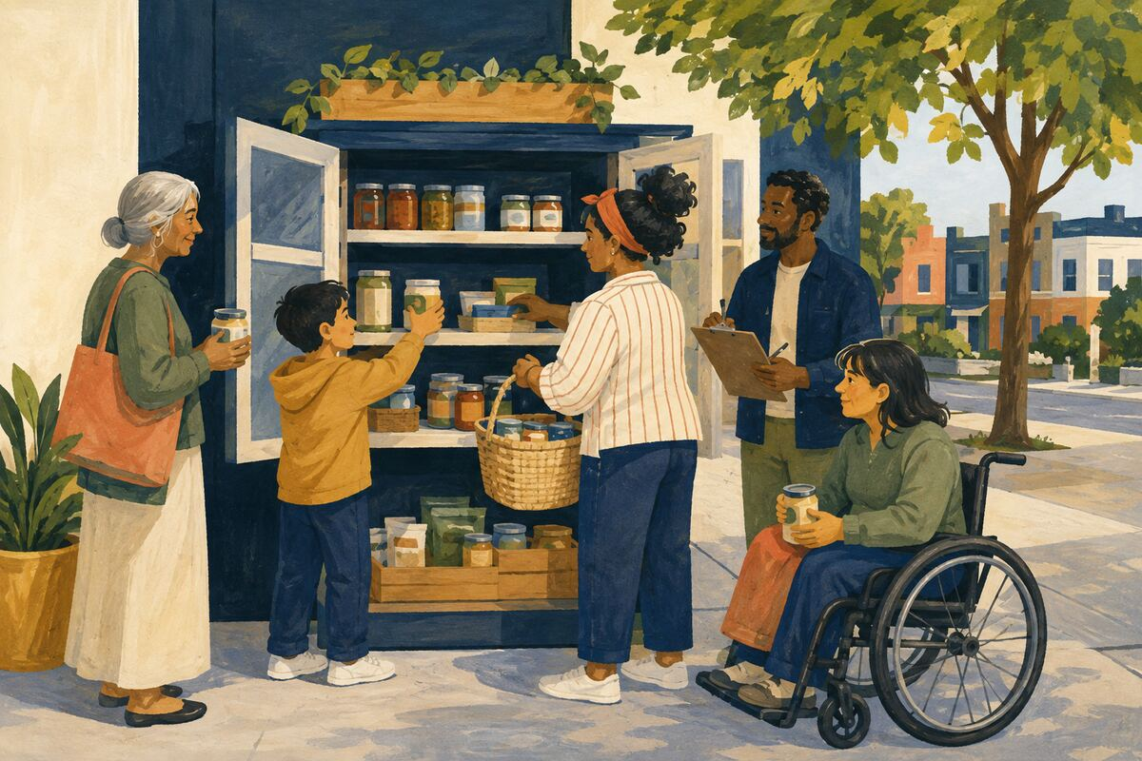
DO Use an approved, monitored location with clear rules for safe, labeled, shelf-stable items.

COMMUNITY BENEFIT Creates low-barrier access to surplus food.

EXAMPLE FOR YOUNGER GENERATIONS Shows that generosity needs systems and care.

FOOD, HUNGER, AND RESPONSIBLE SHARING
103 Share extra garden produce
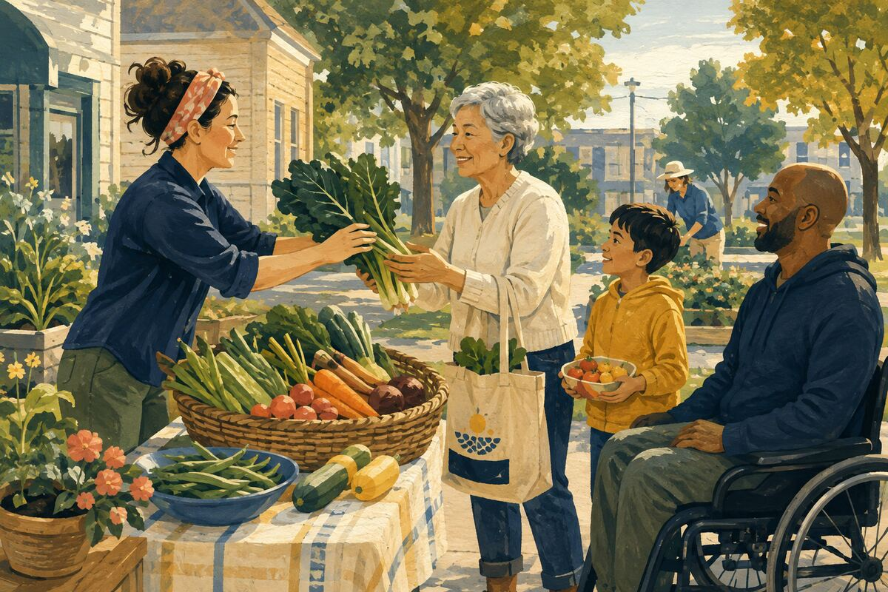
DO Offer clean, usable produce directly or through a local program instead of letting it spoil.

COMMUNITY BENEFIT Turns surplus into nutrition and connection.

EXAMPLE FOR YOUNGER GENERATIONS Teaches abundance can be shared rather than wasted.

FOOD, HUNGER, AND RESPONSIBLE SHARING
104 Bring a complete meal
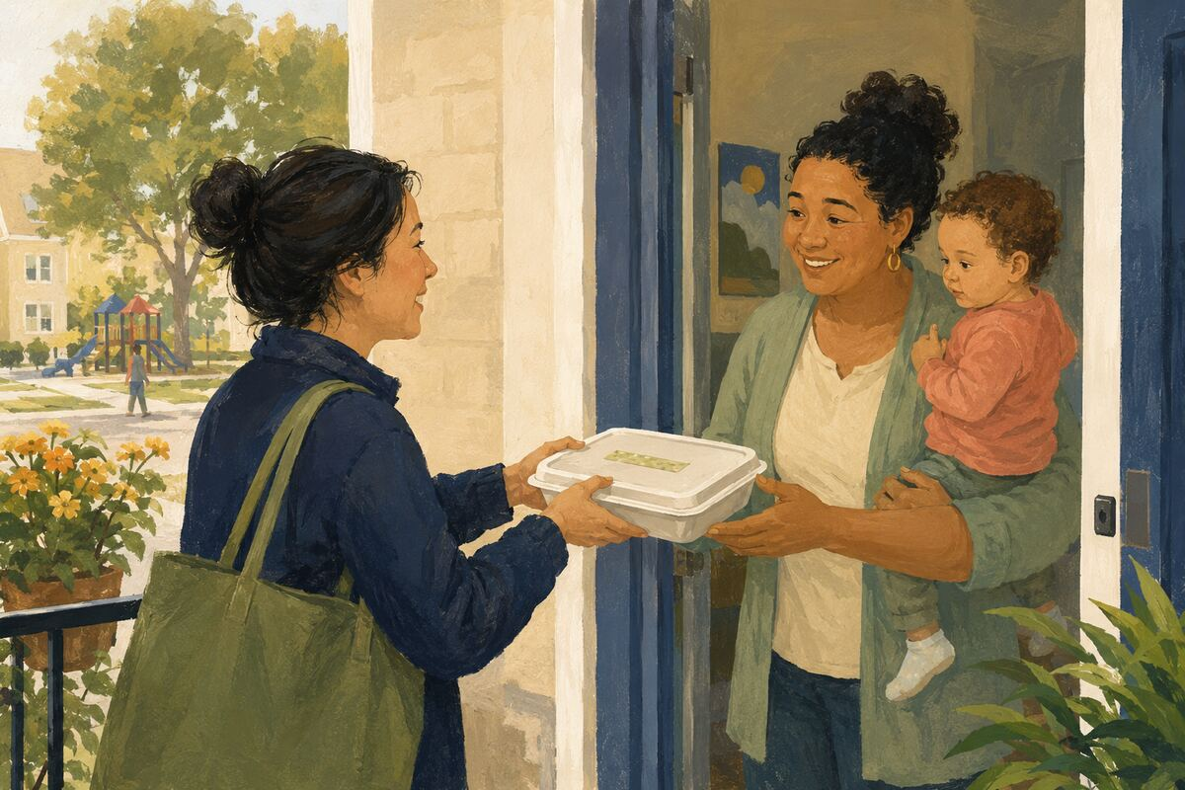
DO When supporting a household, ask about allergies and preferences, label the dish, and use a container that need not be returned.

COMMUNITY BENEFIT Provides usable help without creating new work.

EXAMPLE FOR YOUNGER GENERATIONS Models thoughtful giving from the recipient’s perspective.

FOOD, HUNGER, AND RESPONSIBLE SHARING
105 Learn to store food correctly
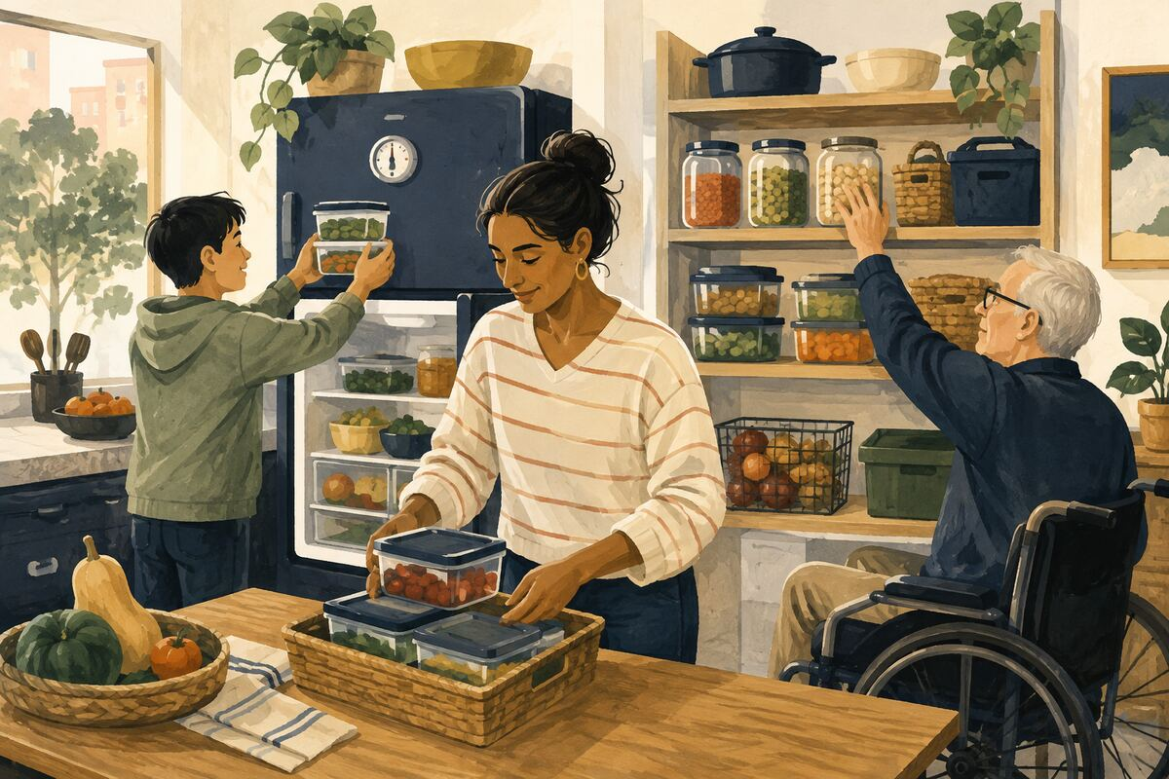
DO Use safe temperatures, labels, and first-in-first-out rotation at home or in a shared pantry.

COMMUNITY BENEFIT Reduces foodborne illness and preventable waste.

EXAMPLE FOR YOUNGER GENERATIONS Teaches that care continues after purchase.

FOOD, HUNGER, AND RESPONSIBLE SHARING
106 Pack only what will be eaten
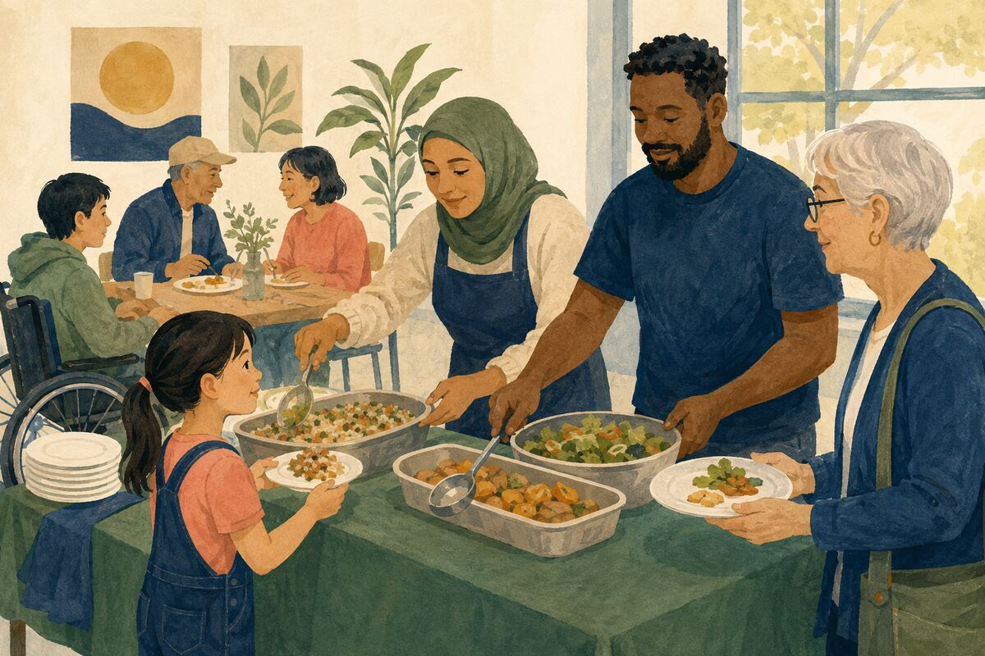
DO Serve smaller first portions and allow seconds rather than discarding untouched food.

COMMUNITY BENEFIT Reduces waste while respecting appetite differences.

EXAMPLE FOR YOUNGER GENERATIONS Models moderation without shame.

FOOD, HUNGER, AND RESPONSIBLE SHARING
107 Pay for one pending meal when a program exists
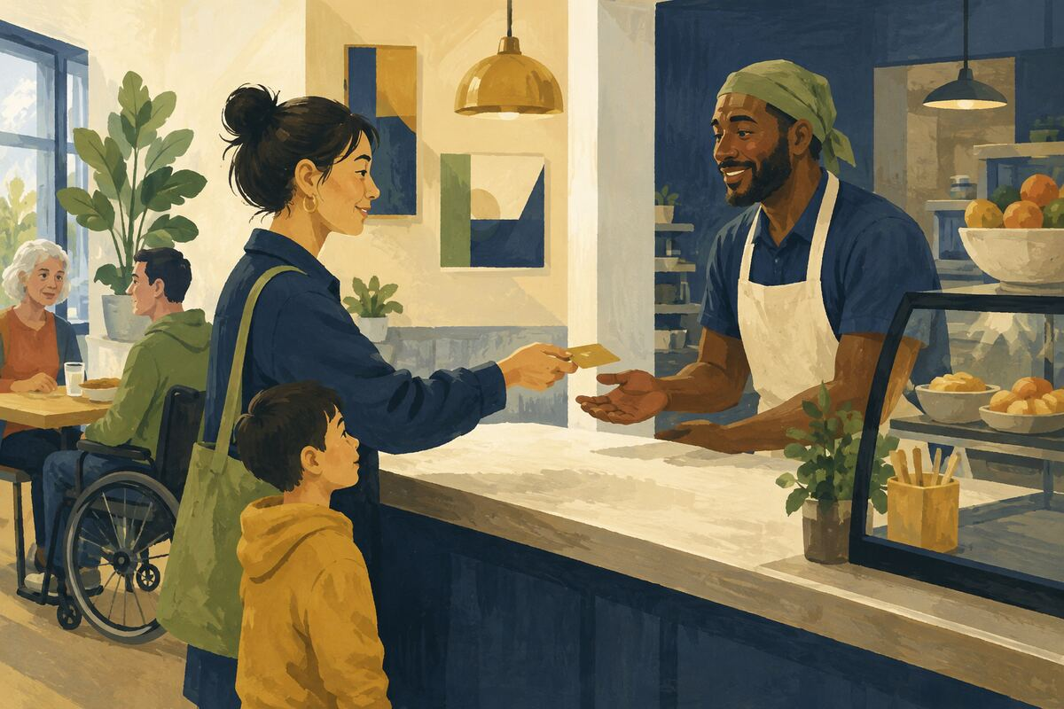
DO Contribute through a restaurant, school, or nonprofit’s established meal-support system.

COMMUNITY BENEFIT Provides food discreetly through an accountable channel.

EXAMPLE FOR YOUNGER GENERATIONS Shows generosity that protects dignity.

FOOD, HUNGER, AND RESPONSIBLE SHARING
108 Help someone apply for food assistance

DO Provide official information, a computer, translation, or transportation while protecting their privacy and choices.

COMMUNITY BENEFIT Connects eligible households with ongoing support.

EXAMPLE FOR YOUNGER GENERATIONS Teaches that navigating systems can be a form of service.

FOOD, HUNGER, AND RESPONSIBLE SHARING
109 Choose one local food producer
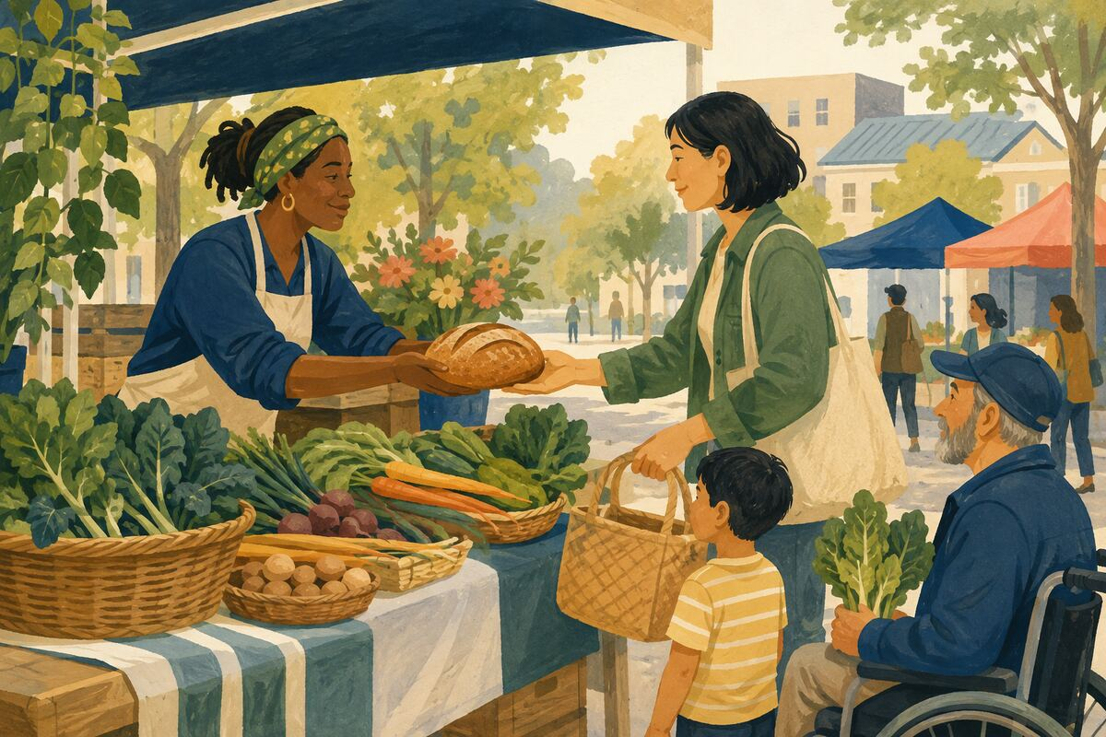
DO Buy an appropriate item from a local farm, market, bakery, or food maker when budget allows.

COMMUNITY BENEFIT Keeps more economic activity in the region and strengthens local supply relationships.

EXAMPLE FOR YOUNGER GENERATIONS Shows how purchasing decisions affect community livelihoods.

FOOD, HUNGER, AND RESPONSIBLE SHARING
110 Clean the shared kitchen

DO Wipe surfaces, wash your dishes, label stored food, and remove expired items according to the agreed rules.

COMMUNITY BENEFIT Protects health and prevents resentment in shared spaces.

EXAMPLE FOR YOUNGER GENERATIONS Teaches that everyone participates in maintenance.

LOCAL BUSINESSES AND SERVICE WORKERS
111 Keep or cancel appointments early

DO Arrive on time or give enough notice for the business to fill the opening.

COMMUNITY BENEFIT Prevents avoidable lost income and wasted preparation.

EXAMPLE FOR YOUNGER GENERATIONS Shows that another person’s time has value.

LOCAL BUSINESSES AND SERVICE WORKERS
112 Pay promptly
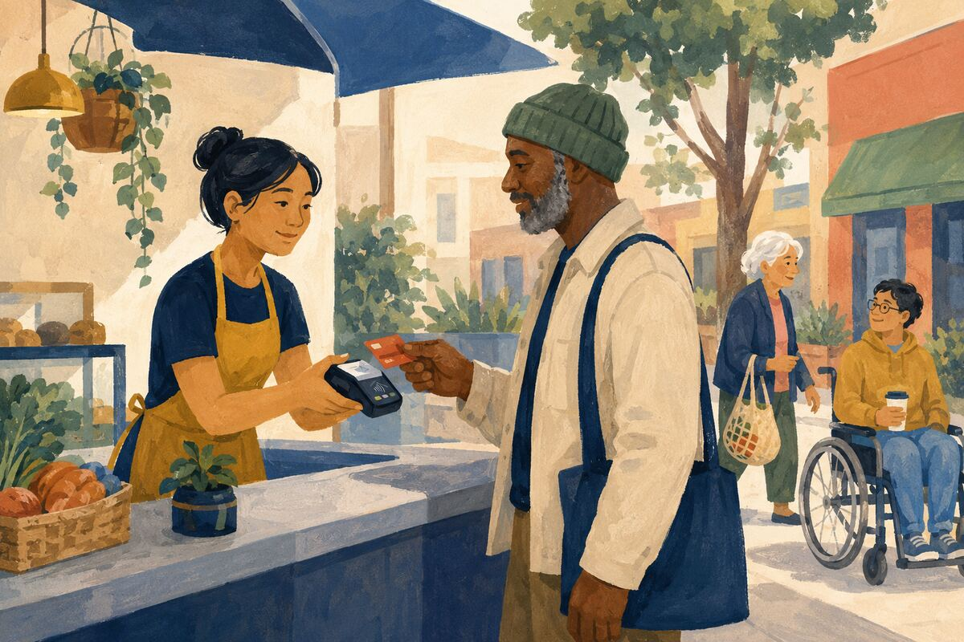
DO Pay invoices, reimbursements, tips, and agreed charges by the promised date.

COMMUNITY BENEFIT Improves cash flow for workers and small businesses.

EXAMPLE FOR YOUNGER GENERATIONS Teaches that receiving service creates an obligation to follow through.

LOCAL BUSINESSES AND SERVICE WORKERS
113 Leave a useful review

DO Describe what was purchased, what went well, and any relevant limitation without exaggeration or personal attacks.

COMMUNITY BENEFIT Helps future customers make better choices and rewards reliable work.

EXAMPLE FOR YOUNGER GENERATIONS Models fair public feedback.

LOCAL BUSINESSES AND SERVICE WORKERS
114 Give the business a chance to correct a minor problem

DO State the issue privately, show the receipt or facts, and ask for a reasonable solution before escalating publicly.

COMMUNITY BENEFIT Allows mistakes to be repaired without disproportionate reputational damage.

EXAMPLE FOR YOUNGER GENERATIONS Teaches fairness and direct communication.

LOCAL BUSINESSES AND SERVICE WORKERS
115 Recommend a reliable provider
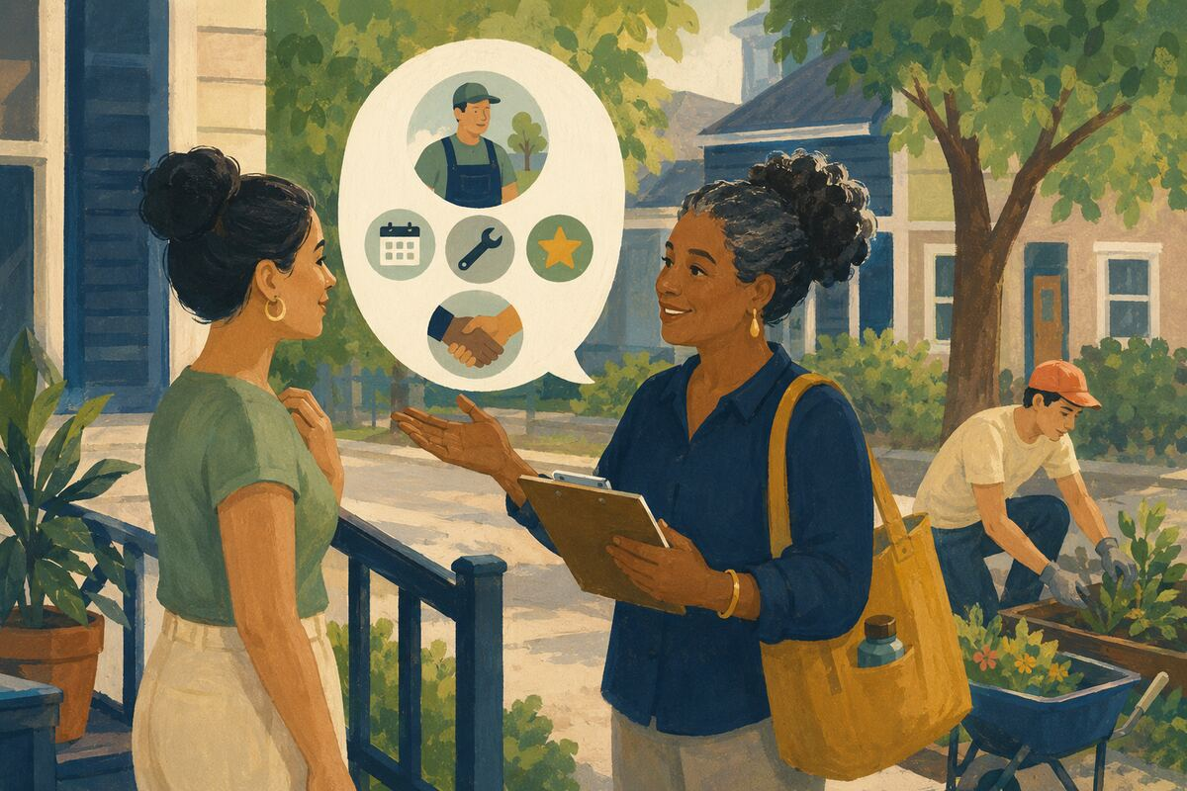
DO Share the provider’s accurate contact information and the work you personally observed; disclose any relationship or incentive.

COMMUNITY BENEFIT Helps trustworthy local businesses find suitable customers.

EXAMPLE FOR YOUNGER GENERATIONS Models honest advocacy.

LOCAL BUSINESSES AND SERVICE WORKERS
116 Treat frontline staff with dignity
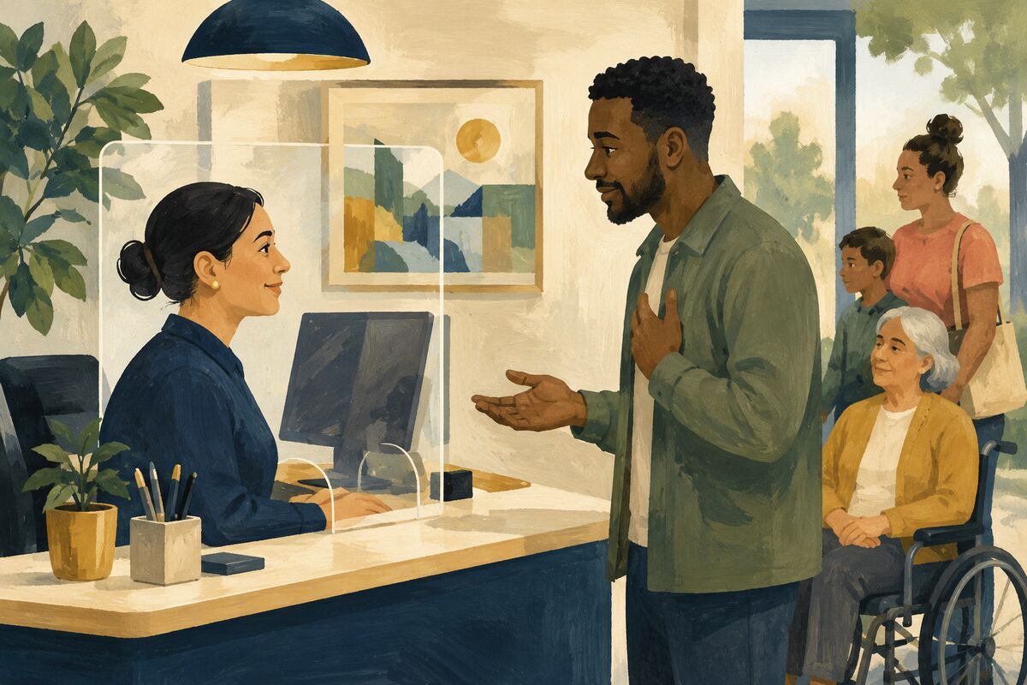
DO Stay calm, avoid insults, and separate the employee from a policy or system they may not control.

COMMUNITY BENEFIT Reduces workplace stress and makes problem resolution more likely.

EXAMPLE FOR YOUNGER GENERATIONS Shows how character appears when something goes wrong.

LOCAL BUSINESSES AND SERVICE WORKERS
117 Give complete order information
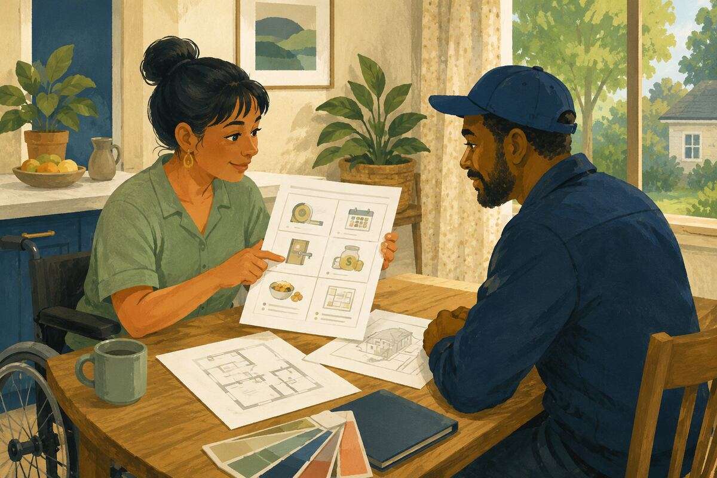
DO Provide measurements, dates, access details, budget limits, allergies, or specifications before work begins.

COMMUNITY BENEFIT Reduces rework, delays, and misunderstandings.

EXAMPLE FOR YOUNGER GENERATIONS Teaches that customers share responsibility for successful outcomes.

LOCAL BUSINESSES AND SERVICE WORKERS
118 Buy gift cards with a plan
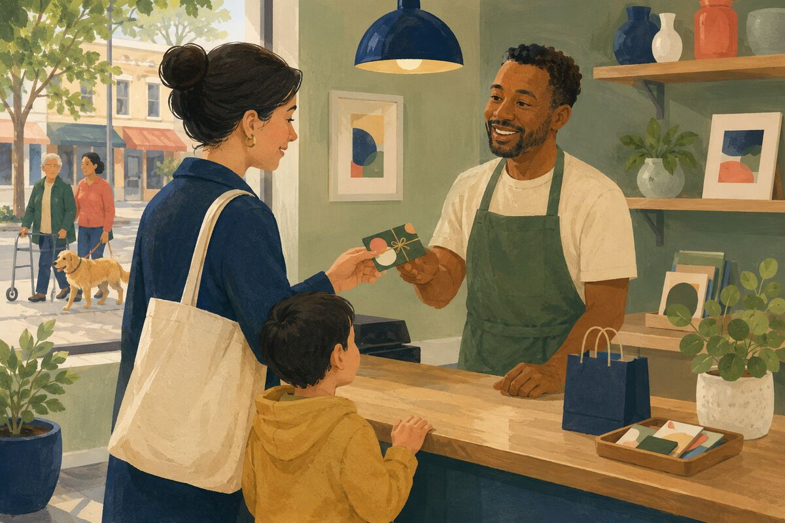
DO Purchase from a stable local business only when you or the recipient is likely to use it.

COMMUNITY BENEFIT Provides near-term revenue without creating unused value.

EXAMPLE FOR YOUNGER GENERATIONS Shows thoughtful support rather than symbolic spending.

LOCAL BUSINESSES AND SERVICE WORKERS
119 Respect closing time
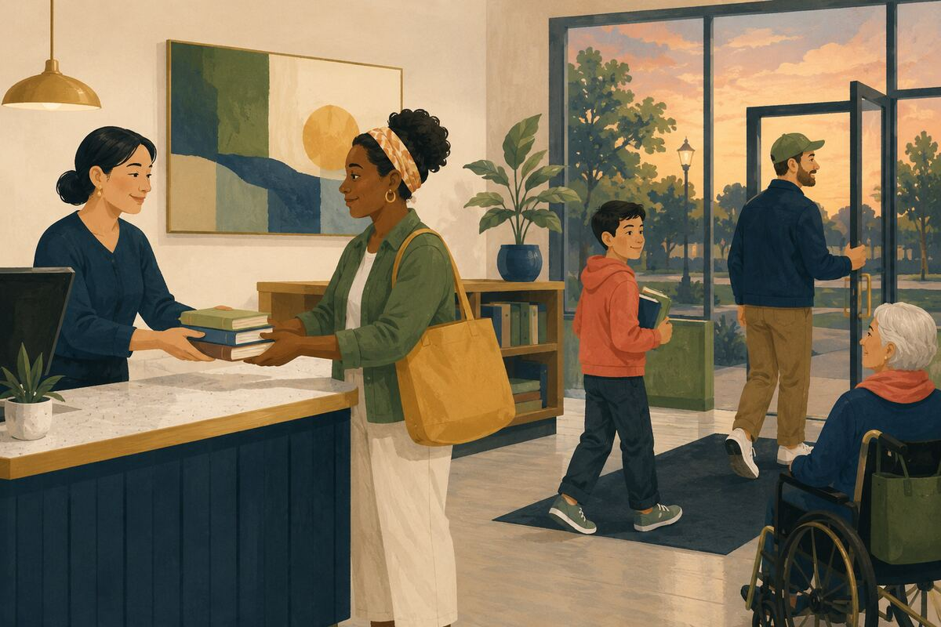
DO Finish purchases, pickups, and questions early enough for staff to complete closing duties on schedule.

COMMUNITY BENEFIT Reduces unpaid or extended labor at the end of a shift.

EXAMPLE FOR YOUNGER GENERATIONS Teaches that service workers have lives beyond the counter.

LOCAL BUSINESSES AND SERVICE WORKERS
120 Praise excellent work to the manager
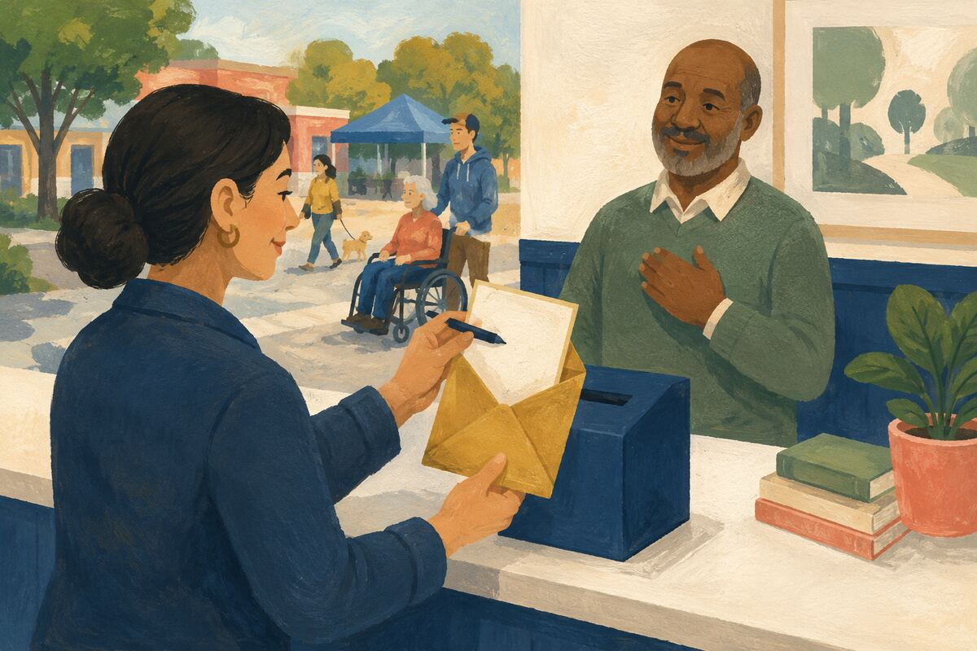
DO Send a short note naming the employee and the specific behavior that helped.

COMMUNITY BENEFIT Creates evidence that can support recognition, coaching, or advancement.

EXAMPLE FOR YOUNGER GENERATIONS Shows younger people how to use their voice to reward good work.

TRUTHFUL INFORMATION AND DIGITAL CITIZENSHIP
121 Open the source before sharing

DO Read beyond the headline and confirm that the source actually supports the claim.

COMMUNITY BENEFIT Reduces the spread of misleading summaries.

EXAMPLE FOR YOUNGER GENERATIONS Teaches that sharing information carries responsibility.

TRUTHFUL INFORMATION AND DIGITAL CITIZENSHIP
122 Check the date and location
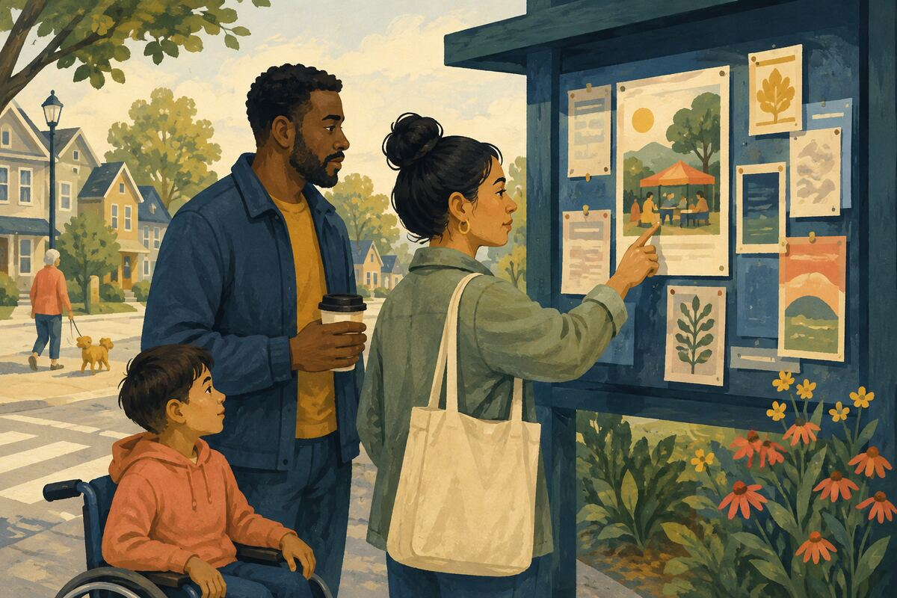
DO Confirm that an image, event, warning, or offer is current and applies to the place being discussed.

COMMUNITY BENEFIT Prevents old or unrelated information from causing new confusion.

EXAMPLE FOR YOUNGER GENERATIONS Models context as part of truth.

TRUTHFUL INFORMATION AND DIGITAL CITIZENSHIP
123 Separate fact from inference
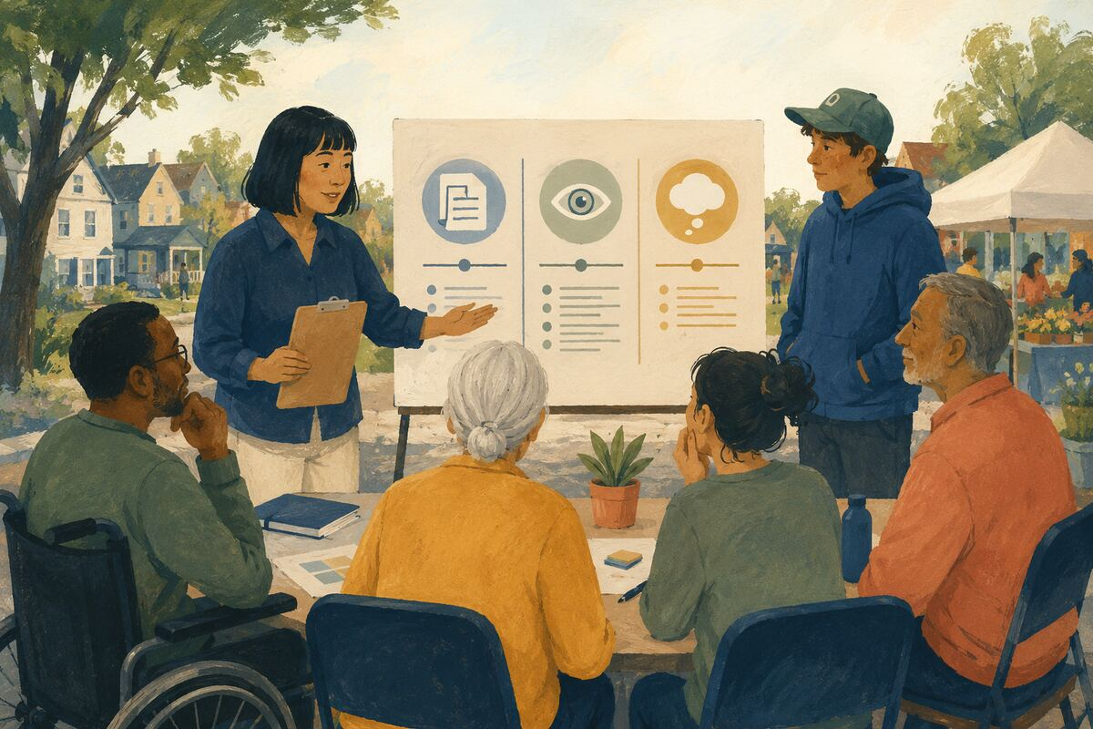
DO Use phrases such as “the document says,” “I observed,” and “I suspect” accurately.

COMMUNITY BENEFIT Helps others judge evidence without confusing opinion for proof.

EXAMPLE FOR YOUNGER GENERATIONS Teaches intellectual honesty.

TRUTHFUL INFORMATION AND DIGITAL CITIZENSHIP
124 Correct without humiliating
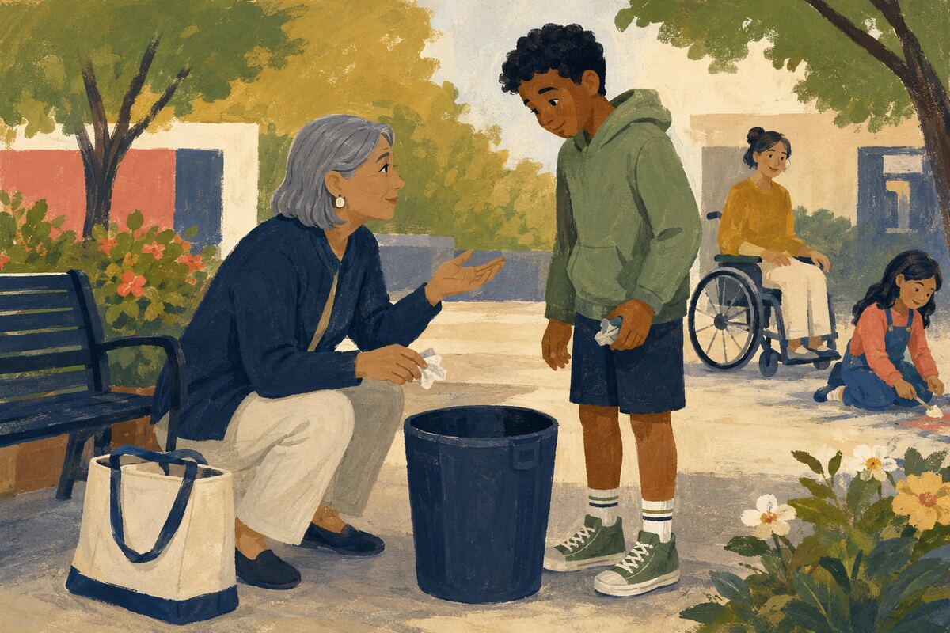
DO Provide the accurate source and a short explanation; avoid ridicule, pile-ons, or attacking the person.

COMMUNITY BENEFIT Makes correction more likely to be accepted and repeated.

EXAMPLE FOR YOUNGER GENERATIONS Shows that truth and kindness can work together.

TRUTHFUL INFORMATION AND DIGITAL CITIZENSHIP
125 Do not amplify harmful content unnecessarily
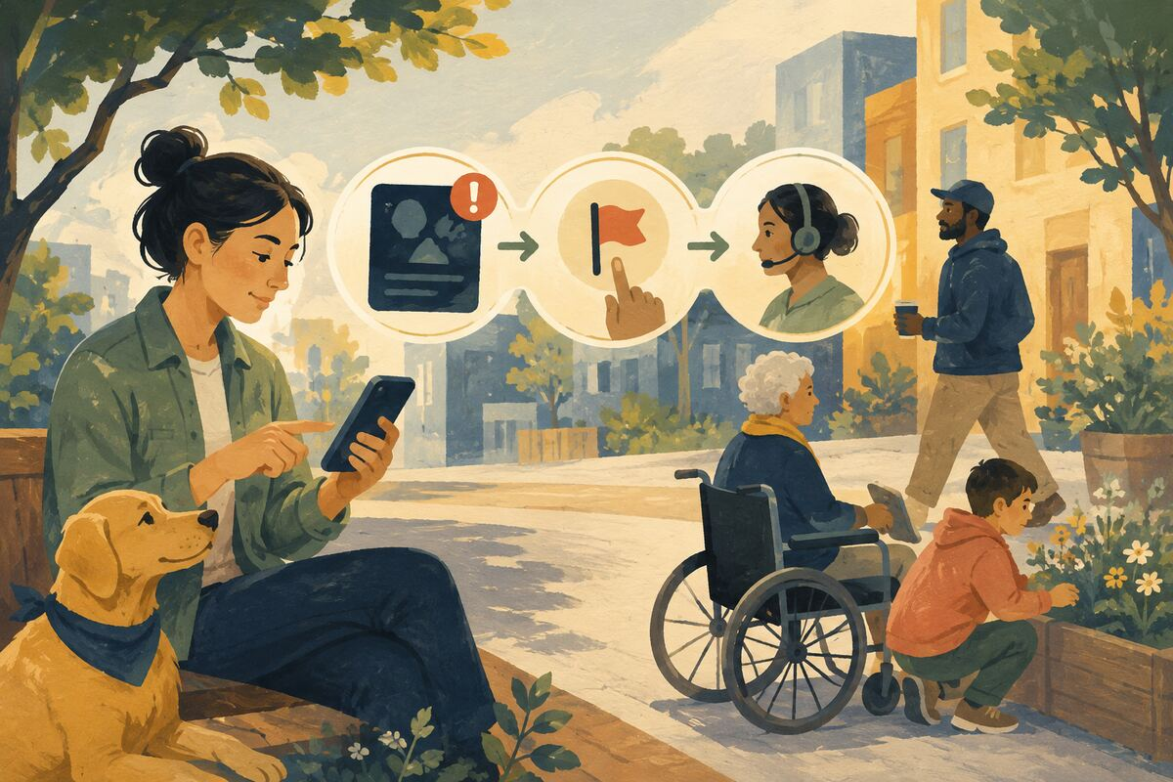
DO Report scams, threats, or abuse through appropriate channels without reposting identifying or graphic material widely.

COMMUNITY BENEFIT Limits additional harm and attention for bad actors.

EXAMPLE FOR YOUNGER GENERATIONS Teaches that awareness does not require amplification.

TRUTHFUL INFORMATION AND DIGITAL CITIZENSHIP
126 Protect another person’s private information
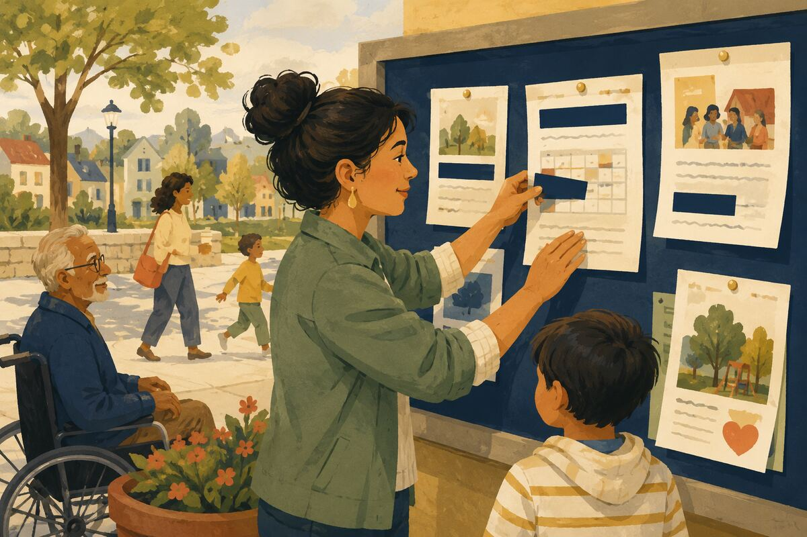
DO Remove addresses, account numbers, school schedules, medical details, and faces before posting documents or images.

COMMUNITY BENEFIT Reduces risks of fraud, harassment, and unwanted exposure.

EXAMPLE FOR YOUNGER GENERATIONS Models consent and digital restraint.

TRUTHFUL INFORMATION AND DIGITAL CITIZENSHIP
127 Enable account protection
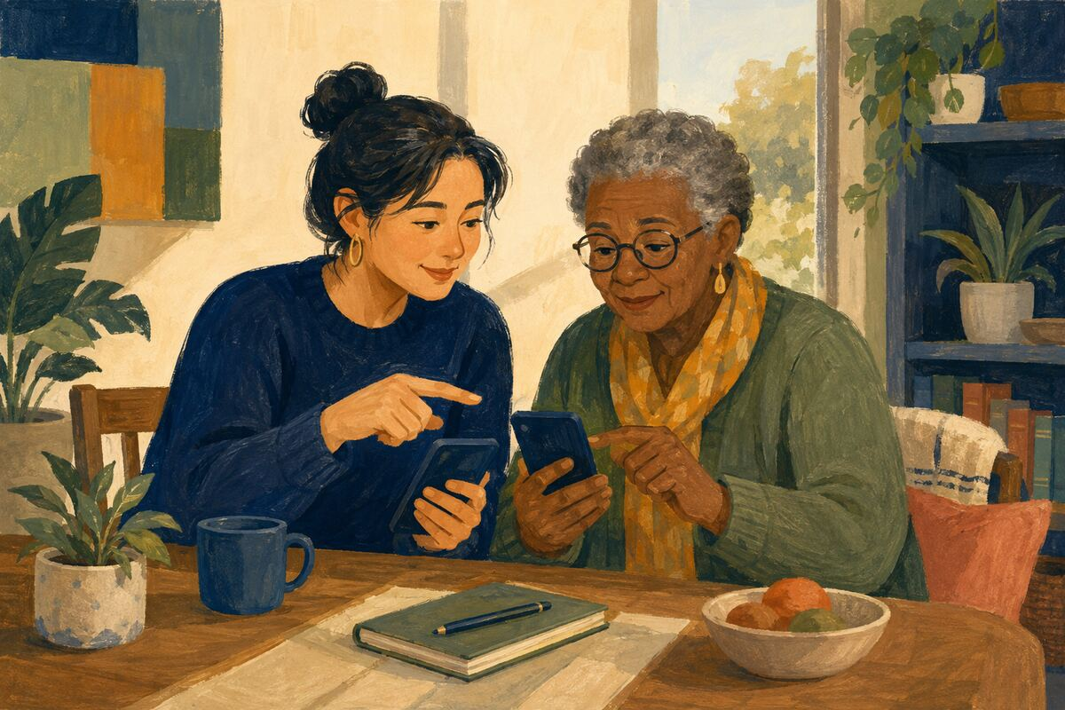
DO Turn on multifactor authentication and unique passwords for important accounts, and help a trusted person do the same.

COMMUNITY BENEFIT Reduces preventable account theft and impersonation.

EXAMPLE FOR YOUNGER GENERATIONS Shows that digital safety is routine maintenance.

TRUTHFUL INFORMATION AND DIGITAL CITIZENSHIP
128 Report a scam to the right place
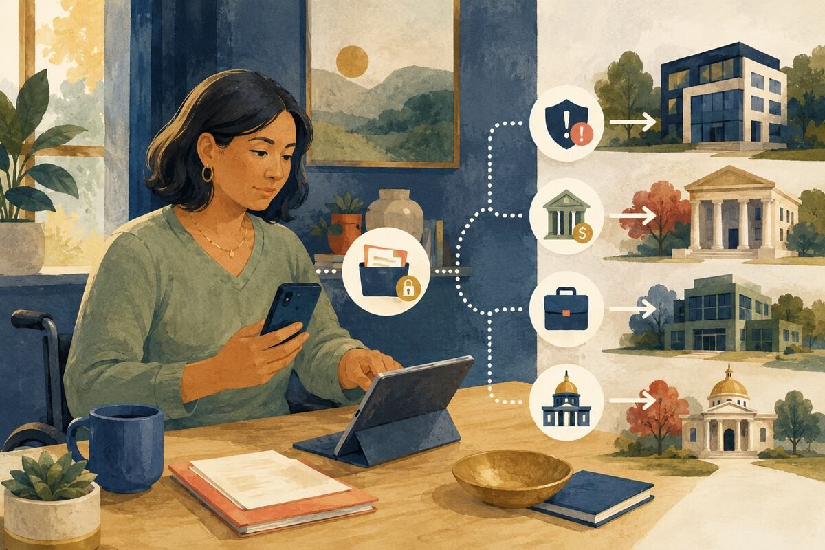
DO Save relevant evidence and notify the platform, financial institution, employer, or public agency without engaging the scammer further.

COMMUNITY BENEFIT Helps contain fraud and creates information that may protect others.

EXAMPLE FOR YOUNGER GENERATIONS Teaches calm response instead of embarrassment or secrecy.

TRUTHFUL INFORMATION AND DIGITAL CITIZENSHIP
129 Credit the original creator
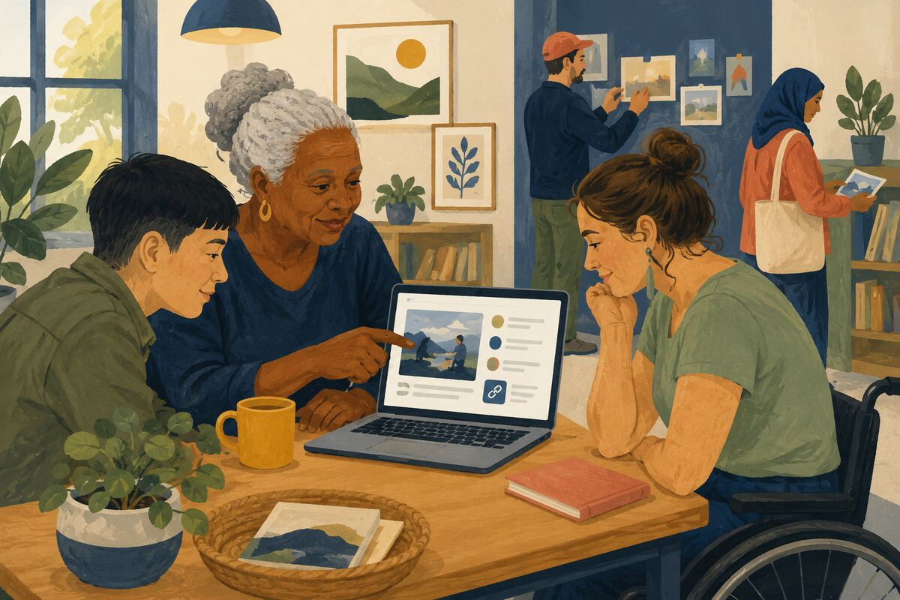
DO Name and link the photographer, writer, researcher, artist, or organization when permission allows sharing.

COMMUNITY BENEFIT Rewards creative and intellectual work and helps others find the source.

EXAMPLE FOR YOUNGER GENERATIONS Teaches that online material did not appear from nowhere.

TRUTHFUL INFORMATION AND DIGITAL CITIZENSHIP
130 Put the phone away while driving
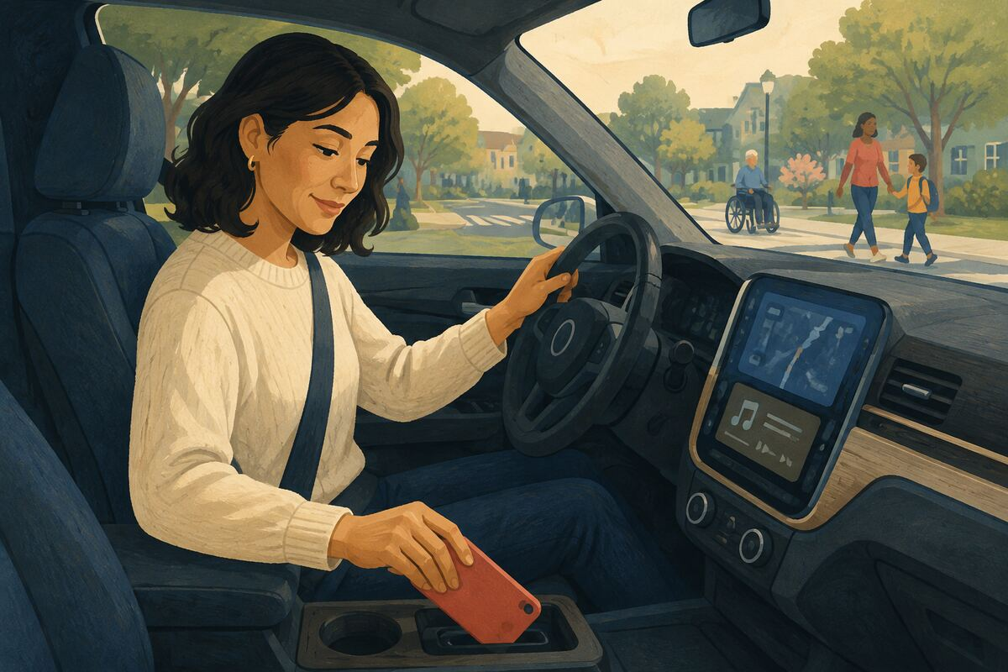
DO Set navigation and audio before moving, use legal hands-free tools, or pull over safely.

COMMUNITY BENEFIT Prevents distraction-related crashes and near misses.

EXAMPLE FOR YOUNGER GENERATIONS Gives young passengers a visible model of safe technology use.

WORKPLACES AND ORGANIZATIONS
131 Start meetings with a decision
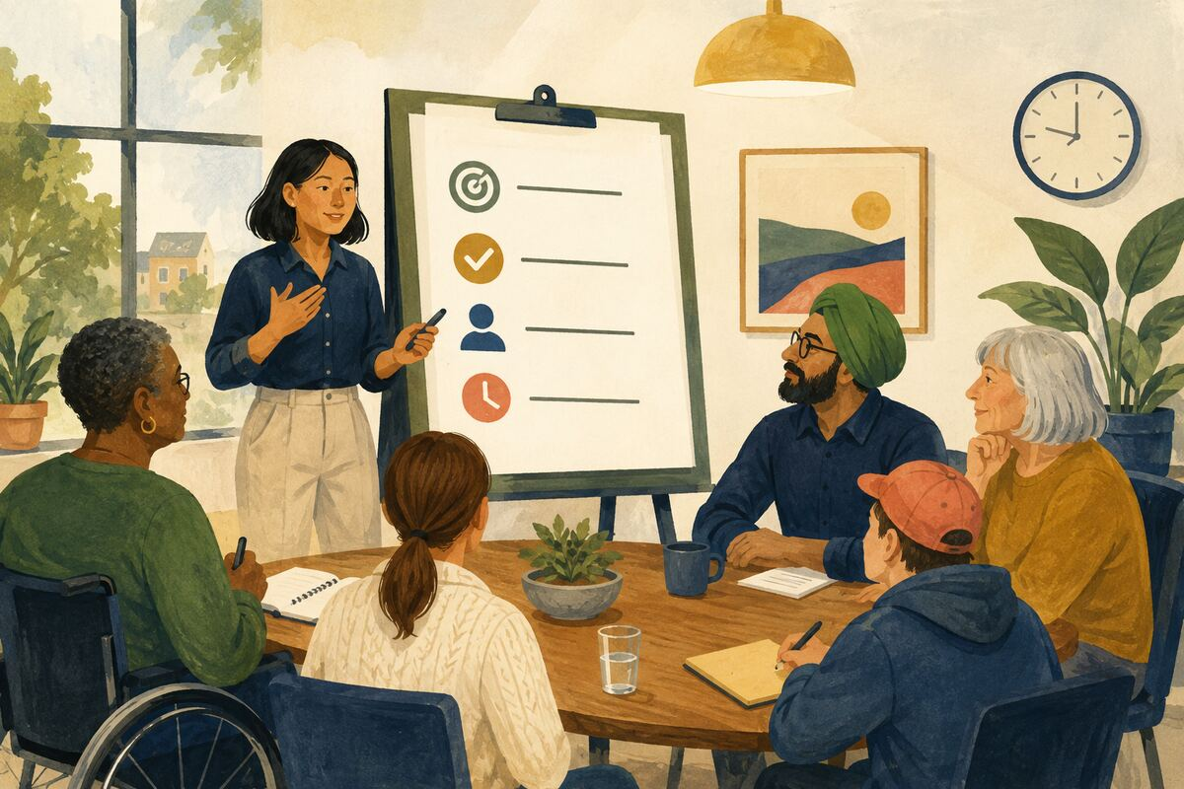
DO State the purpose, decision needed, owner, and ending time before discussion begins.

COMMUNITY BENEFIT Reduces wasted time and makes participation more focused.

EXAMPLE FOR YOUNGER GENERATIONS Shows younger workers that structure can respect everyone’s time.

WORKPLACES AND ORGANIZATIONS
132 End with owners and dates
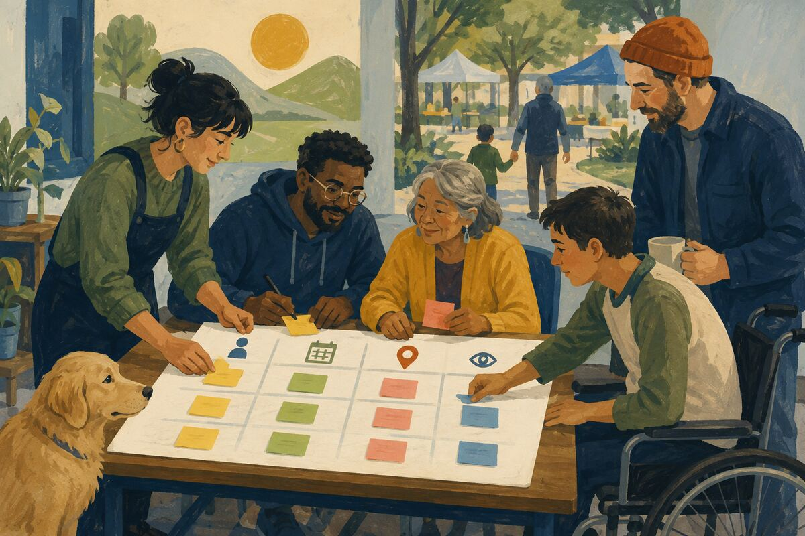
DO Record who will do what, by when, and where progress will be visible.

COMMUNITY BENEFIT Turns conversation into accountable action.

EXAMPLE FOR YOUNGER GENERATIONS Models follow-through as part of teamwork.

WORKPLACES AND ORGANIZATIONS
133 Document one recurring task
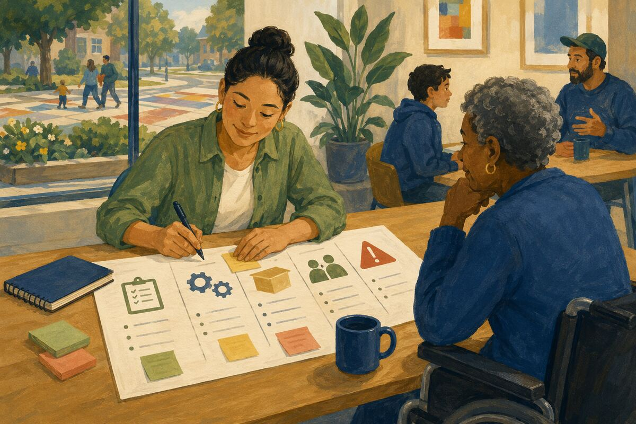
DO Write the steps, inputs, outputs, contacts, and common mistakes so another person can perform it.

COMMUNITY BENEFIT Reduces dependence on one employee and improves continuity.

EXAMPLE FOR YOUNGER GENERATIONS Teaches that knowledge should strengthen the team.

WORKPLACES AND ORGANIZATIONS
134 Name a mistake early
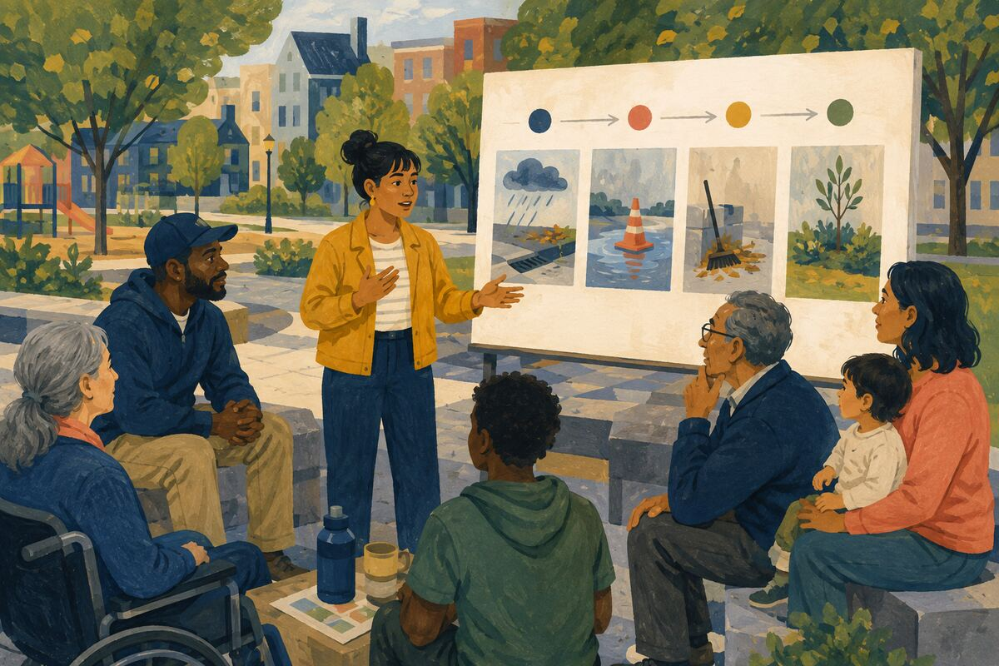
DO Explain what happened, current impact, immediate containment, and next corrective step.

COMMUNITY BENEFIT Limits damage and allows help to arrive sooner.

EXAMPLE FOR YOUNGER GENERATIONS Shows that honesty is more valuable than hiding imperfection.

WORKPLACES AND ORGANIZATIONS
135 Give credit by name
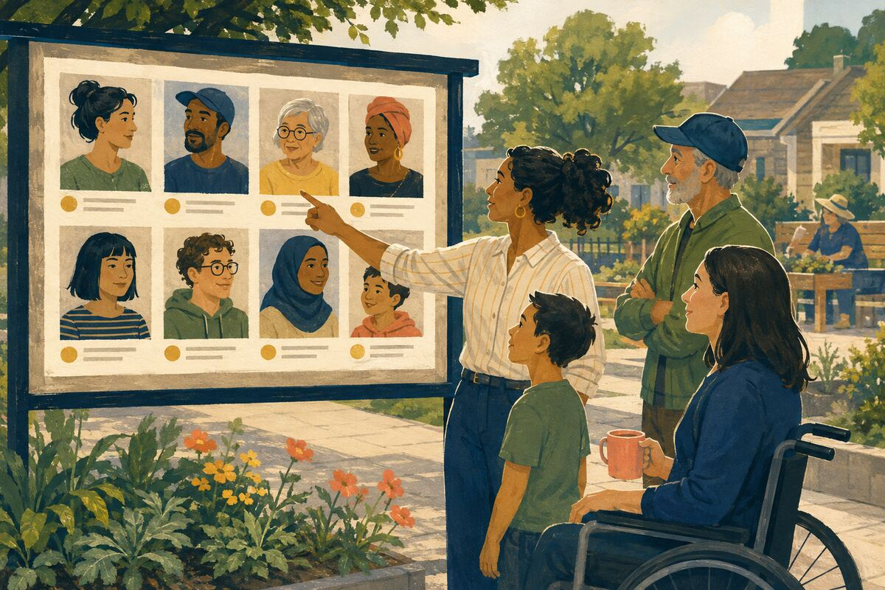
DO Identify the people who researched, built, reviewed, or supported the work.

COMMUNITY BENEFIT Rewards contribution and improves trust across roles.

EXAMPLE FOR YOUNGER GENERATIONS Models generosity in professional recognition.

WORKPLACES AND ORGANIZATIONS
136 Train the next person completely
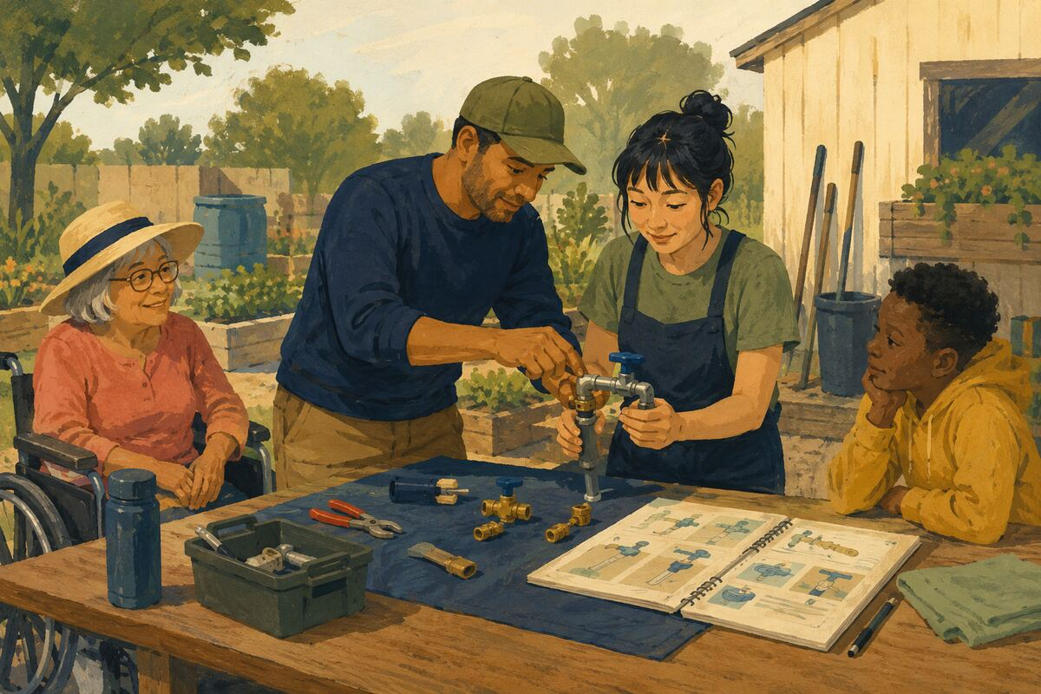
DO Share context, demonstrate the task, observe practice, and leave usable reference material.

COMMUNITY BENEFIT Raises team capability and reduces repeated confusion.

EXAMPLE FOR YOUNGER GENERATIONS Shows that expertise creates value when passed on.

WORKPLACES AND ORGANIZATIONS
137 Reduce one unnecessary approval
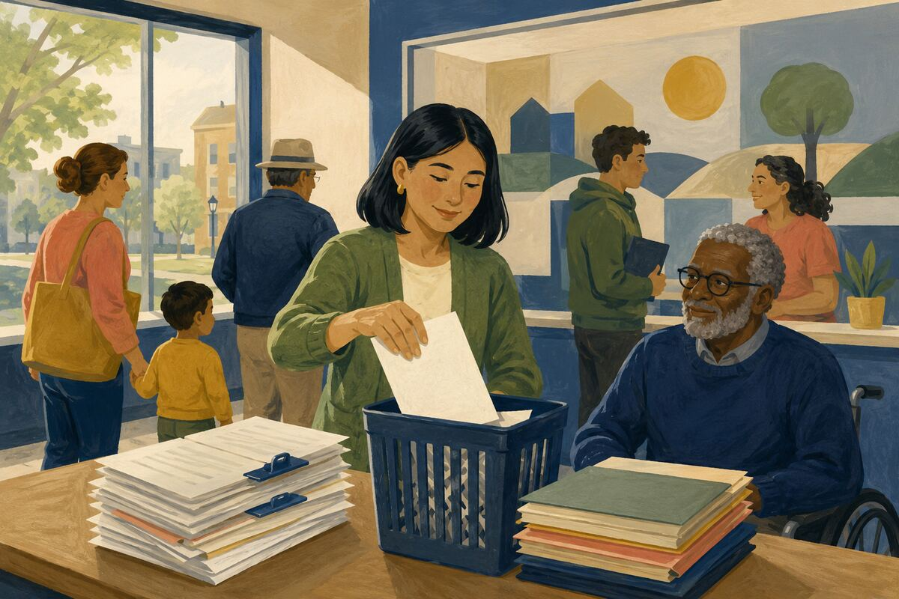
DO With proper authority, remove a duplicate review or clarify when approval is not required.

COMMUNITY BENEFIT Shortens cycle time while preserving meaningful controls.

EXAMPLE FOR YOUNGER GENERATIONS Teaches younger workers to improve systems, not merely endure them.

WORKPLACES AND ORGANIZATIONS
138 Protect focused work time

DO Bundle nonurgent questions, use agendas, and avoid creating false urgency through late planning.

COMMUNITY BENEFIT Improves quality and reduces burnout.

EXAMPLE FOR YOUNGER GENERATIONS Models respect for attention as a limited resource.

WORKPLACES AND ORGANIZATIONS
139 Make instructions testable
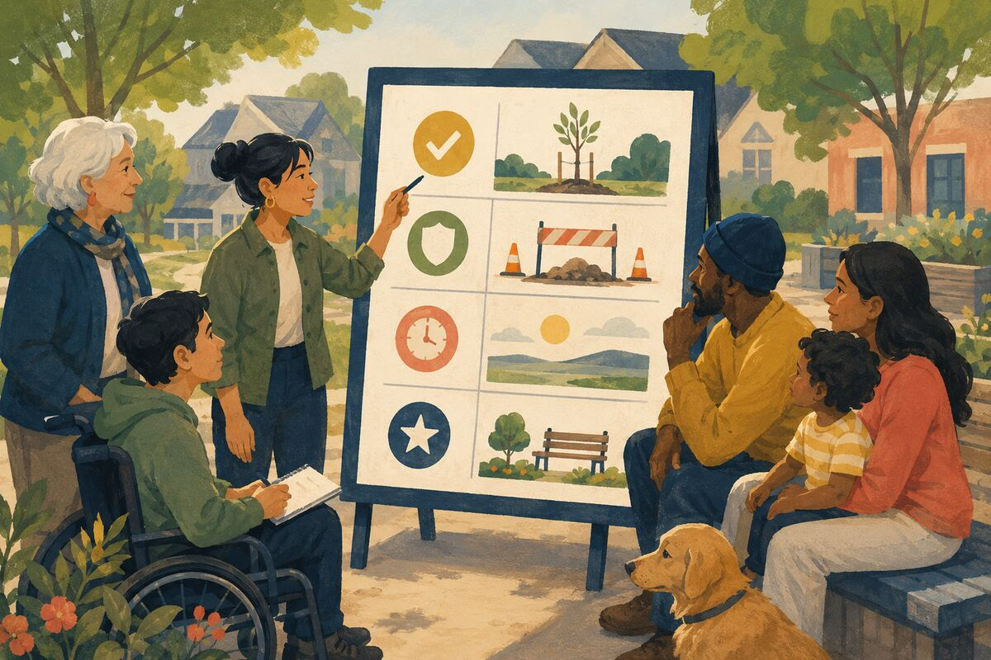
DO State the expected result, constraints, deadline, and example of completion.

COMMUNITY BENEFIT Reduces interpretation errors and rework.

EXAMPLE FOR YOUNGER GENERATIONS Teaches that clear leadership makes success easier.

WORKPLACES AND ORGANIZATIONS
140 Leave a clean handoff
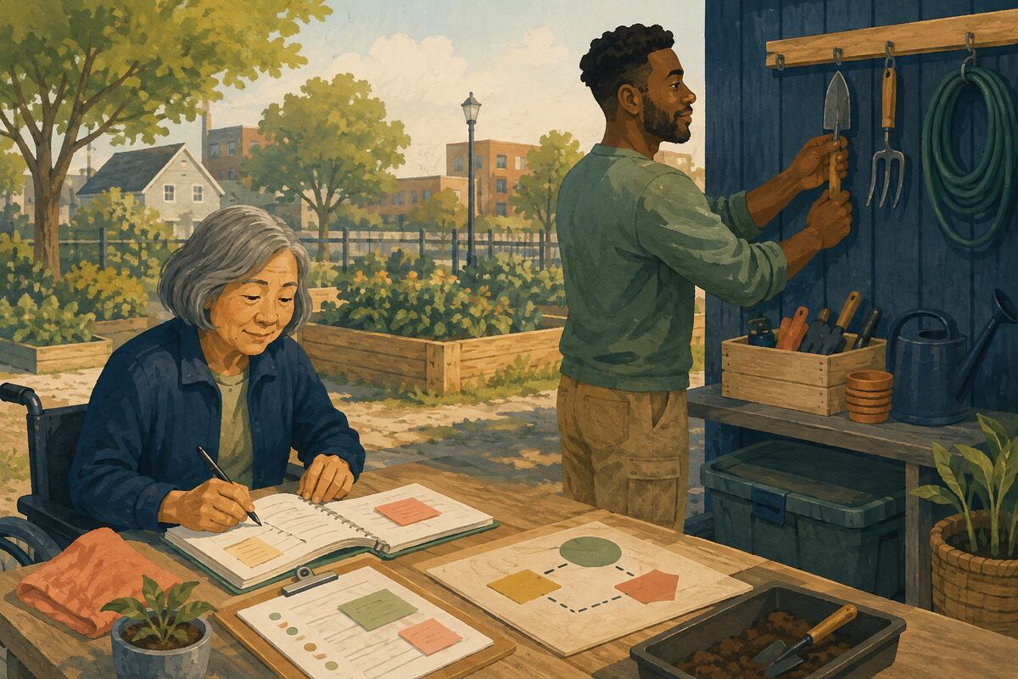
DO Update the record, label unfinished work, return tools, and identify the next decision before stepping away.

COMMUNITY BENEFIT Prevents dropped tasks and duplicate investigation.

EXAMPLE FOR YOUNGER GENERATIONS Shows responsibility beyond one’s own portion of the work.

CIVIC PARTICIPATION AND PUBLIC INSTITUTIONS
141 Register and verify your voting information
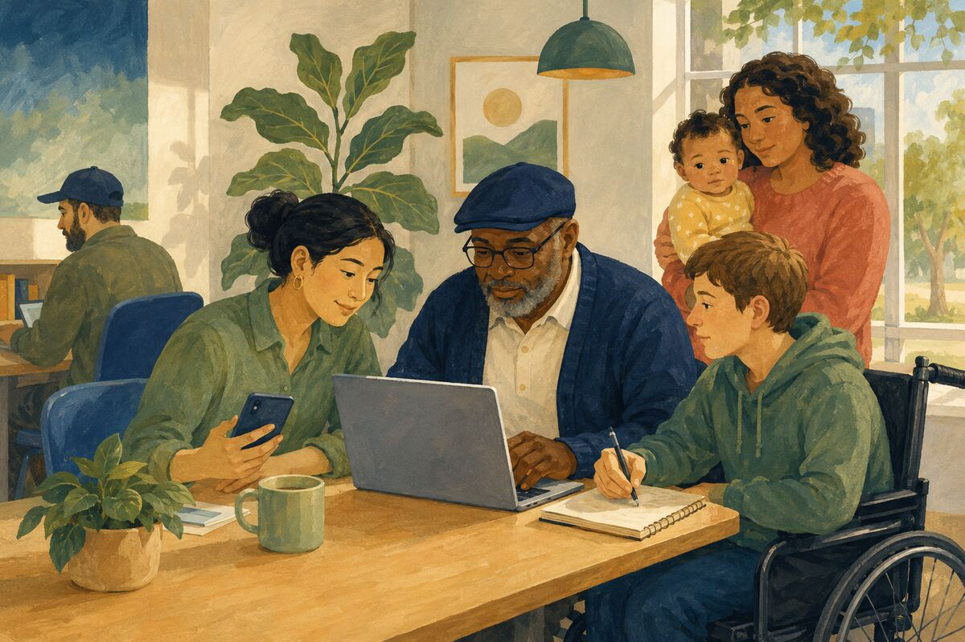
DO Use the official election source to confirm registration, identification rules, dates, and polling or ballot instructions.

COMMUNITY BENEFIT Reduces preventable barriers to lawful participation.

EXAMPLE FOR YOUNGER GENERATIONS Shows younger generations that citizenship includes preparation.

CIVIC PARTICIPATION AND PUBLIC INSTITUTIONS
142 Read the agenda before a public meeting
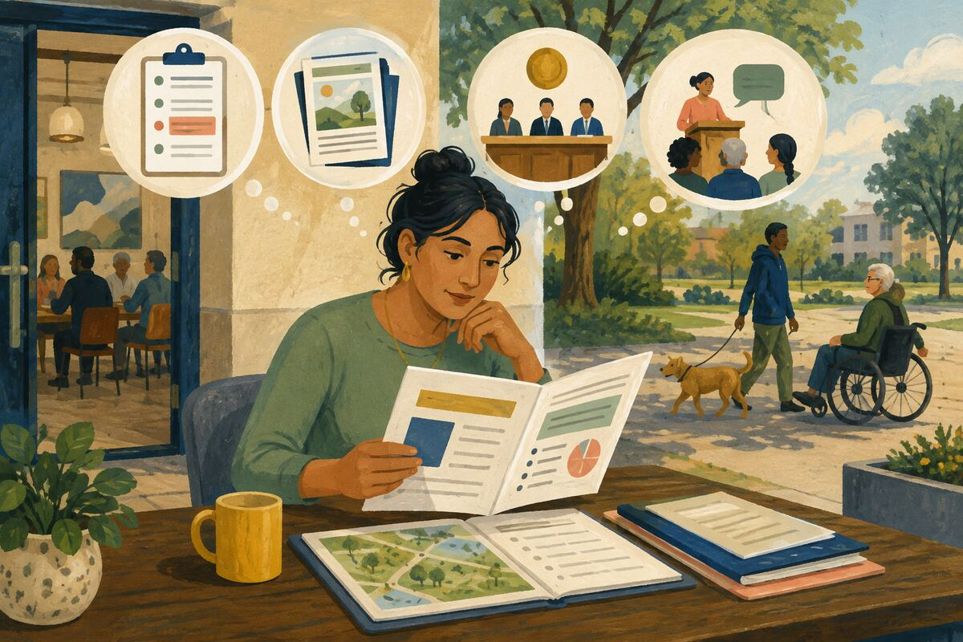
DO Identify the exact item, supporting documents, decision authority, and comment rules.

COMMUNITY BENEFIT Produces more relevant public input and better use of meeting time.

EXAMPLE FOR YOUNGER GENERATIONS Models informed participation rather than reaction.

CIVIC PARTICIPATION AND PUBLIC INSTITUTIONS
143 Make one specific public comment
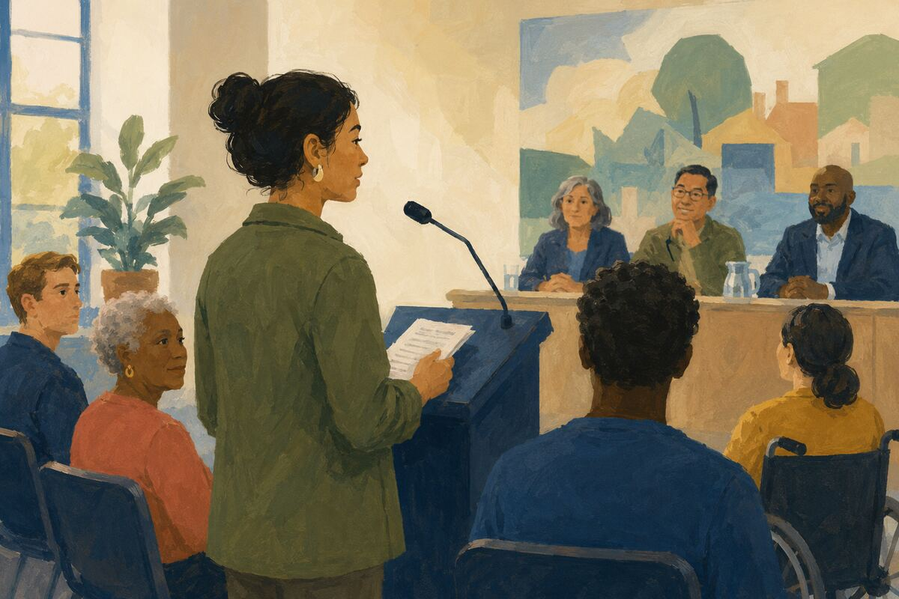
DO State your connection to the issue, one factual concern, and one requested action within the time limit.

COMMUNITY BENEFIT Gives decision-makers usable community input.

EXAMPLE FOR YOUNGER GENERATIONS Shows that civic voice can be concise and constructive.

CIVIC PARTICIPATION AND PUBLIC INSTITUTIONS
144 Report a public defect precisely
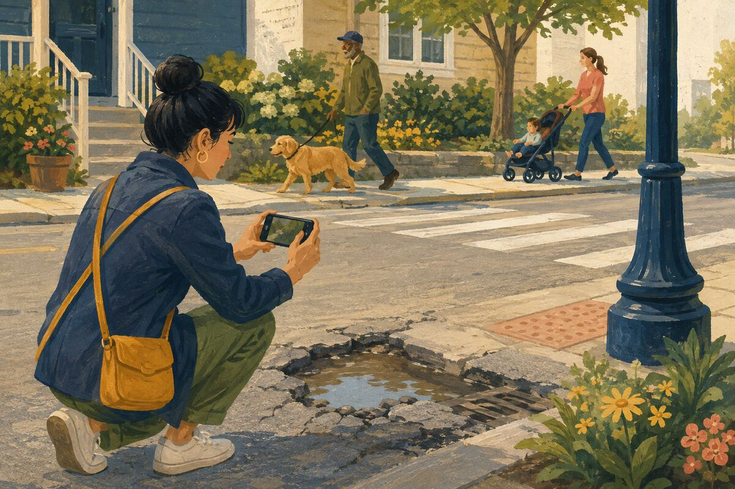
DO Provide the exact location, time, photograph when safe, and service category for potholes, leaks, signs, or other issues.

COMMUNITY BENEFIT Helps public staff route and resolve work more efficiently.

EXAMPLE FOR YOUNGER GENERATIONS Teaches that government works better with actionable information.

CIVIC PARTICIPATION AND PUBLIC INSTITUTIONS
145 Thank a public employee for competent help
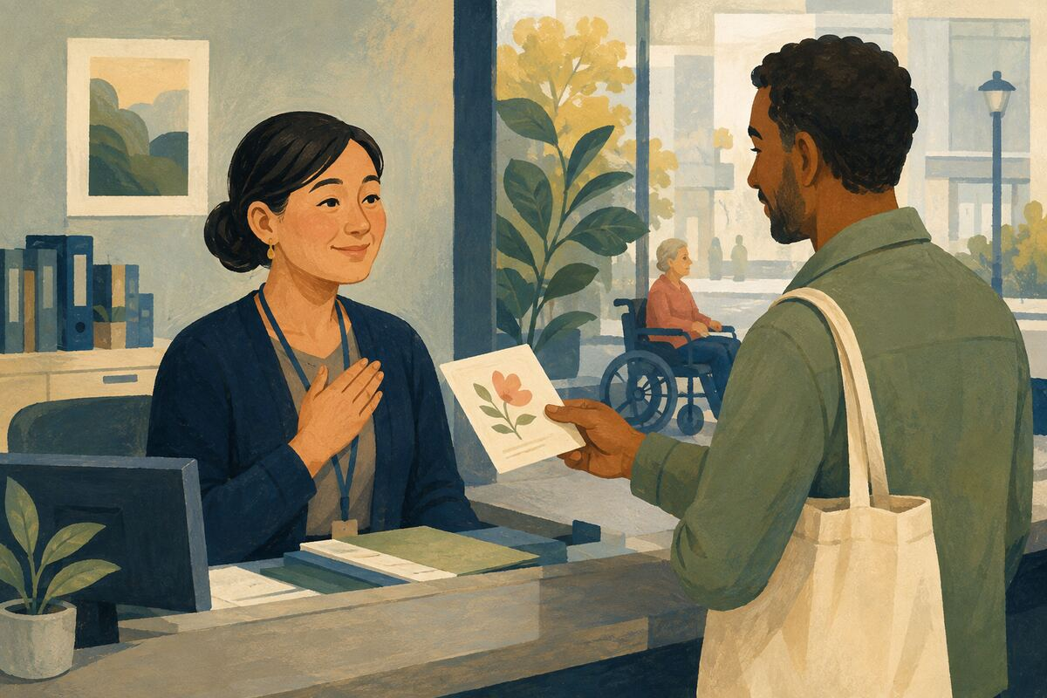
DO Send a brief note naming the employee and what they resolved.

COMMUNITY BENEFIT Creates a record of good service and reinforces effective behavior.

EXAMPLE FOR YOUNGER GENERATIONS Shows that accountability includes recognizing success.

CIVIC PARTICIPATION AND PUBLIC INSTITUTIONS
146 Request a public record responsibly

DO Ask for a specific record, date range, format, and subject rather than an unnecessarily broad search.

COMMUNITY BENEFIT Supports transparency while reducing avoidable retrieval work.

EXAMPLE FOR YOUNGER GENERATIONS Teaches that rights are strongest when used thoughtfully.

CIVIC PARTICIPATION AND PUBLIC INSTITUTIONS
147 Serve on one committee you can support
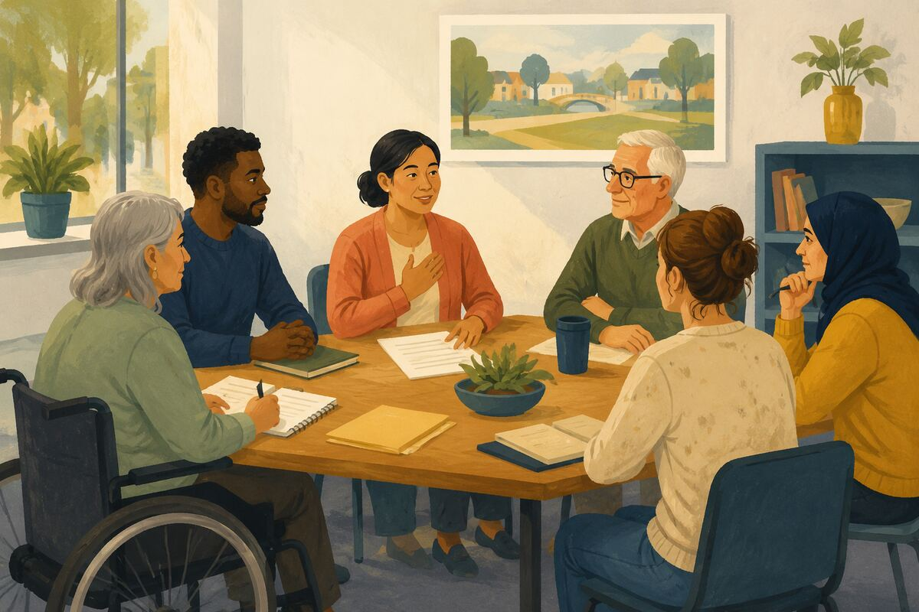
DO Accept a role only when you can prepare, attend, disclose conflicts, and complete assignments.

COMMUNITY BENEFIT Improves the reliability of community governance.

EXAMPLE FOR YOUNGER GENERATIONS Shows that leadership is work, not only status.

CIVIC PARTICIPATION AND PUBLIC INSTITUTIONS
148 Learn which agency owns the problem
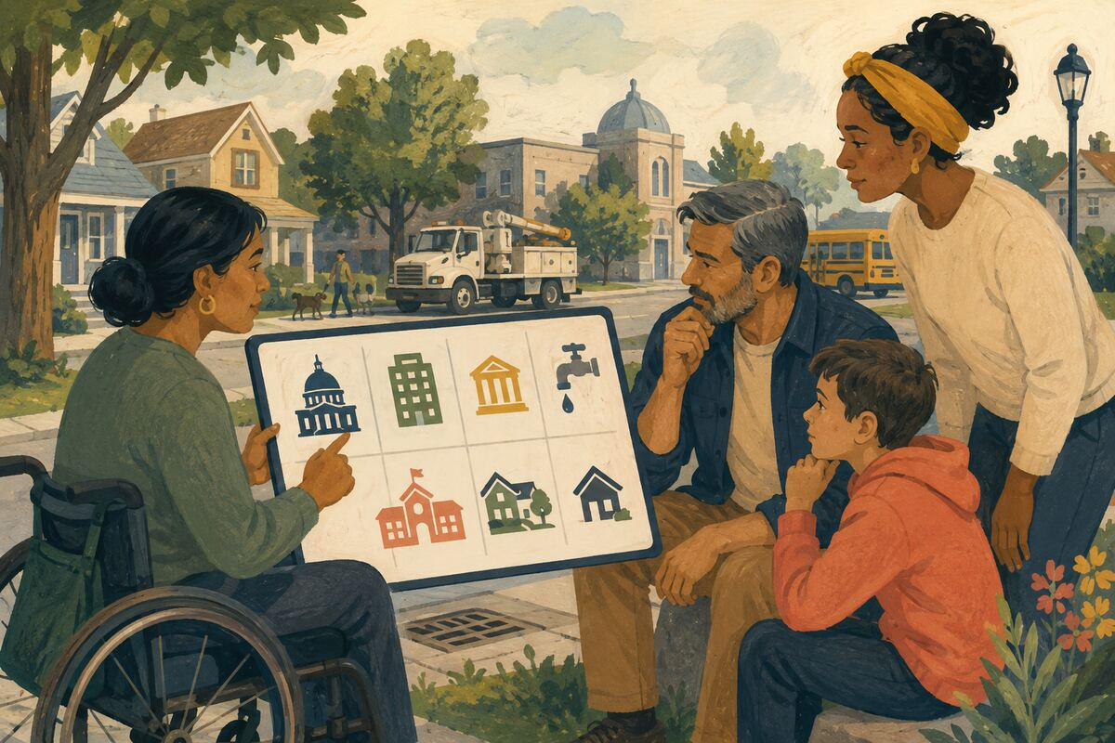
DO Check whether the issue belongs to a city, county, state, utility, school, HOA, or private owner before contacting everyone.

COMMUNITY BENEFIT Gets requests to the responsible party faster.

EXAMPLE FOR YOUNGER GENERATIONS Teaches systems thinking and efficient advocacy.

CIVIC PARTICIPATION AND PUBLIC INSTITUTIONS
149 Disagree without threats or personal exposure
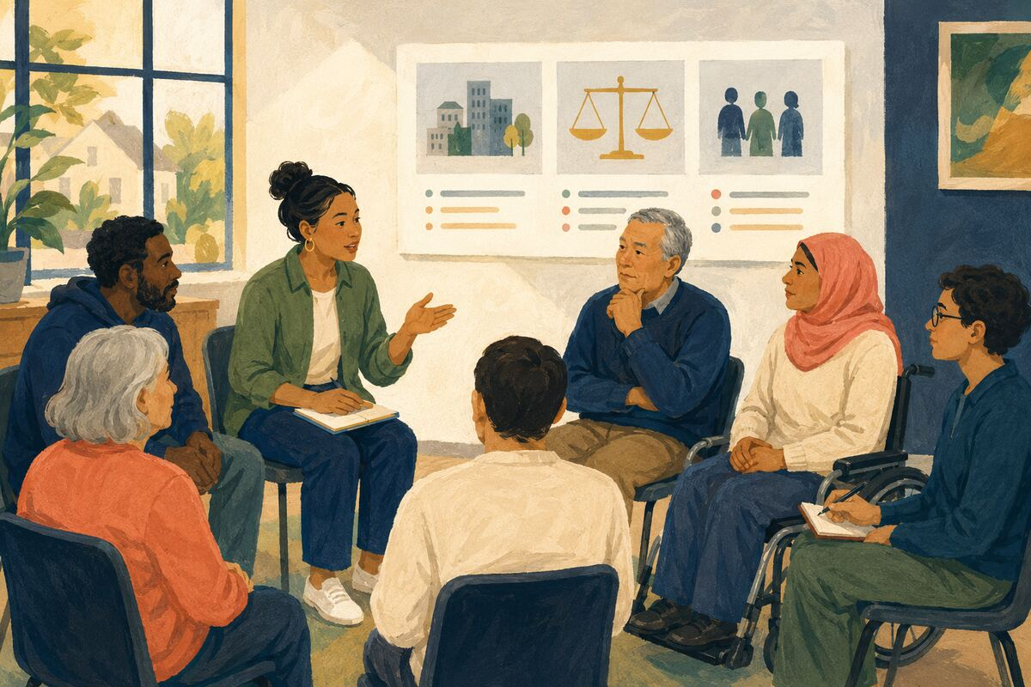
DO Criticize policy, evidence, and conduct without harassment, slurs, doxxing, or intimidation.

COMMUNITY BENEFIT Protects democratic participation and personal safety.

EXAMPLE FOR YOUNGER GENERATIONS Models strong disagreement within shared civic rules.

CIVIC PARTICIPATION AND PUBLIC INSTITUTIONS
150 Follow up with the case number
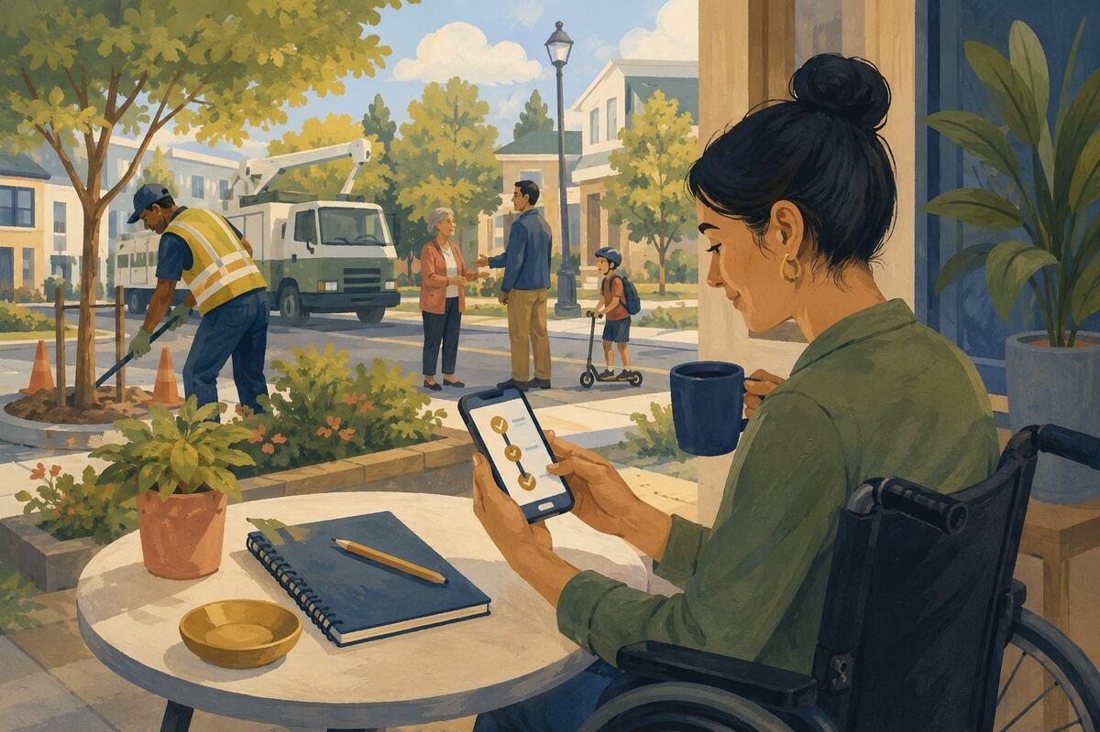
DO Save the reference number, check reasonable progress, and close or update the request when resolved.

COMMUNITY BENEFIT Creates accountability without duplicating work.

EXAMPLE FOR YOUNGER GENERATIONS Shows that participation includes finishing the loop.

WELCOMING, INCLUSION, AND BELONGING
151 Explain an unwritten rule
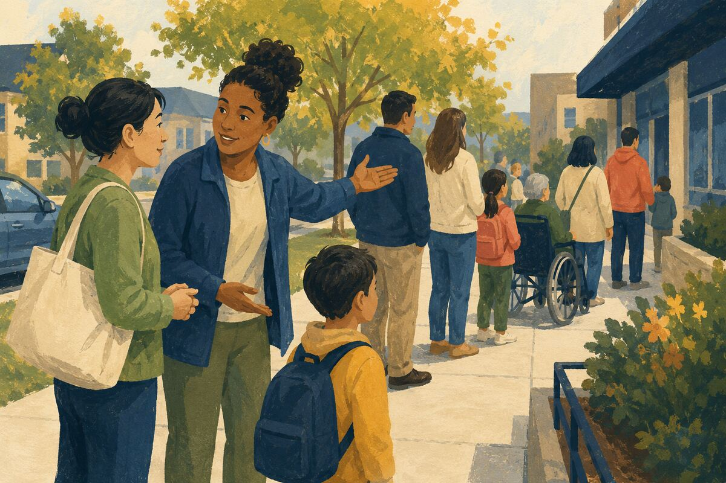
DO Tell a newcomer how the line, meeting, school pickup, neighborhood event, or workplace custom operates without making them feel foolish.

COMMUNITY BENEFIT Reduces exclusion caused by insider knowledge.

EXAMPLE FOR YOUNGER GENERATIONS Shows that belonging can be created through explanation.

WELCOMING, INCLUSION, AND BELONGING
152 Provide the important information in plain language
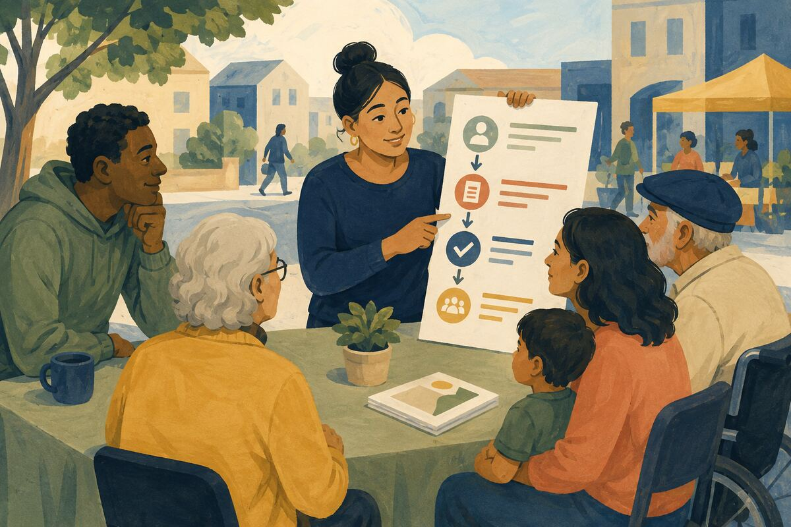
DO Replace jargon with short steps and define any term that cannot be removed.

COMMUNITY BENEFIT Makes services and decisions accessible to more people.

EXAMPLE FOR YOUNGER GENERATIONS Teaches that expertise should clarify, not dominate.

WELCOMING, INCLUSION, AND BELONGING
153 Offer translation through a qualified channel
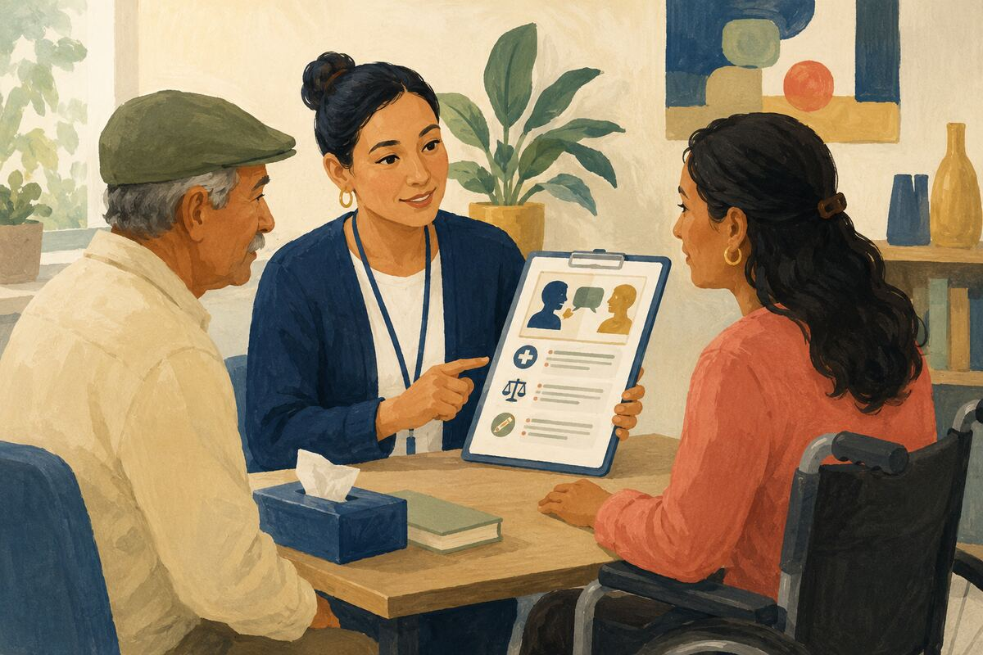
DO Use approved interpreters or translated materials for medical, legal, educational, or official matters; do not rely on children for sensitive interpretation.

COMMUNITY BENEFIT Improves accuracy, privacy, and equitable access.

EXAMPLE FOR YOUNGER GENERATIONS Shows respect for language differences and professional boundaries.

WELCOMING, INCLUSION, AND BELONGING
154 Invite, then accept the answer
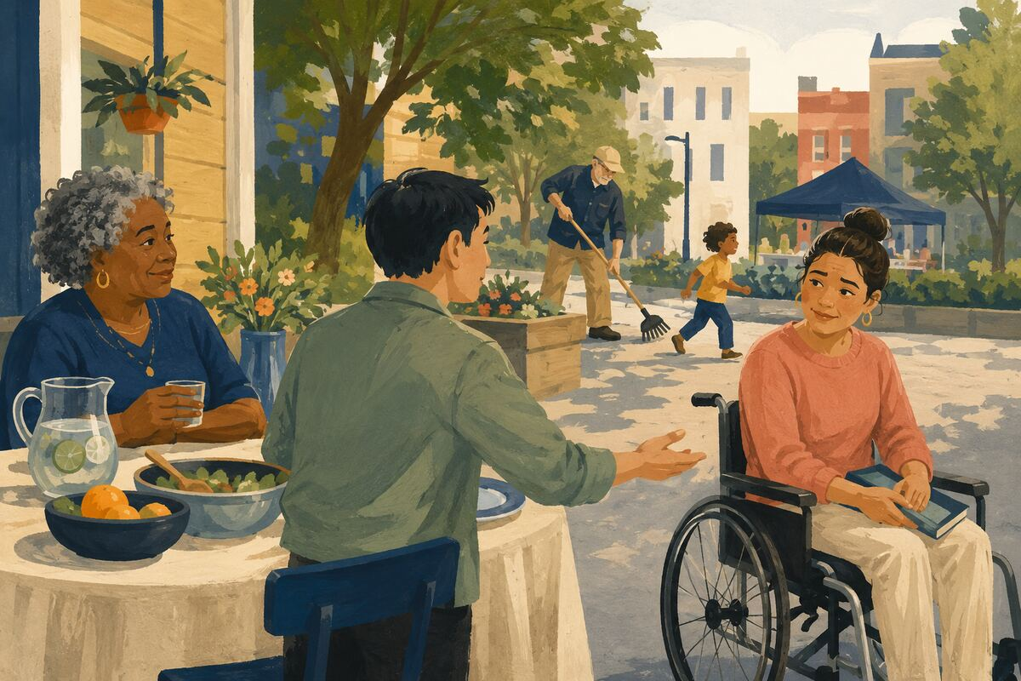
DO Include someone in a meal, activity, meeting, or conversation without pressuring them to participate.

COMMUNITY BENEFIT Opens a door while preserving personal choice.

EXAMPLE FOR YOUNGER GENERATIONS Models hospitality with consent.

WELCOMING, INCLUSION, AND BELONGING
155 Pronounce and spell names carefully
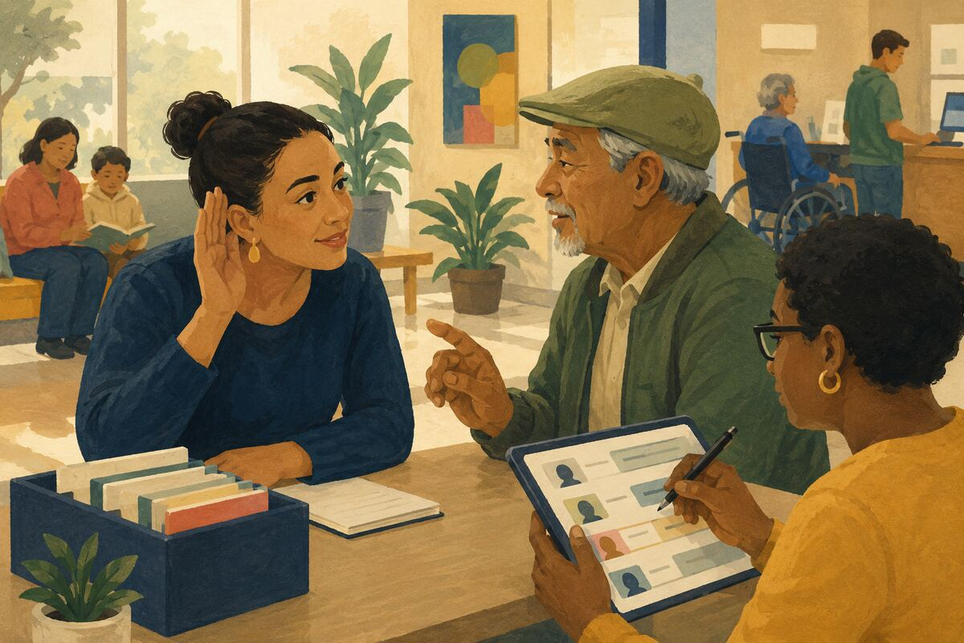
DO Ask, listen, record the correct form, and update labels or lists when wrong.

COMMUNITY BENEFIT Reduces repeated signals that a person does not belong.

EXAMPLE FOR YOUNGER GENERATIONS Teaches respect through attention to detail.

WELCOMING, INCLUSION, AND BELONGING
156 Make room for different participation styles
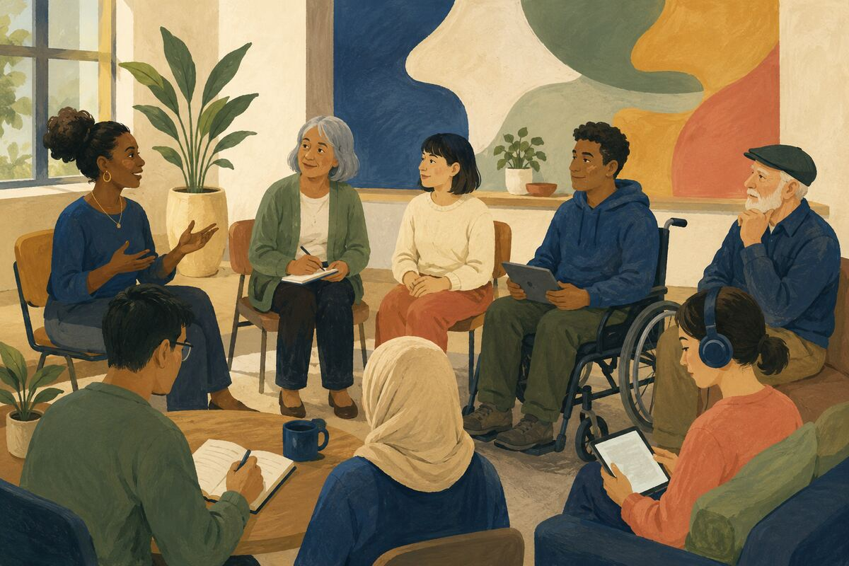
DO Allow speaking, writing, advance comments, quiet reflection, or accessible technology when appropriate.

COMMUNITY BENEFIT Improves the range and quality of contributions.

EXAMPLE FOR YOUNGER GENERATIONS Shows that equal participation does not always look identical.

WELCOMING, INCLUSION, AND BELONGING
157 Choose accessible event details
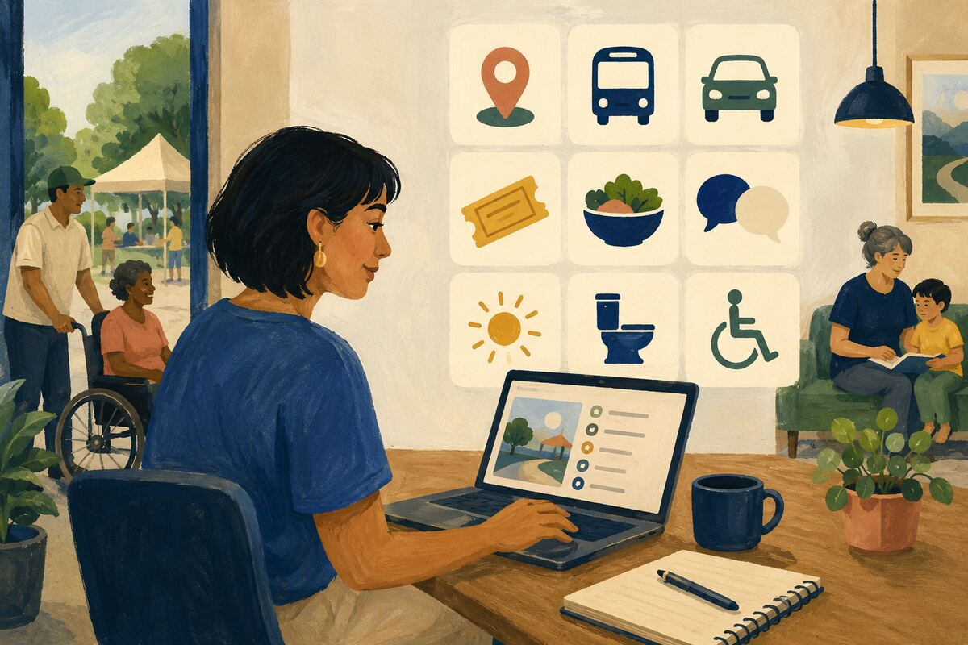
DO Publish location, transit, parking, cost, food, language, sensory, restroom, and mobility information before the event.

COMMUNITY BENEFIT Lets people decide and prepare without disclosing private needs publicly.

EXAMPLE FOR YOUNGER GENERATIONS Models inclusion through logistics.

WELCOMING, INCLUSION, AND BELONGING
158 Interrupt a demeaning joke calmly

DO State that the comment is not appropriate and redirect the conversation without escalating danger.

COMMUNITY BENEFIT Sets a boundary that protects targeted people and group standards.

EXAMPLE FOR YOUNGER GENERATIONS Shows younger people that silence is also a choice.

WELCOMING, INCLUSION, AND BELONGING
159 Learn one tradition from its practitioners
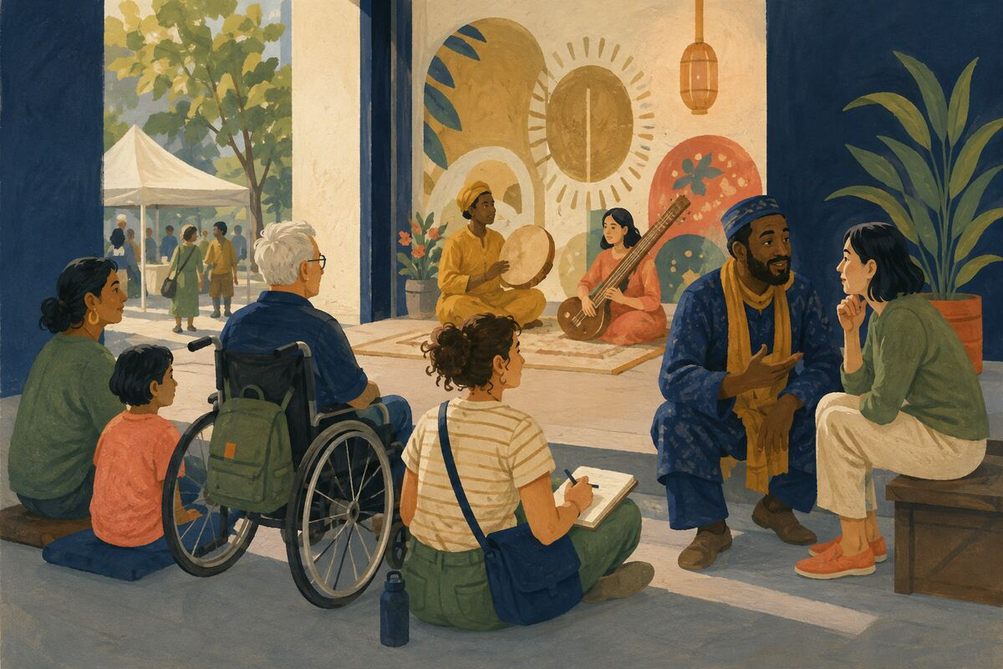
DO Attend an open cultural event, read credible sources, or ask respectful questions without treating anyone as a spokesperson for an entire group.

COMMUNITY BENEFIT Builds understanding without stereotyping.

EXAMPLE FOR YOUNGER GENERATIONS Teaches curiosity joined with humility.

WELCOMING, INCLUSION, AND BELONGING
160 Notice who is missing
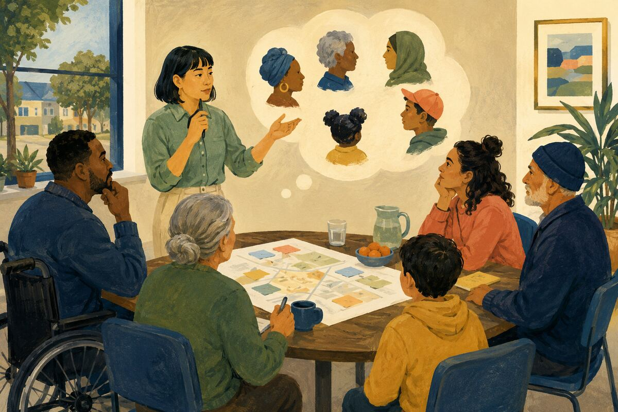
DO Before finalizing a decision, ask which affected people were not present and how their input can be obtained.

COMMUNITY BENEFIT Reduces blind spots and avoidable exclusion.

EXAMPLE FOR YOUNGER GENERATIONS Models representation as a practical quality check.

HOMES, BUILDINGS, AND PROPERTY STEWARDSHIP
161 Replace a burned-out exterior light safely
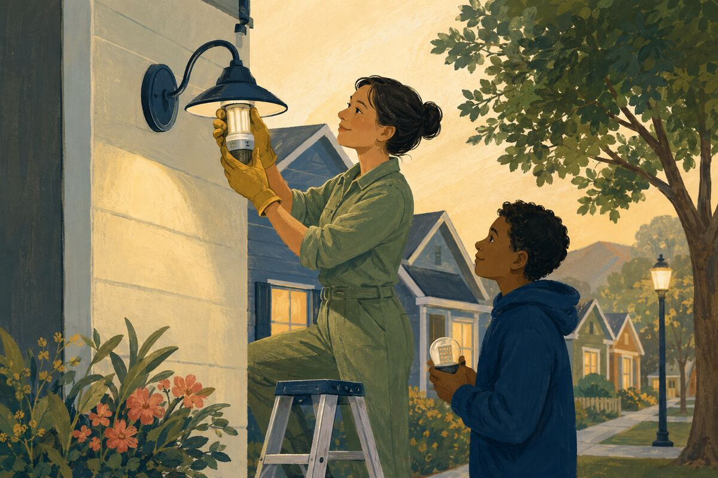
DO Use an appropriate fixture and avoid glare into neighboring homes or the sky.

COMMUNITY BENEFIT Improves visibility near entries and walking routes.

EXAMPLE FOR YOUNGER GENERATIONS Shows that property care includes community impact.

HOMES, BUILDINGS, AND PROPERTY STEWARDSHIP
162 Keep the address and entry visible
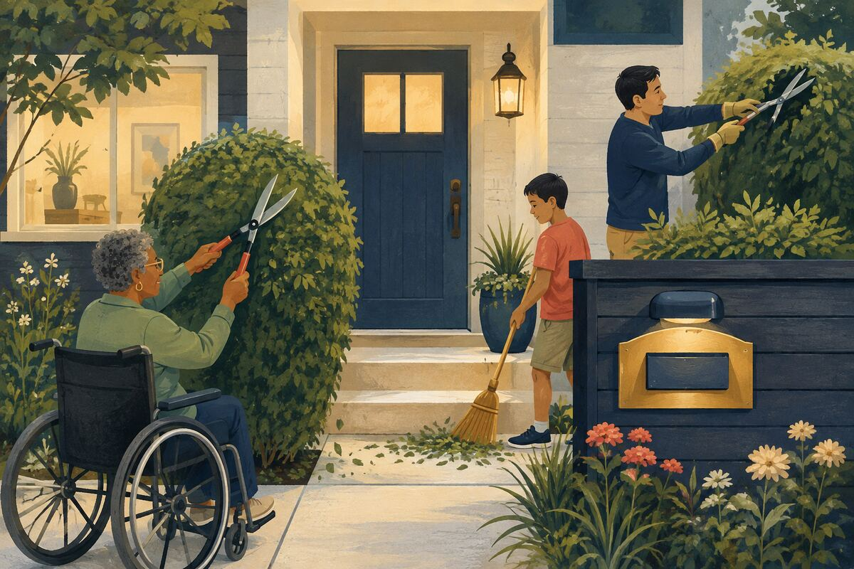
DO Trim obstructions and maintain readable numbers without compromising security.

COMMUNITY BENEFIT Helps visitors, deliveries, and responders locate the property.

EXAMPLE FOR YOUNGER GENERATIONS Teaches that small details support larger systems.

HOMES, BUILDINGS, AND PROPERTY STEWARDSHIP
163 Clear the sidewalk edge
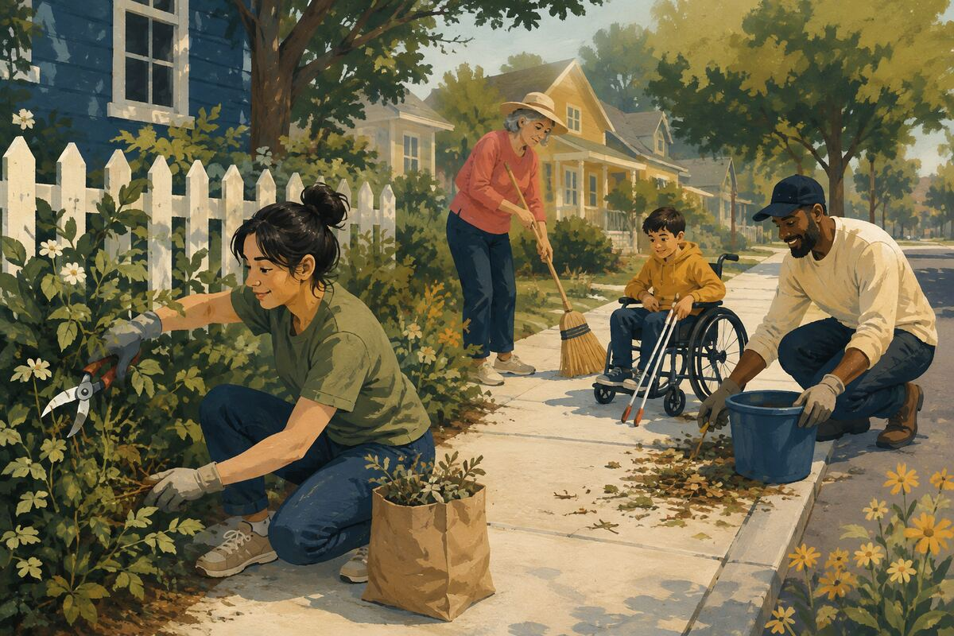
DO Trim vegetation and remove safe debris from the route while respecting property lines and local rules.

COMMUNITY BENEFIT Improves passage and sightlines for the public.

EXAMPLE FOR YOUNGER GENERATIONS Models stewardship beyond the front door.

HOMES, BUILDINGS, AND PROPERTY STEWARDSHIP
164 Fix a small leak before it grows
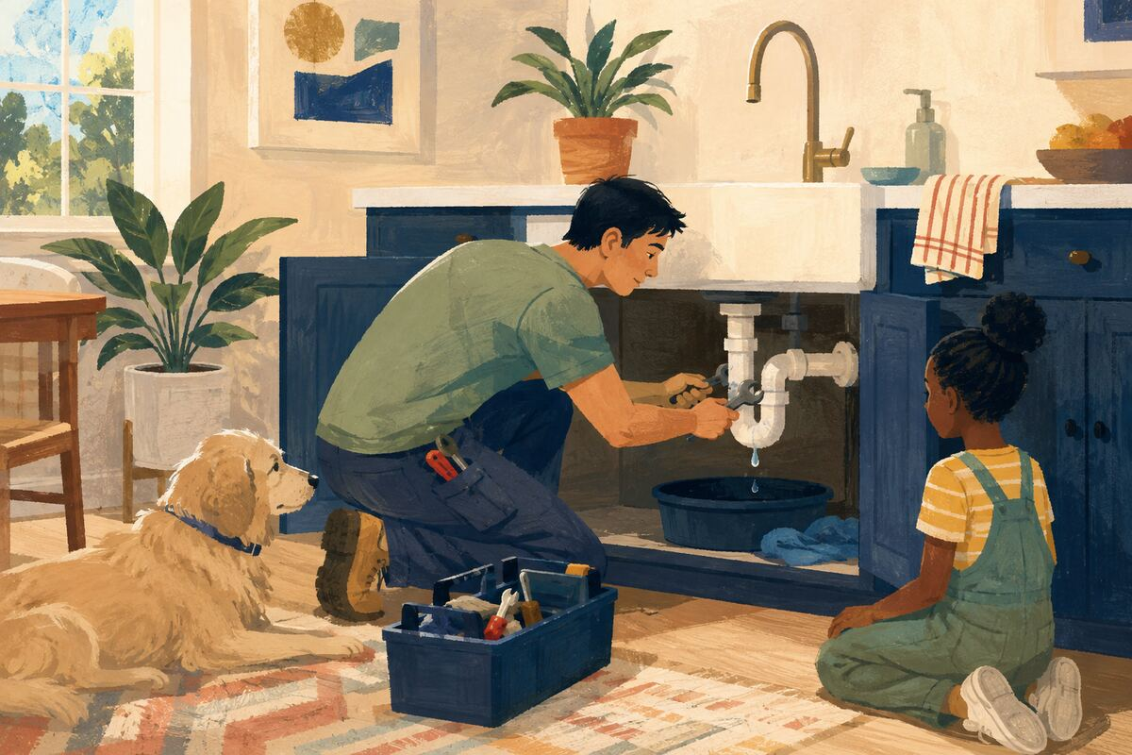
DO Repair or promptly report dripping plumbing, roof intrusion, irrigation leaks, or appliance seepage.

COMMUNITY BENEFIT Prevents water waste, mold, and expensive damage.

EXAMPLE FOR YOUNGER GENERATIONS Shows the value of early maintenance.

HOMES, BUILDINGS, AND PROPERTY STEWARDSHIP
165 Label the utility shutoffs
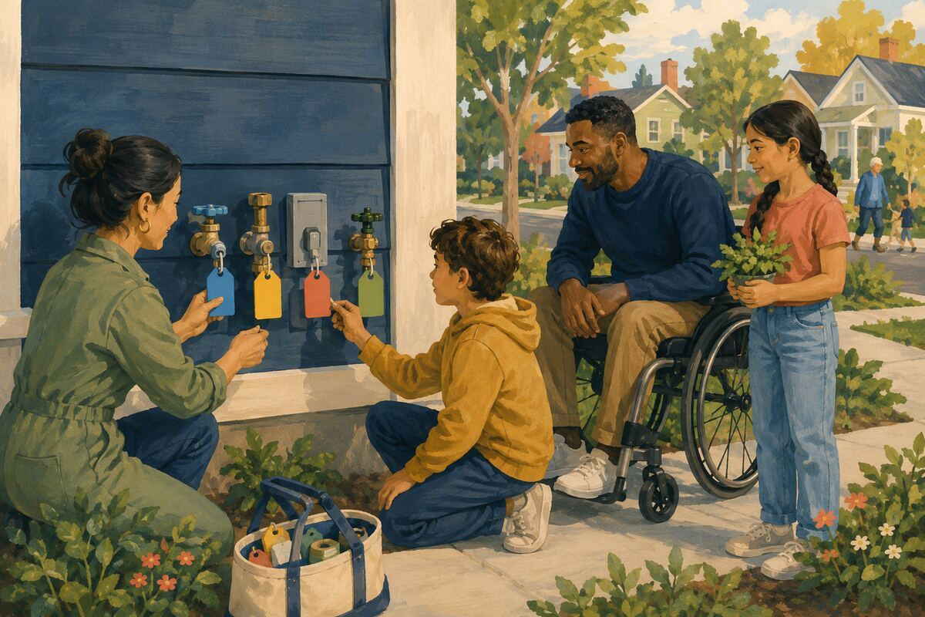
DO Clearly identify water, gas, electrical, and irrigation controls for authorized household use.

COMMUNITY BENEFIT Reduces confusion during repairs or emergencies.

EXAMPLE FOR YOUNGER GENERATIONS Teaches practical readiness.

HOMES, BUILDINGS, AND PROPERTY STEWARDSHIP
166 Share contractor information honestly
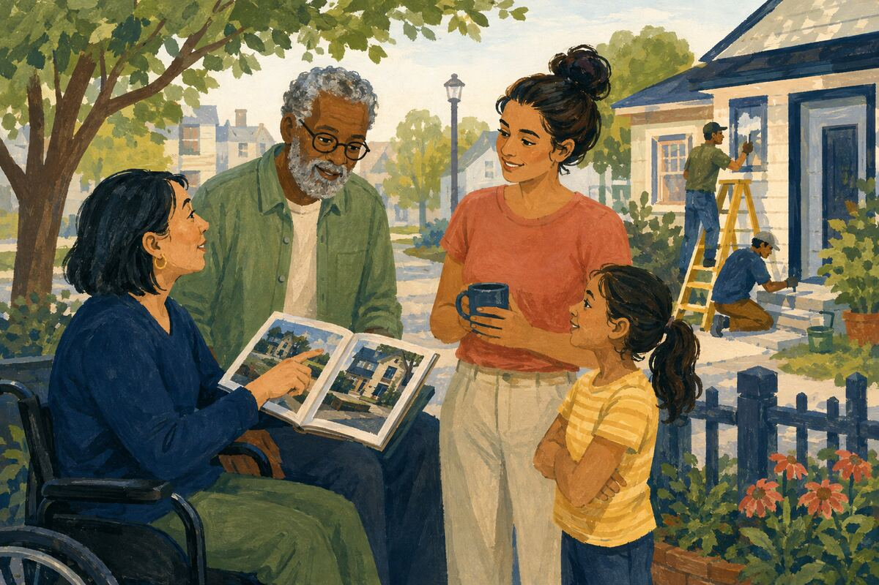
DO Recommend only providers whose work you observed and include what was done, when, and any limitation.

COMMUNITY BENEFIT Helps neighbors make better maintenance decisions.

EXAMPLE FOR YOUNGER GENERATIONS Models evidence-based recommendations.

HOMES, BUILDINGS, AND PROPERTY STEWARDSHIP
167 Remove trip hazards
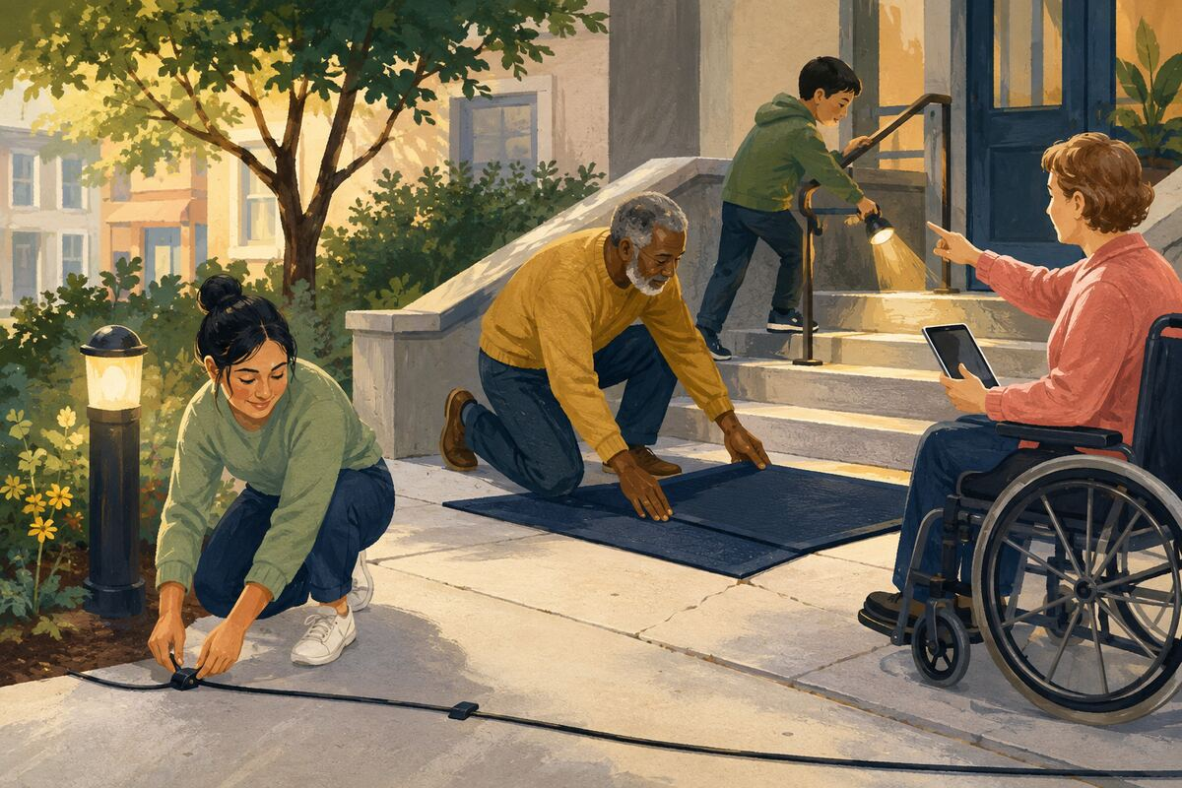
DO Secure cords, repair loose mats, improve lighting, and report damaged stairs or walkways.

COMMUNITY BENEFIT Prevents falls in homes and shared buildings.

EXAMPLE FOR YOUNGER GENERATIONS Shows that safety comes from noticing ordinary risks.

HOMES, BUILDINGS, AND PROPERTY STEWARDSHIP
168 Maintain smoke-free shared air
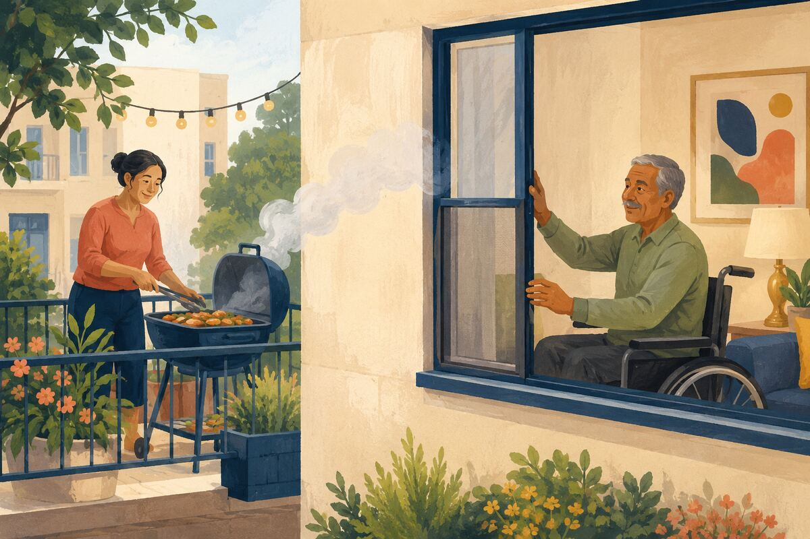
DO Follow building rules and keep smoke, fumes, dust, and strong chemicals from entering neighboring units.

COMMUNITY BENEFIT Protects health and peaceful enjoyment of shared housing.

EXAMPLE FOR YOUNGER GENERATIONS Teaches that walls do not contain every consequence.

HOMES, BUILDINGS, AND PROPERTY STEWARDSHIP
169 Document major home improvements
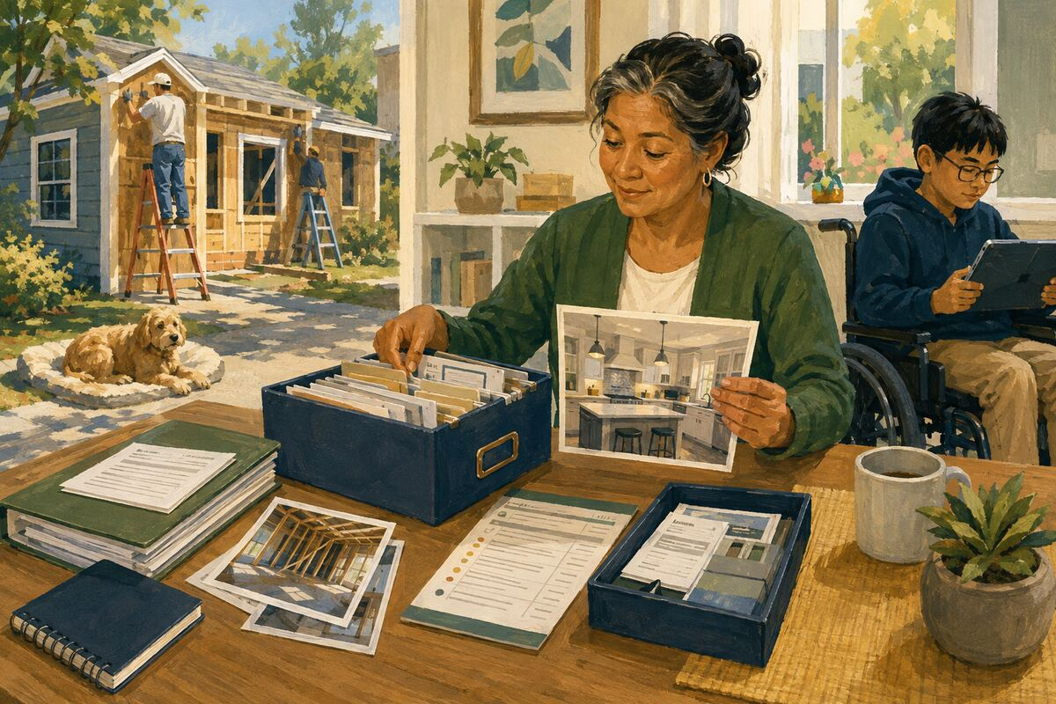
DO Keep permits, invoices, warranties, dates, model numbers, and before-and-after records together.

COMMUNITY BENEFIT Helps future owners maintain the property accurately.

EXAMPLE FOR YOUNGER GENERATIONS Shows stewardship across generations of ownership.

HOMES, BUILDINGS, AND PROPERTY STEWARDSHIP
170 Report vacant-property hazards
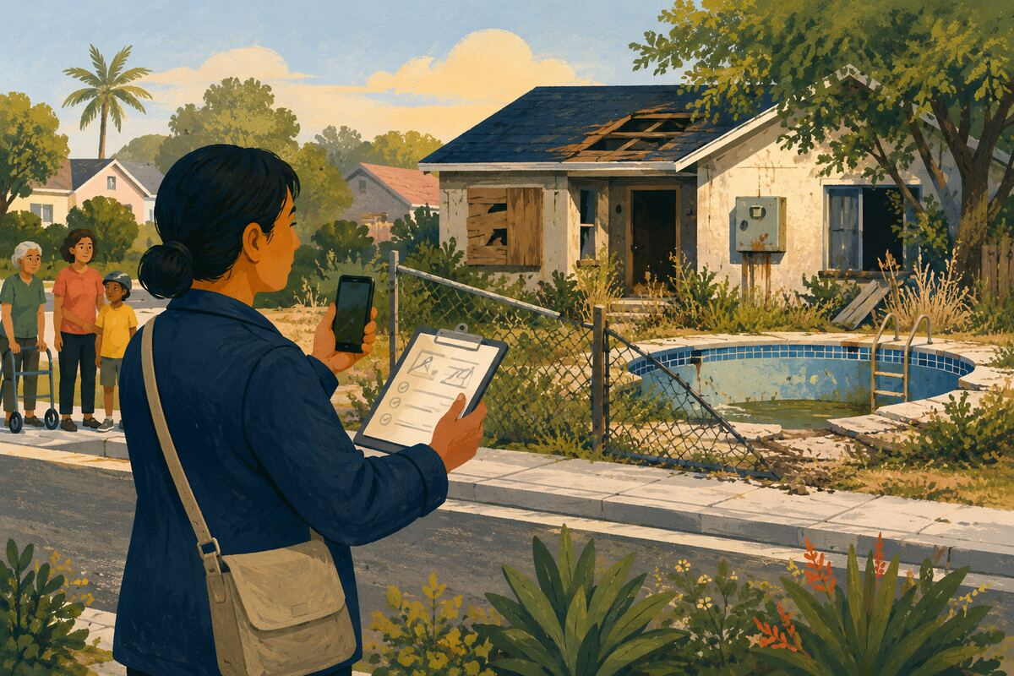
DO Notify the responsible owner or agency about unsecured pools, broken fencing, leaks, fire hazards, or open structures without entering.

COMMUNITY BENEFIT Helps prevent injury, damage, and neighborhood decline.

EXAMPLE FOR YOUNGER GENERATIONS Models safe action instead of trespassing or ignoring risk.

SKILLS, MENTORING, AND OPPORTUNITY
171 Teach one practical skill

DO Show someone how to cook a basic meal, use a tool, make a budget, navigate transit, or complete another skill you know safely.

COMMUNITY BENEFIT Increases independence and spreads useful capability.

EXAMPLE FOR YOUNGER GENERATIONS Shows that knowledge is meant to be passed forward.

SKILLS, MENTORING, AND OPPORTUNITY
172 Review one resume honestly
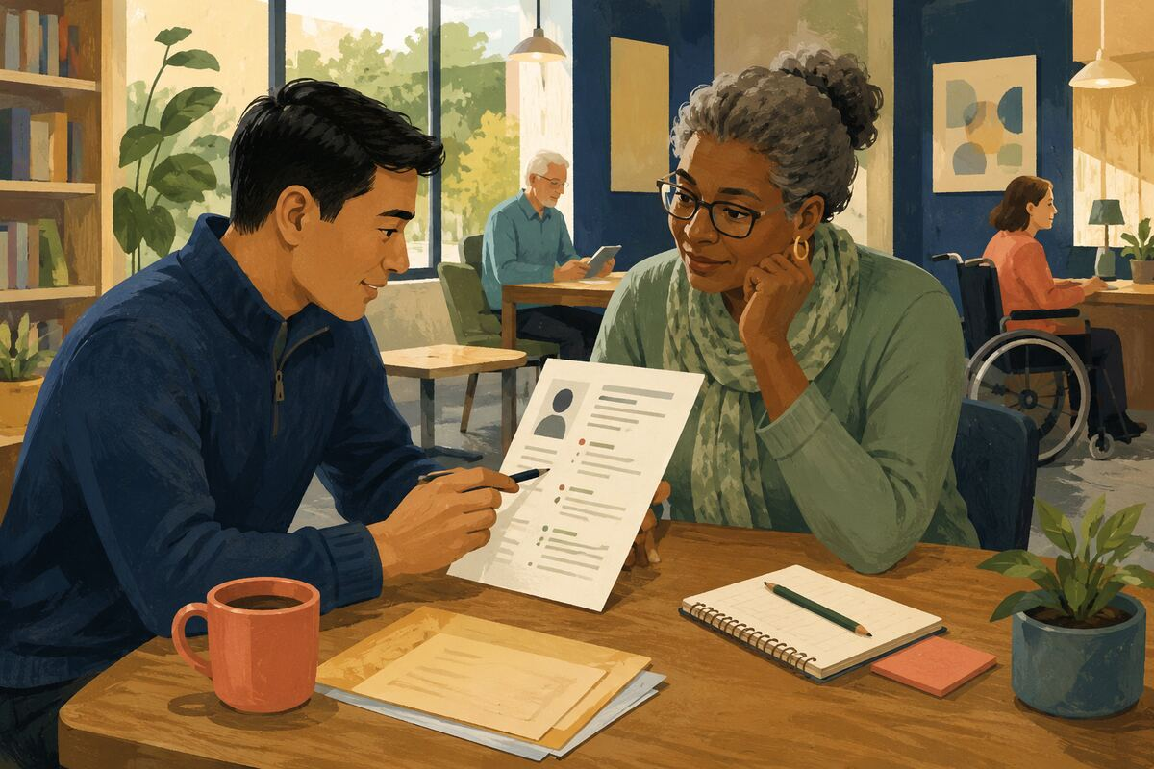
DO Correct errors, strengthen evidence, and explain the reason for each change without rewriting the person into someone else.

COMMUNITY BENEFIT Improves access to employment while building the applicant’s skill.

EXAMPLE FOR YOUNGER GENERATIONS Models help that preserves ownership.

SKILLS, MENTORING, AND OPPORTUNITY
173 Practice an interview
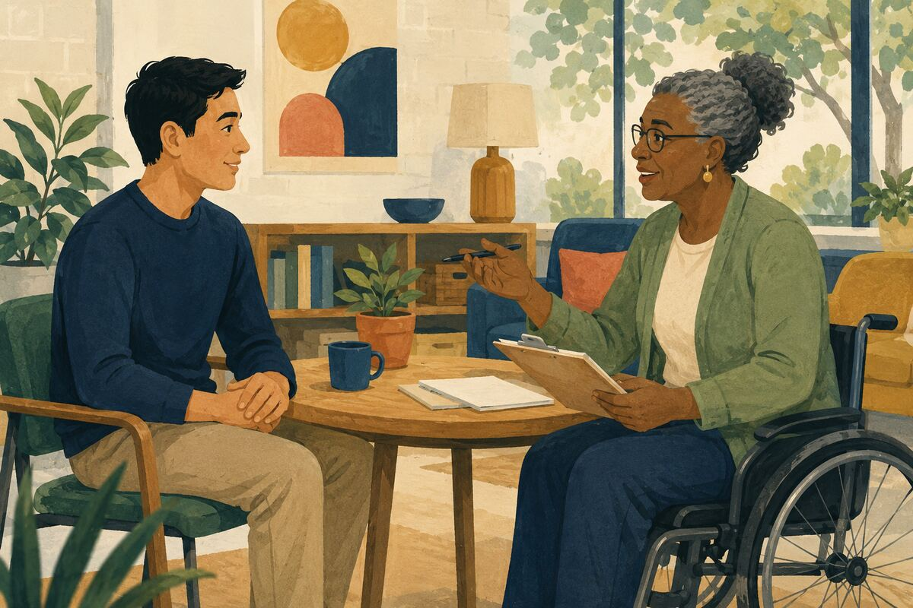
DO Ask realistic questions, give specific feedback, and help the person prepare examples from their own experience.

COMMUNITY BENEFIT Builds confidence and communication for job opportunities.

EXAMPLE FOR YOUNGER GENERATIONS Shows that preparation can open doors.

SKILLS, MENTORING, AND OPPORTUNITY
174 Make a warm introduction
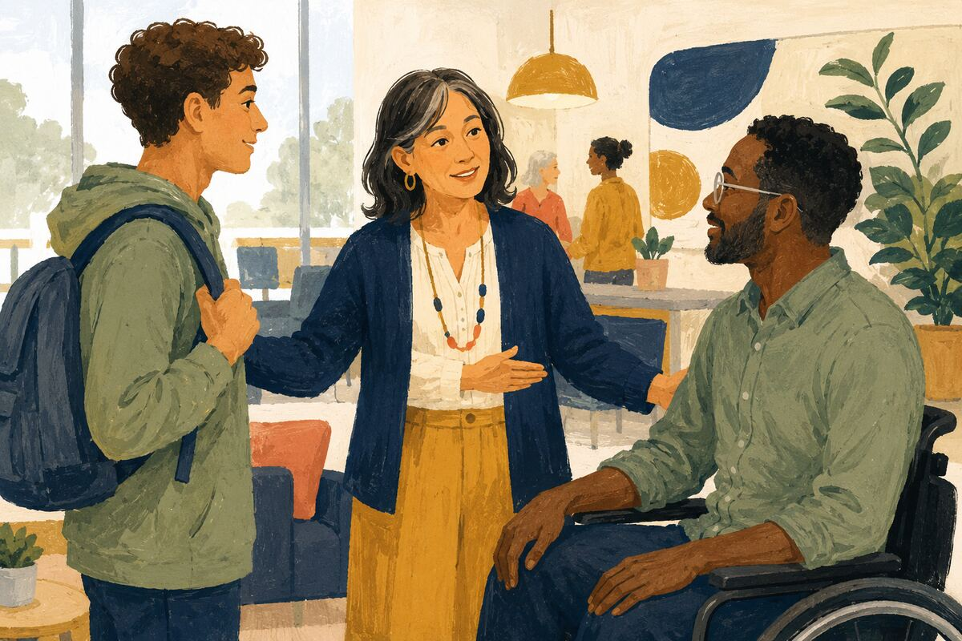
DO With consent from both people, explain why a student, job seeker, volunteer, or expert should meet a relevant contact.

COMMUNITY BENEFIT Transfers social access more fairly and efficiently.

EXAMPLE FOR YOUNGER GENERATIONS Teaches that networks can be used to include others.

SKILLS, MENTORING, AND OPPORTUNITY
175 Explain one financial basic
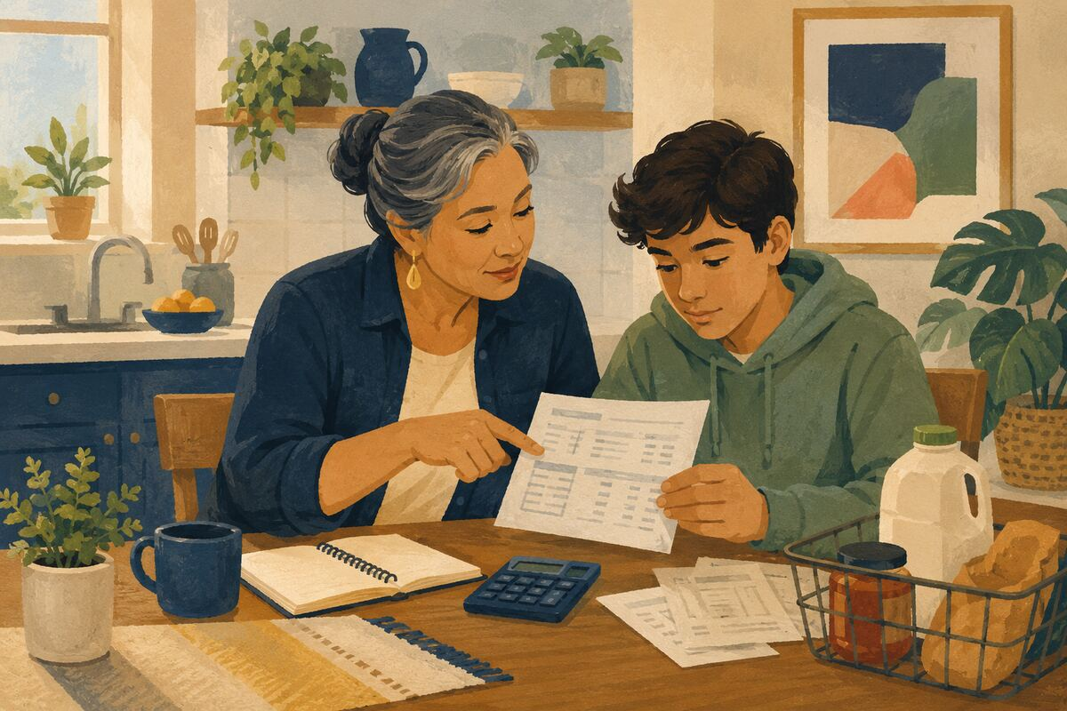
DO Teach a young person how to read a pay stub, compare unit prices, avoid fees, or understand interest using real examples.

COMMUNITY BENEFIT Improves everyday decision-making and reduces costly mistakes.

EXAMPLE FOR YOUNGER GENERATIONS Models money knowledge as a shared life skill.

SKILLS, MENTORING, AND OPPORTUNITY
176 Let a learner do the task
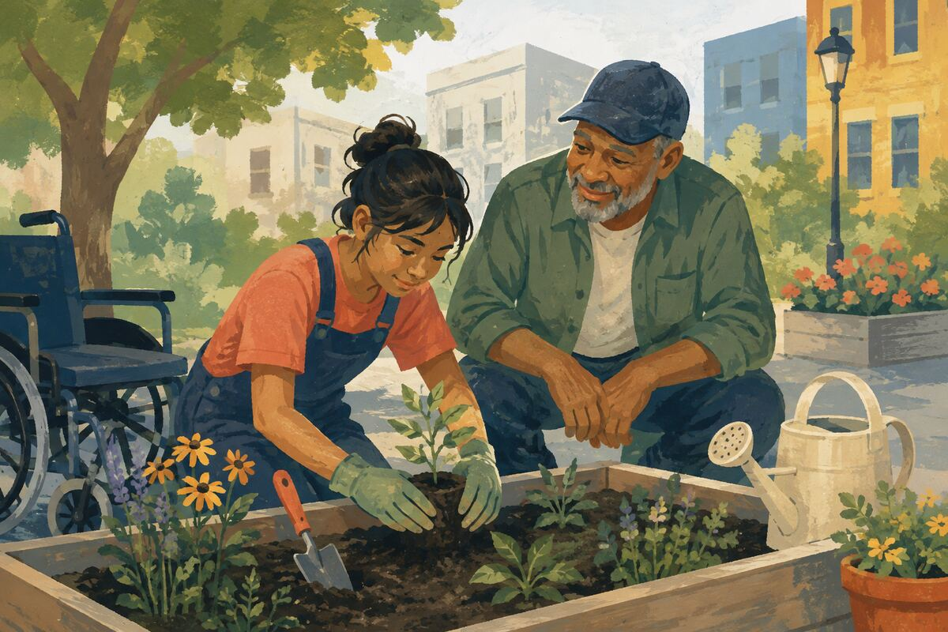
DO Demonstrate, supervise, and then allow the person to complete the work rather than taking it back at the first mistake.

COMMUNITY BENEFIT Creates real competence instead of dependence.

EXAMPLE FOR YOUNGER GENERATIONS Shows patience with the learning process.

SKILLS, MENTORING, AND OPPORTUNITY
177 Share the mistake behind your expertise
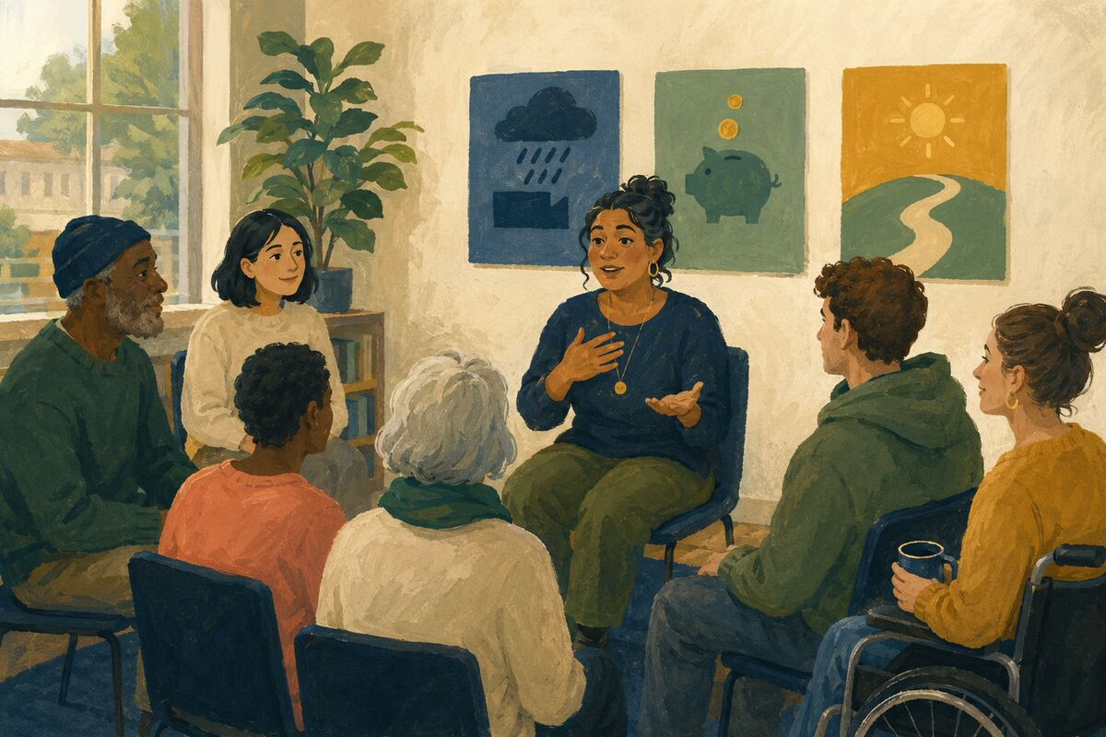
DO Explain one failure, what it cost, and what changed afterward.

COMMUNITY BENEFIT Gives learners realistic expectations and reusable lessons.

EXAMPLE FOR YOUNGER GENERATIONS Shows that growth includes honest reflection.

SKILLS, MENTORING, AND OPPORTUNITY
178 Sponsor one opportunity
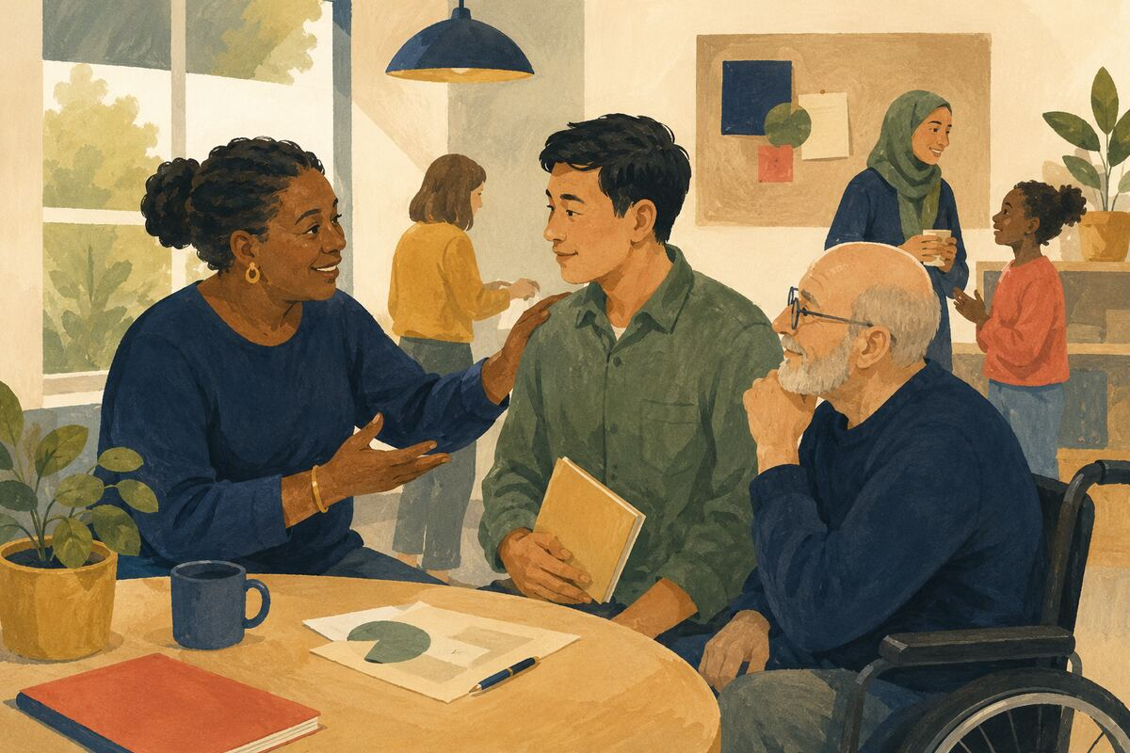
DO Recommend a capable person for a project, presentation, leadership role, or paid task and remain available for support.

COMMUNITY BENEFIT Converts potential into visible experience.

EXAMPLE FOR YOUNGER GENERATIONS Models using influence to expand opportunity.

SKILLS, MENTORING, AND OPPORTUNITY
179 Create a simple how-to guide
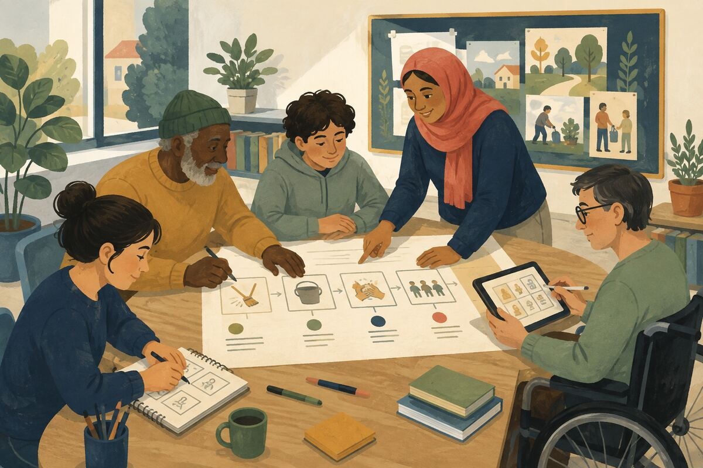
DO Write or record the steps for a common community task and make it accessible to the people who need it.

COMMUNITY BENEFIT Allows help to scale beyond one conversation.

EXAMPLE FOR YOUNGER GENERATIONS Shows younger generations how to turn experience into public value.

SKILLS, MENTORING, AND OPPORTUNITY
180 Ask what support is actually needed
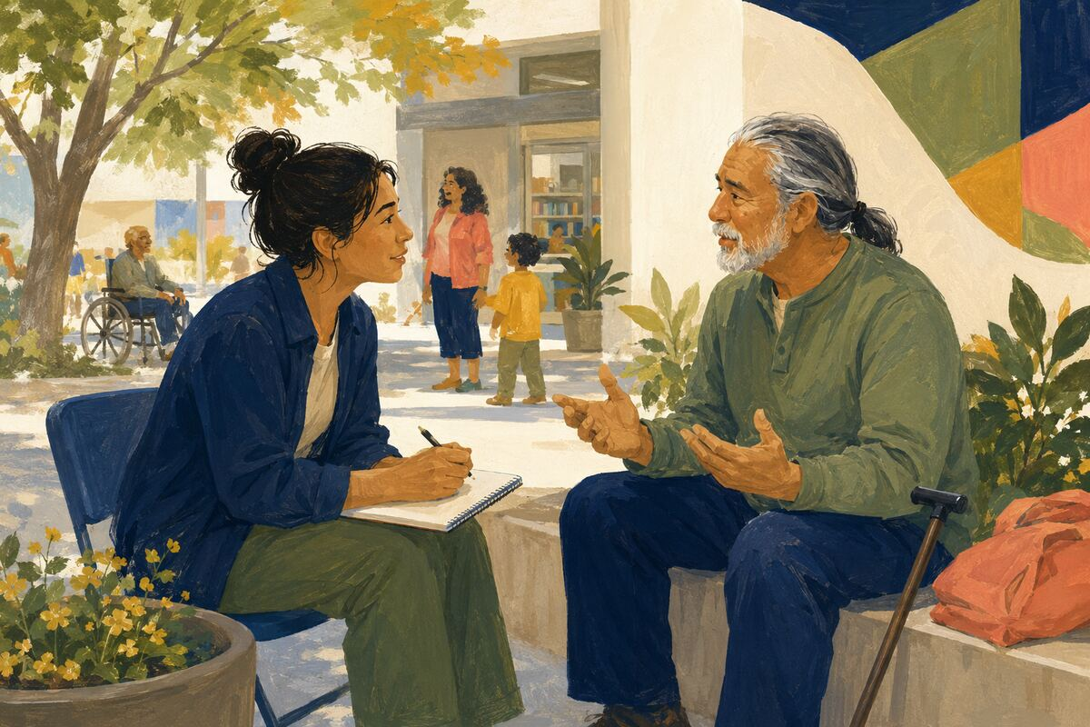
DO Before mentoring, ask the person’s goal, current obstacle, and preferred form of help.

COMMUNITY BENEFIT Prevents advice from becoming irrelevant or controlling.

EXAMPLE FOR YOUNGER GENERATIONS Teaches that service begins with listening.

ANIMALS AND SHARED RESPONSIBILITY
181 Keep pets safely contained
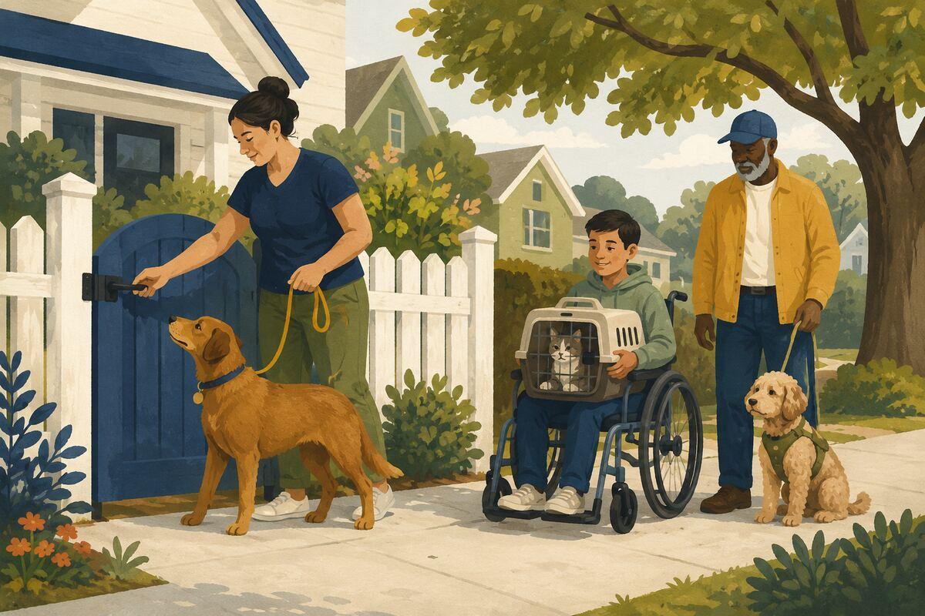
DO Maintain fences, gates, leashes, carriers, and identification appropriate to the animal and local rules.

COMMUNITY BENEFIT Protects animals, neighbors, wildlife, and drivers.

EXAMPLE FOR YOUNGER GENERATIONS Teaches that love includes responsible control.

ANIMALS AND SHARED RESPONSIBILITY
182 Pick up pet waste
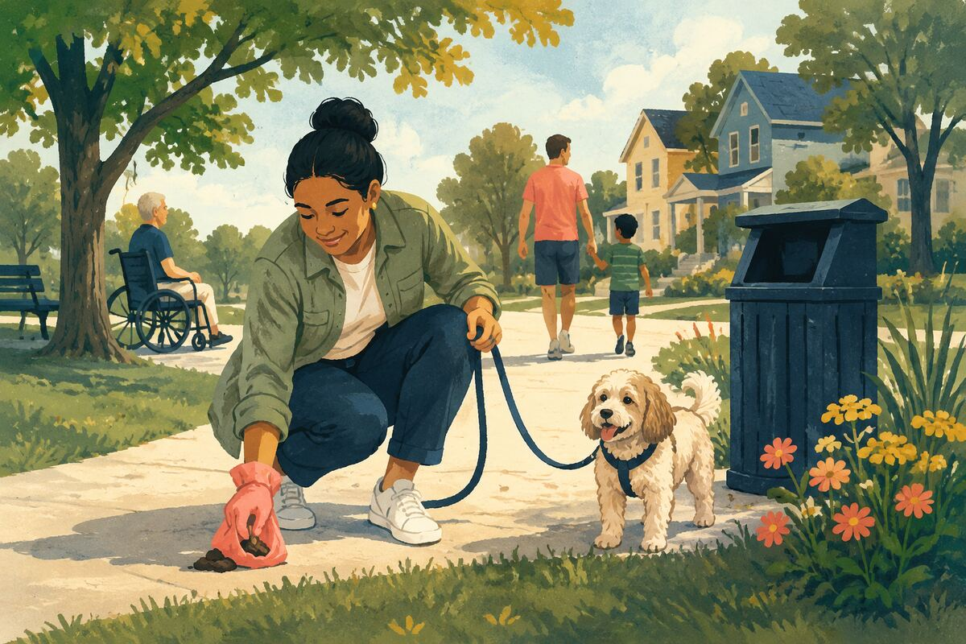
DO Carry bags, remove waste promptly, and dispose of it correctly.

COMMUNITY BENEFIT Keeps public spaces cleaner and reduces health and water-quality problems.

EXAMPLE FOR YOUNGER GENERATIONS Shows that ownership includes unpleasant tasks.

ANIMALS AND SHARED RESPONSIBILITY
183 Provide current identification
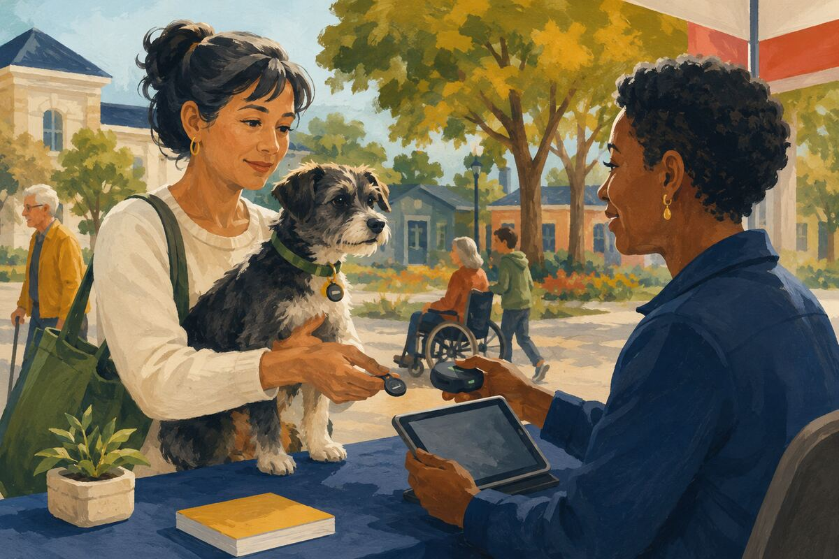
DO Use a readable tag and current microchip registration where appropriate.

COMMUNITY BENEFIT Improves the chance that a lost animal returns home quickly.

EXAMPLE FOR YOUNGER GENERATIONS Models preparation for predictable problems.

ANIMALS AND SHARED RESPONSIBILITY
184 Report a lost pet with useful details
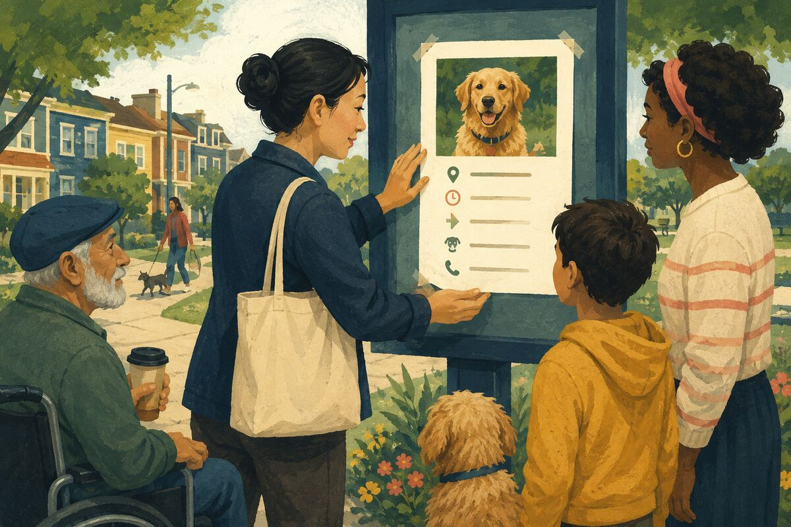
DO Share a clear photo, last known location, time, direction, temperament, and safe contact method without encouraging dangerous chasing.

COMMUNITY BENEFIT Coordinates a more effective and safer search.

EXAMPLE FOR YOUNGER GENERATIONS Teaches calm, accurate communication during stress.

ANIMALS AND SHARED RESPONSIBILITY
185 Check for wildlife before yard work
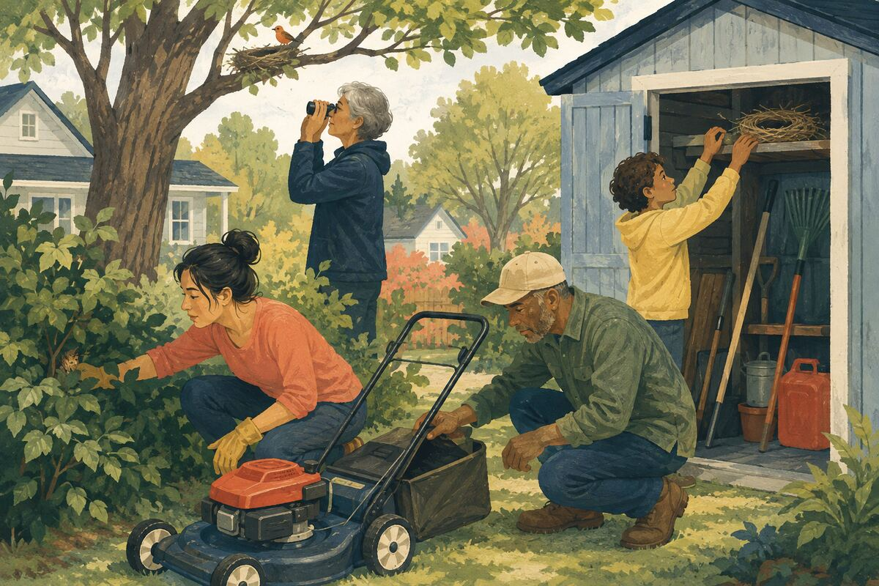
DO Inspect brush, equipment, sheds, and trees for nests or animals and follow local guidance.

COMMUNITY BENEFIT Prevents avoidable injury to wildlife and people.

EXAMPLE FOR YOUNGER GENERATIONS Shows that human spaces are shared with other living things.

ANIMALS AND SHARED RESPONSIBILITY
186 Offer water responsibly during extreme heat

DO Place and maintain clean water only where appropriate and where it will not create hazards, pests, or wildlife conflict.

COMMUNITY BENEFIT Supports animals while avoiding careless unintended consequences.

EXAMPLE FOR YOUNGER GENERATIONS Teaches that compassion also requires judgment.

ANIMALS AND SHARED RESPONSIBILITY
187 Support a shelter’s actual needs
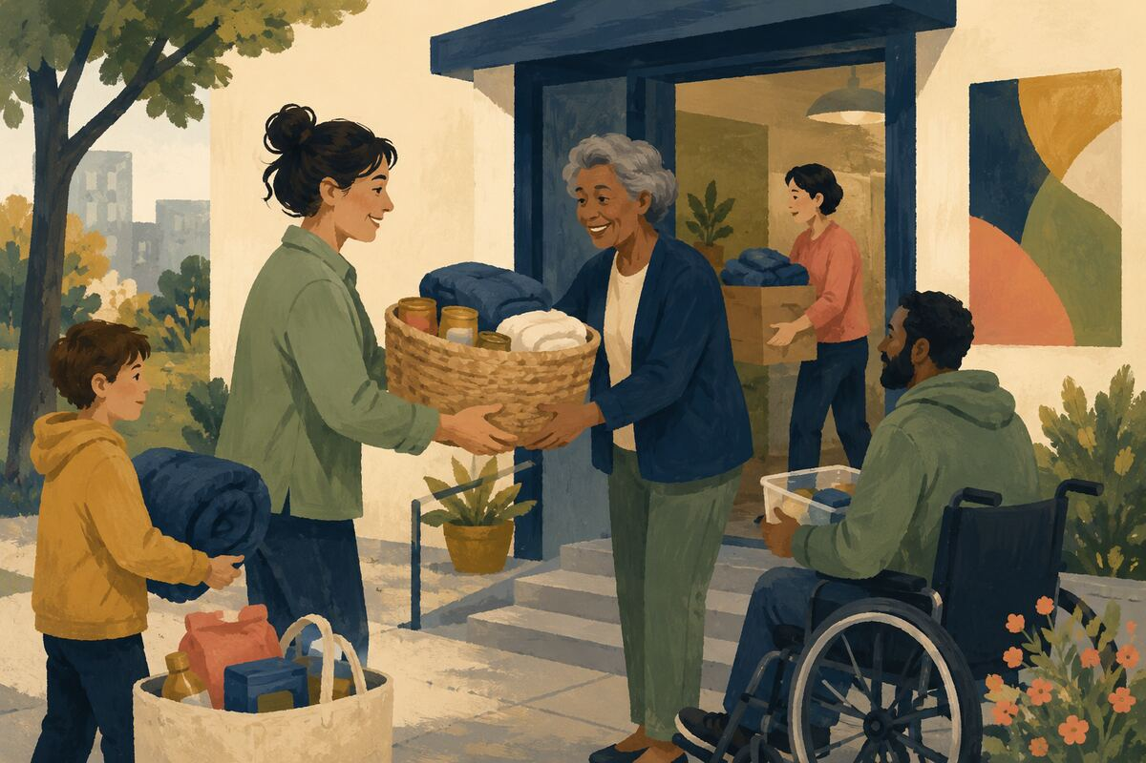
DO Donate requested food, bedding, funds, transport, foster care, or volunteer time rather than unrequested items.

COMMUNITY BENEFIT Directs help toward the shelter’s current capacity and priorities.

EXAMPLE FOR YOUNGER GENERATIONS Models listening before giving.

ANIMALS AND SHARED RESPONSIBILITY
188 Help reunite, do not simply keep
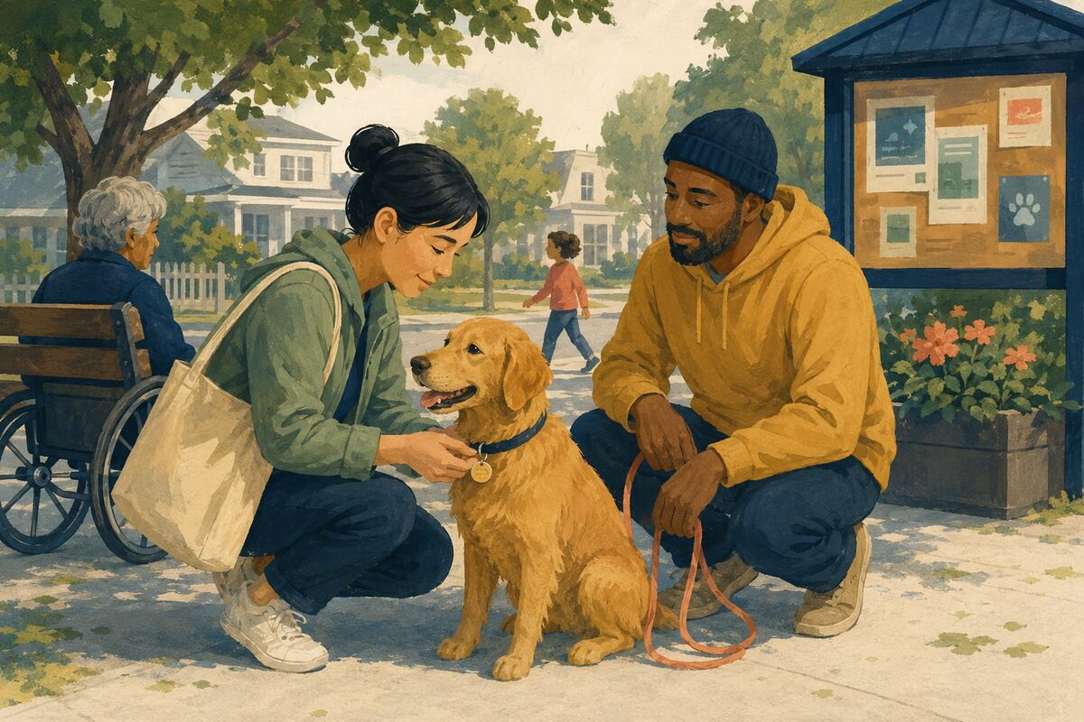
DO If a friendly animal is found, check identification and follow local lost-animal procedures before assuming abandonment.

COMMUNITY BENEFIT Preserves the owner-animal relationship and speeds reunion.

EXAMPLE FOR YOUNGER GENERATIONS Teaches respect for claims we cannot immediately see.

ANIMALS AND SHARED RESPONSIBILITY
189 Train for calm public behavior
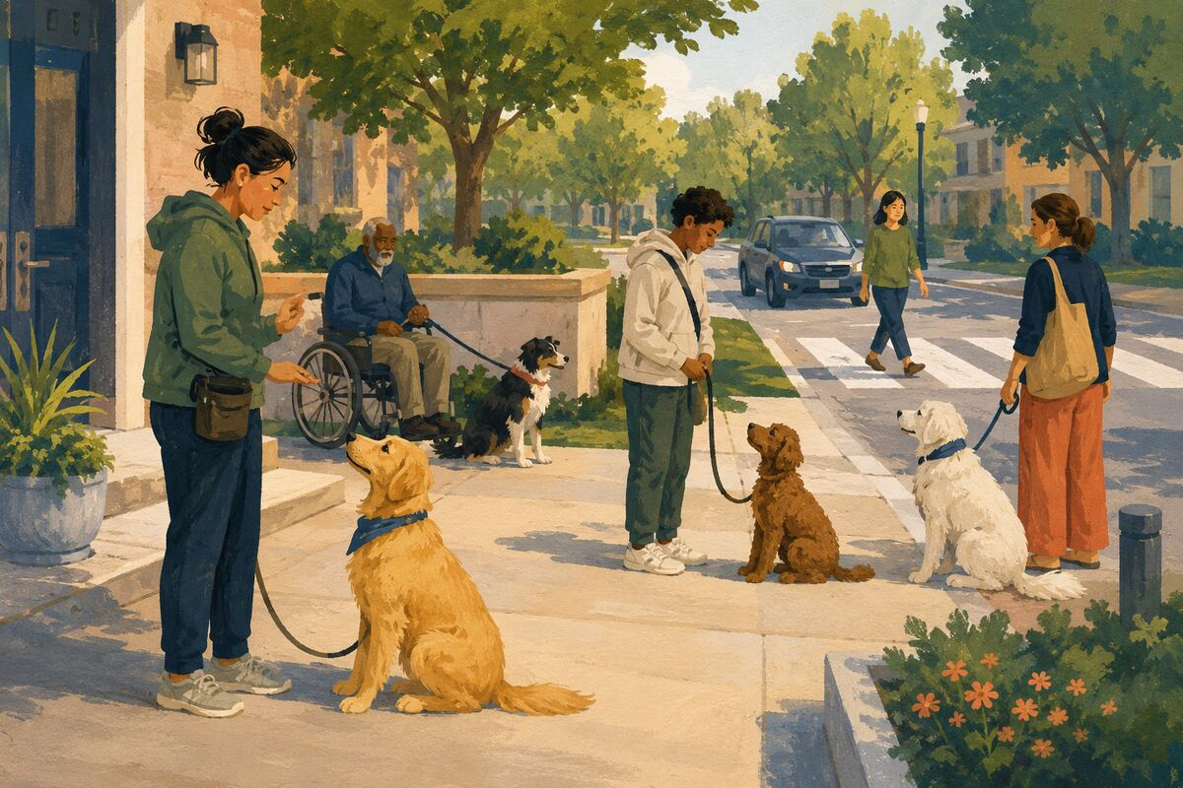
DO Use humane, appropriate training so pets can be managed around people, animals, doors, and vehicles.

COMMUNITY BENEFIT Reduces bites, escapes, fear, and conflict.

EXAMPLE FOR YOUNGER GENERATIONS Shows that responsible freedom requires preparation.

ANIMALS AND SHARED RESPONSIBILITY
190 Plan for pets in emergencies
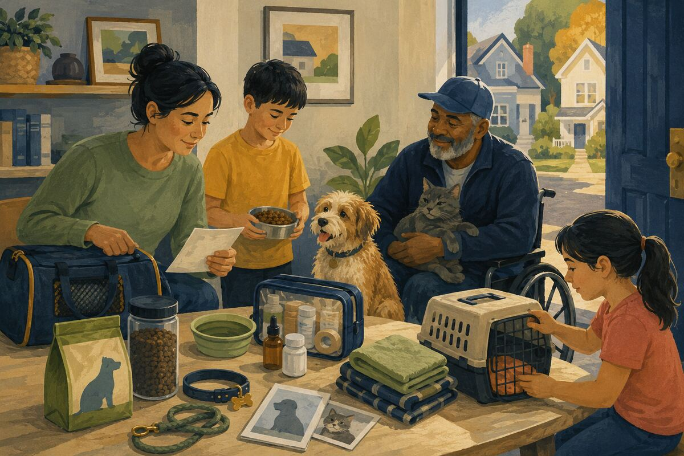
DO Include food, medication, carriers, records, contacts, and pet-friendly shelter options in household planning.

COMMUNITY BENEFIT Prevents animals from being abandoned or delaying evacuation.

EXAMPLE FOR YOUNGER GENERATIONS Teaches planning for every dependent member of a household.

COMMUNITY CULTURE, MORALE, AND MEMORY
191 Attend a local performance or exhibit
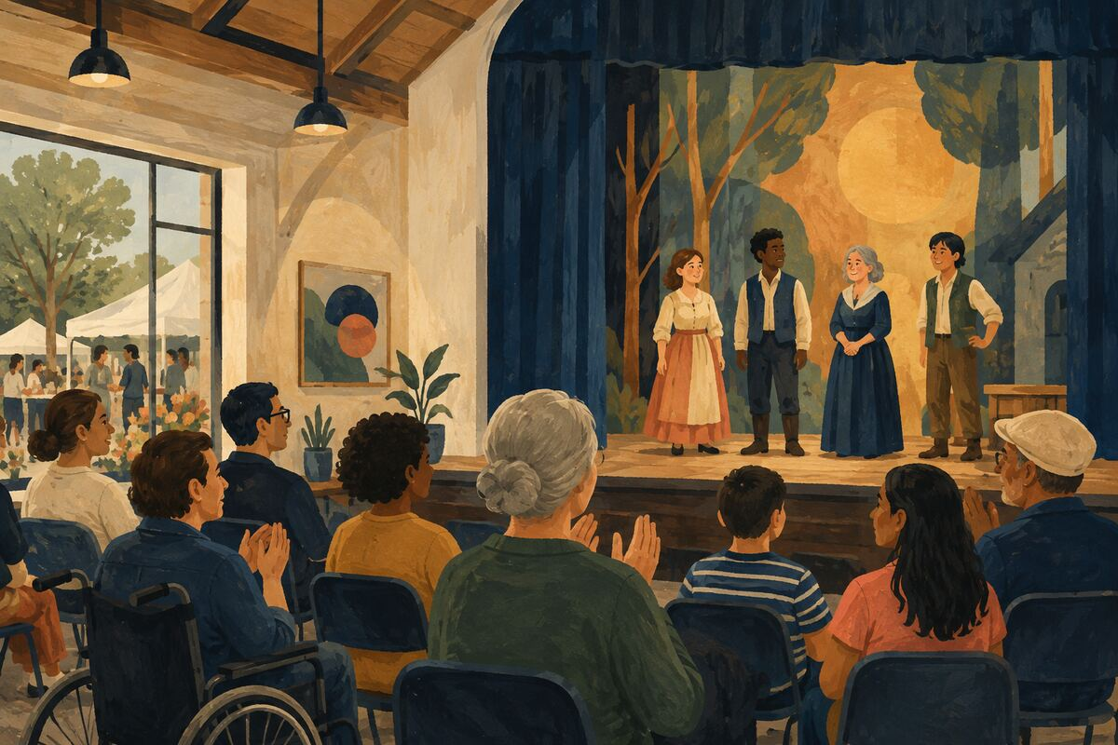
DO Choose a community play, concert, lecture, market, museum, or student exhibition and participate respectfully.

COMMUNITY BENEFIT Supports local creators and creates shared experiences.

EXAMPLE FOR YOUNGER GENERATIONS Shows younger generations that culture is sustained by audiences.

COMMUNITY CULTURE, MORALE, AND MEMORY
192 Record an elder’s story with permission
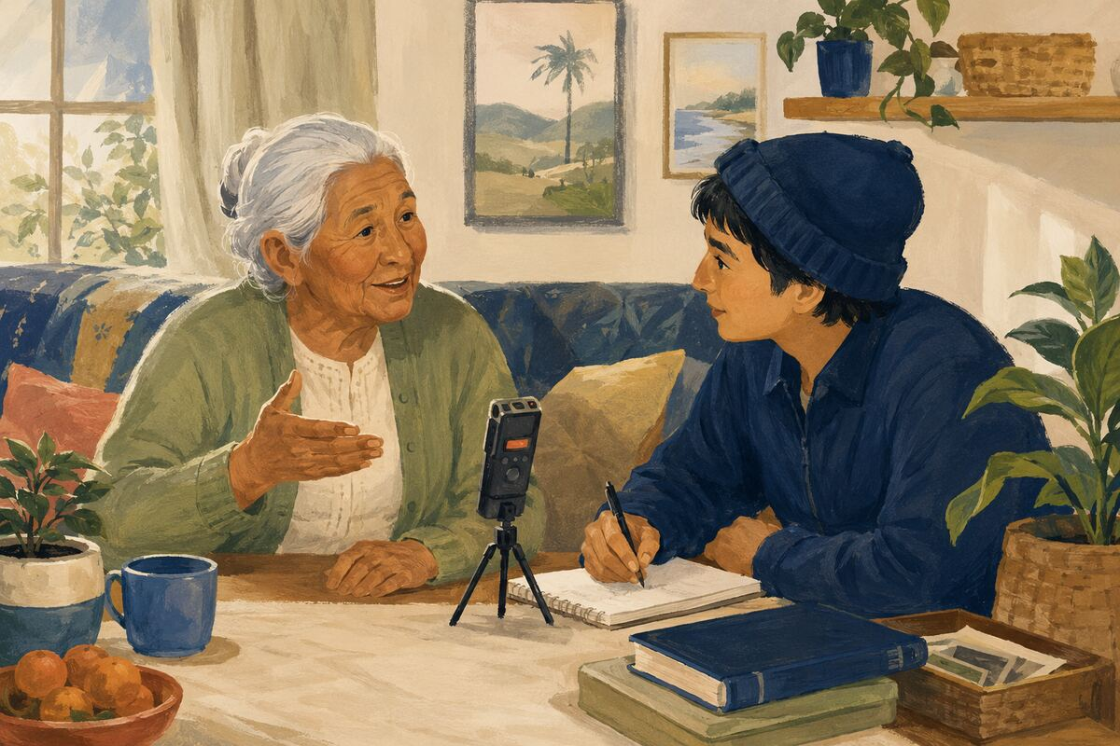
DO Ask about a place, job, migration, tradition, or community change and save the recording or notes where the family can access them.

COMMUNITY BENEFIT Preserves firsthand memory that may otherwise disappear.

EXAMPLE FOR YOUNGER GENERATIONS Teaches that history lives in ordinary people.

COMMUNITY CULTURE, MORALE, AND MEMORY
193 Learn the story of one local place
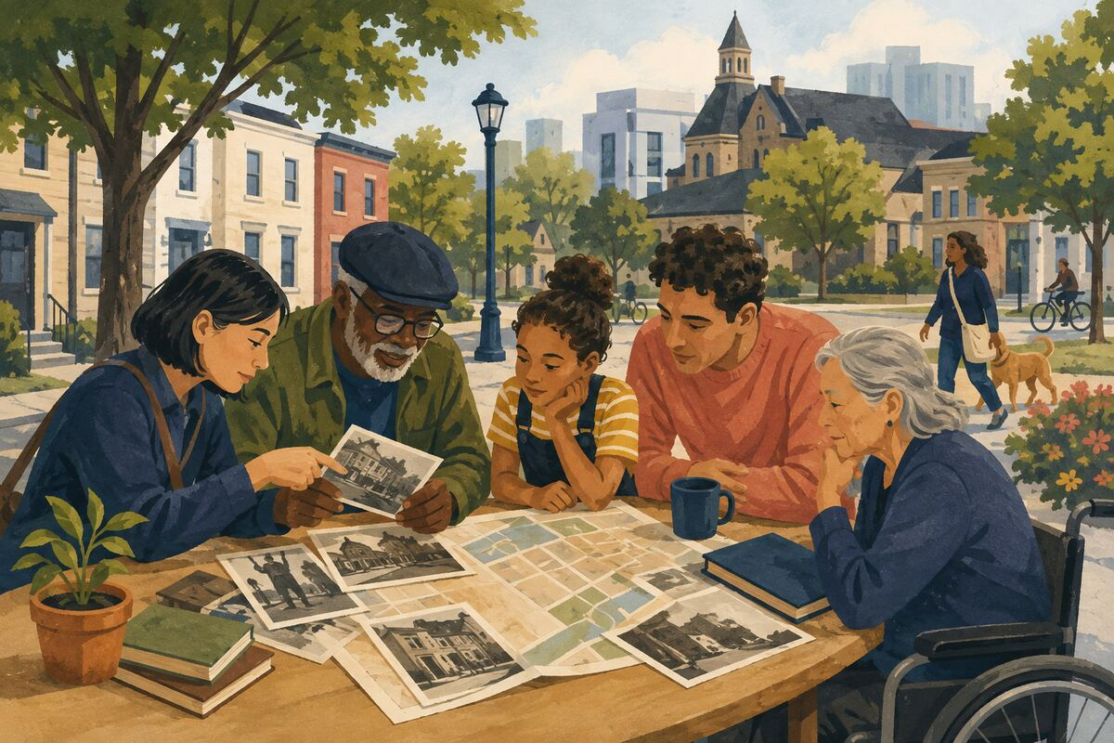
DO Research the origin, prior uses, people, and changes connected to a street, park, building, or neighborhood.

COMMUNITY BENEFIT Deepens attachment and improves understanding of current issues.

EXAMPLE FOR YOUNGER GENERATIONS Shows that places have histories before our arrival.

COMMUNITY CULTURE, MORALE, AND MEMORY
194 Celebrate maintenance work
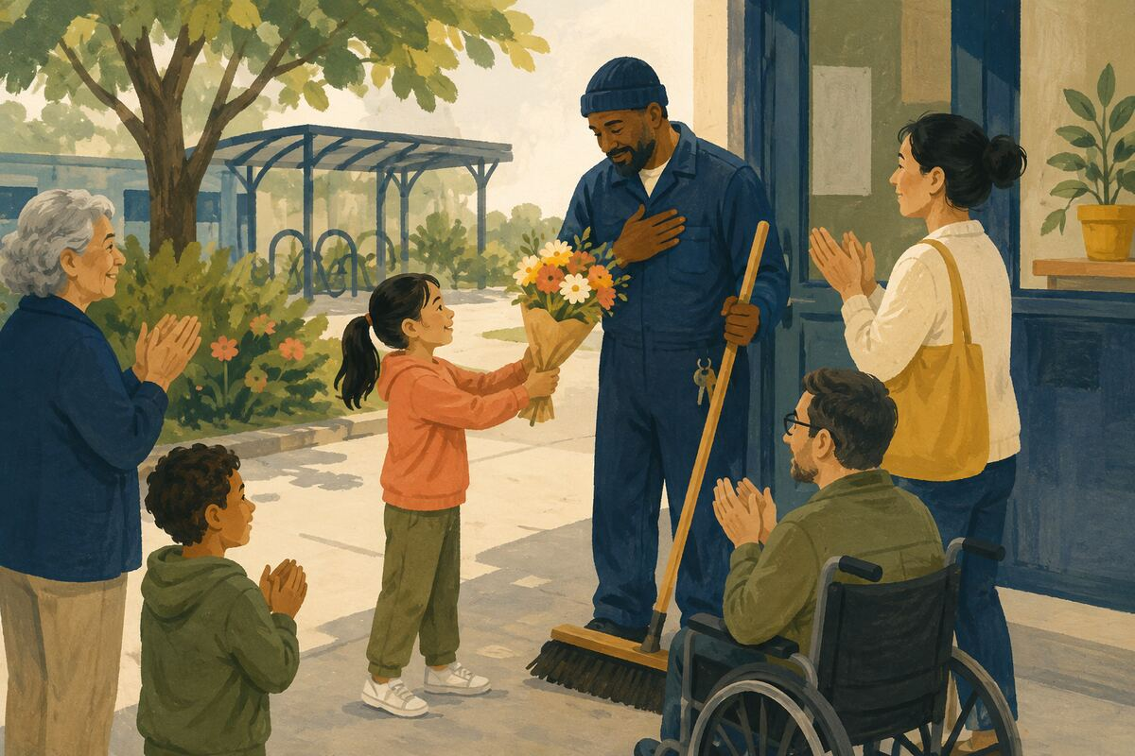
DO Thank the custodian, groundskeeper, technician, volunteer, organizer, or caregiver who keeps something functioning.

COMMUNITY BENEFIT Raises the visibility and dignity of essential work.

EXAMPLE FOR YOUNGER GENERATIONS Teaches children to value upkeep, not only new construction.

COMMUNITY CULTURE, MORALE, AND MEMORY
195 Create a small neighborhood tradition
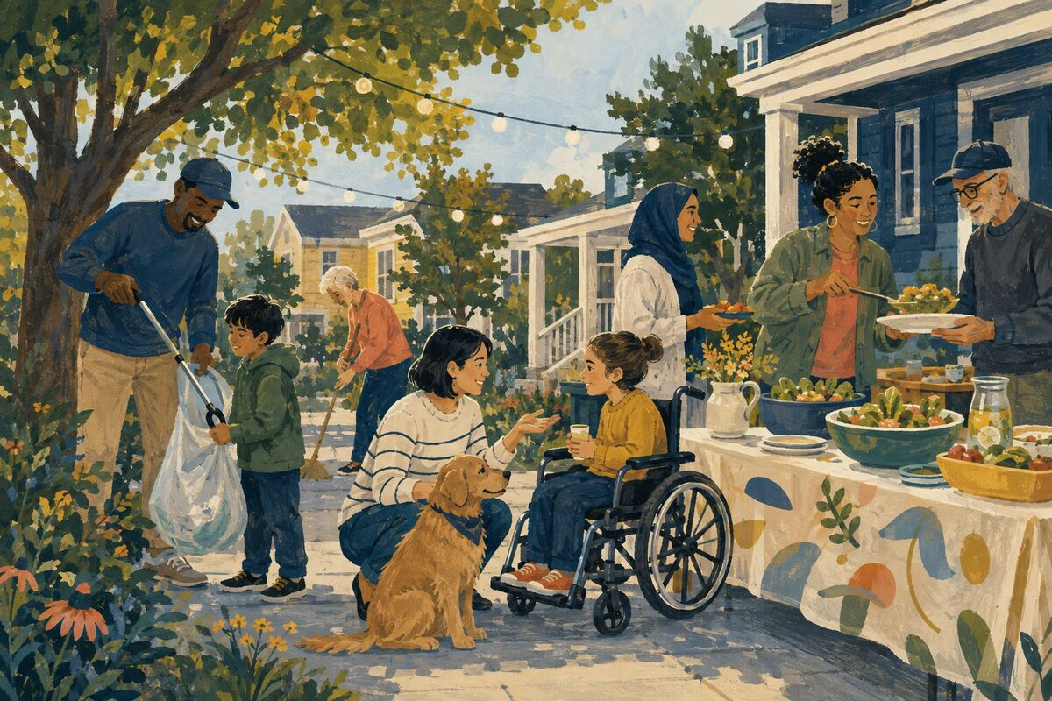
DO Organize a yearly cleanup, book exchange, porch-light walk, shared meal, or welcome note with simple, inclusive rules.

COMMUNITY BENEFIT Creates repeated contact and a sense of continuity.

EXAMPLE FOR YOUNGER GENERATIONS Shows that community can be intentionally built.

COMMUNITY CULTURE, MORALE, AND MEMORY
196 Share a skill across generations
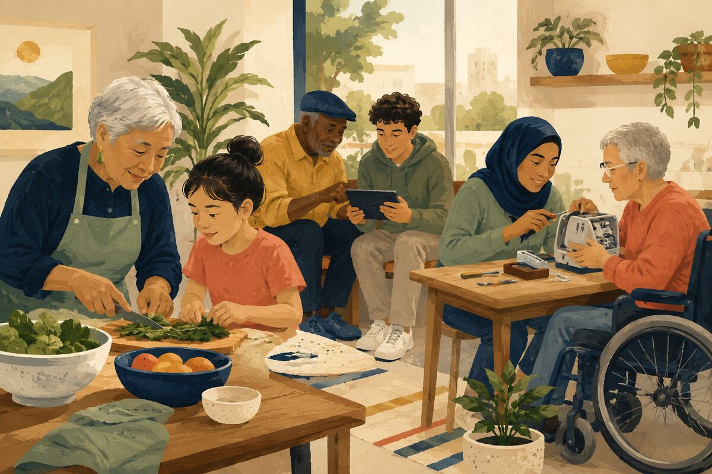
DO Pair younger and older participants to exchange technology, cooking, language, repair, music, gardening, or local knowledge.

COMMUNITY BENEFIT Builds mutual respect and preserves practical knowledge.

EXAMPLE FOR YOUNGER GENERATIONS Shows that every generation can teach and learn.

COMMUNITY CULTURE, MORALE, AND MEMORY
197 Display local art with permission
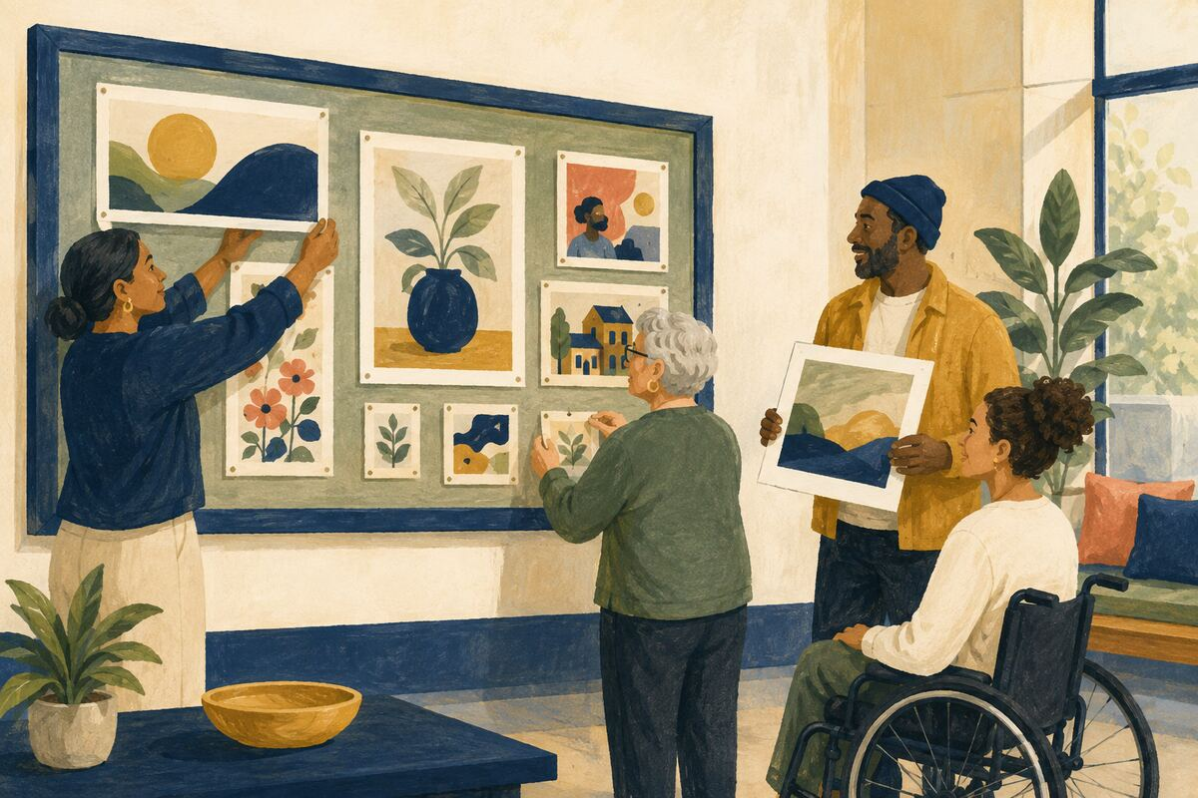
DO Offer an appropriate wall, bulletin board, website, or event space to local creators with clear credit and terms.

COMMUNITY BENEFIT Makes local talent visible and strengthens shared identity.

EXAMPLE FOR YOUNGER GENERATIONS Models creating platforms for others.

COMMUNITY CULTURE, MORALE, AND MEMORY
198 Mark a community achievement accurately
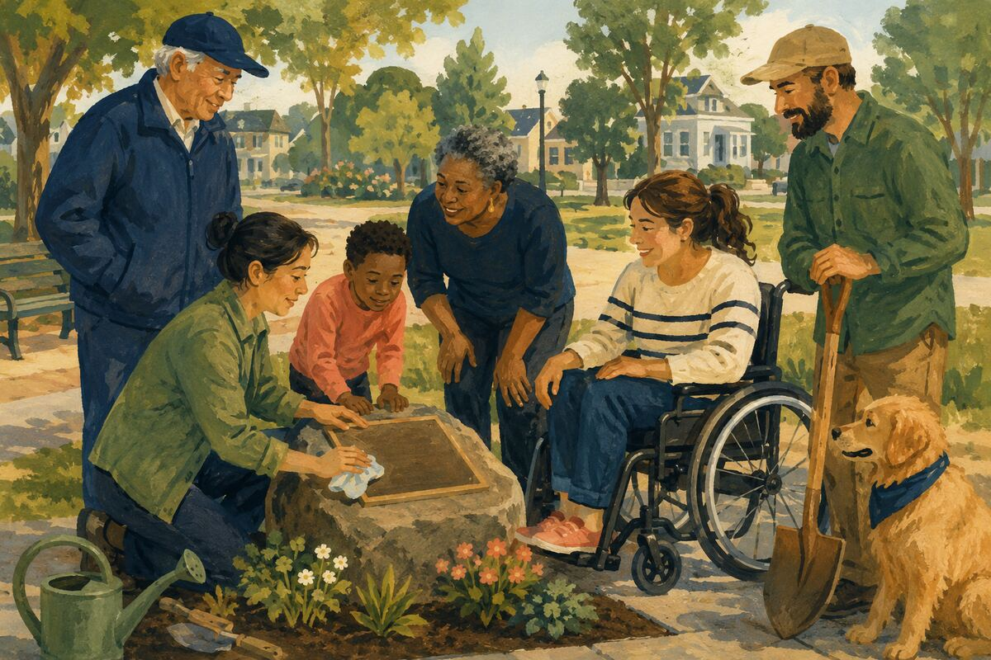
DO Recognize a milestone, volunteer effort, recovery, or improvement and name the people and facts correctly.

COMMUNITY BENEFIT Creates shared memory and reinforces successful cooperation.

EXAMPLE FOR YOUNGER GENERATIONS Teaches that progress deserves documentation.

COMMUNITY CULTURE, MORALE, AND MEMORY
199 Invite someone who usually serves to participate
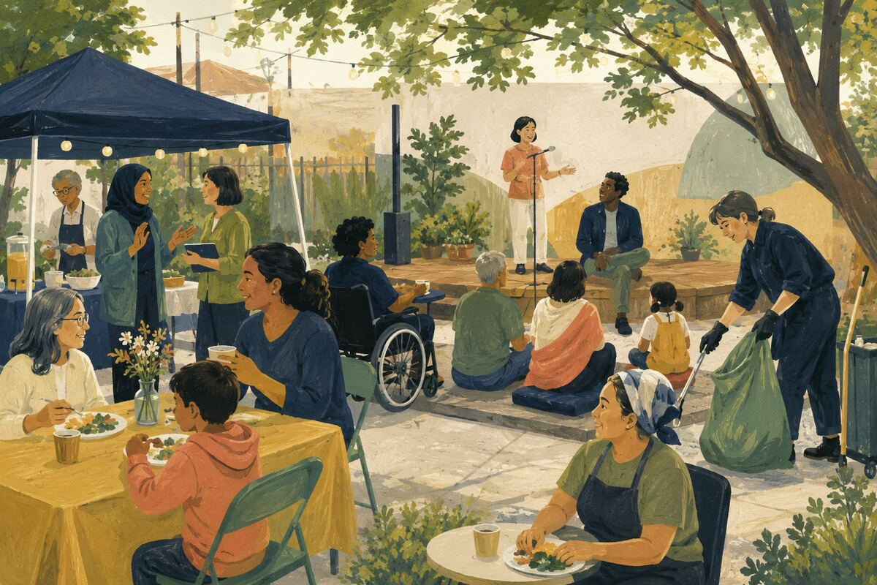
DO Make sure organizers, caregivers, translators, and cleanup workers also have time to eat, watch, speak, or enjoy the event.

COMMUNITY BENEFIT Prevents the same people from remaining permanently invisible.

EXAMPLE FOR YOUNGER GENERATIONS Shows that contributors deserve belonging, not only duties.

COMMUNITY CULTURE, MORALE, AND MEMORY
200 End gatherings with shared cleanup
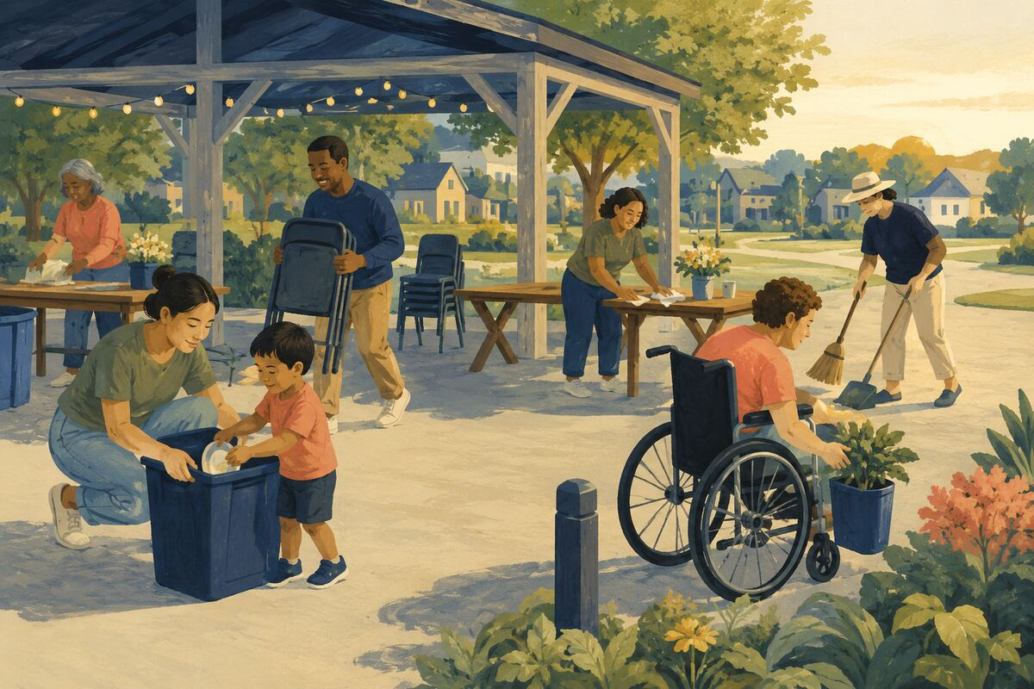
DO Give everyone a small closing role and leave the venue cleaner and properly reset.

COMMUNITY BENEFIT Reduces labor for hosts and makes events easier to repeat.

EXAMPLE FOR YOUNGER GENERATIONS Teaches that celebration includes restoration.

A Community Credo
We notice what needs care.
We begin with what is within reach.
We make room for different abilities and experiences.
We keep promises, share knowledge, and repair what we can.
We protect dignity while offering help.
We leave places, systems, and relationships stronger than we found them.
We teach by doing.
Small acts become shared habits. Shared habits become a stronger community.

